

SUMMER 2017

PRE-SEASON REPORT

ISLAND SINGLES CHAMPIONSHIP

SATURDAY – 8th APRIL

LIBERATION SINGLES OPEN SATURDAY - 22ND APRIL

(ENTRY FORMS AT THE END OF THE REPORT) – DON’T LEAVE IT TOO LATE!!

The New Season is almost upon us as the excitement builds for another great season.



The 100 CLUB will be a new part of the club’s website – COMING SOON!!

Neil Selby becomes the latest Carrefour PC player to play in the Premier League, will he suffer the same fate that Chris Romeril and Jake Romeril did and be relegated or will he be a title challenger. It should be the latter with Neil having won several Island Championships. Jake Romeril is back in the Premier League and will be looking to redeem himself.

Andrew Bellamy-Burt is the Current Summer League champion will be looking at making it 3 Summer titles in a row, but with Toby Northern taking the Winter title, Geoffroy Buffetrille finishing 2nd for the last two seasons it’s going to another really close title race.

That’s not forgetting Matt Pinel who will be representing Jersey in the World Singles Championship in Belgium in April, Ross Payne, Alice Ibitson, David Ibitson, Keith Pinel, Brian Harris and last but certainly not least current Island Singles and Liberation Singles champion Matt Buesnel. What a line up!!!

A Sneak Peek of the 100 CLUB, Player 2, Ross Payne.

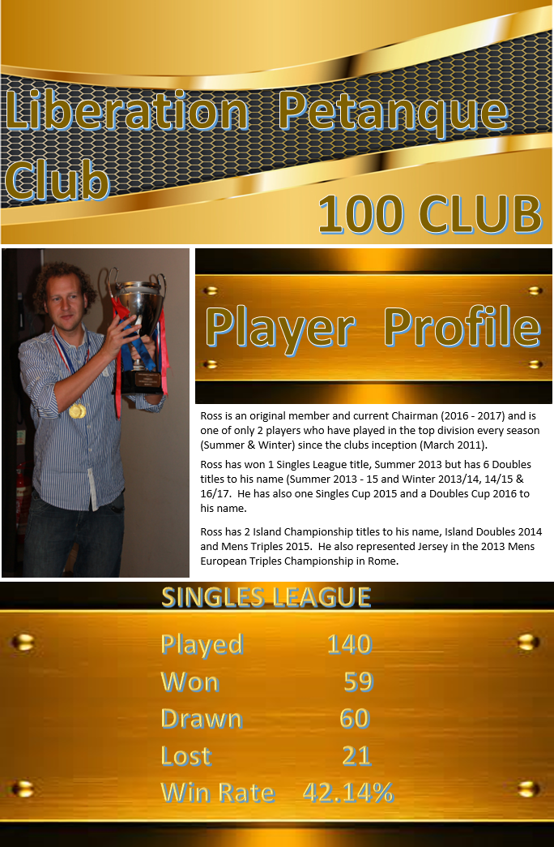

Rob Gregory makes the step up into Division 1 and will be tested in another really tough league, which has Callum Stewart in it! Callum finished 3rd in the Winter Premier League, what a difference a season makes.

He must be favourite for the Division 1 title? He will come up against pals Joey Le Clech, Jonny Hill and Brendan Jones. John McGaw, Brigitte Ibitson, James Mold, Paul Le Moine and Ian Foster complete the strong line up.

We welcome many new faces in Division 2 as David & Susan Le Gresley, Harrison Marie, Richard Williams, Jean Stewart join the club. They will play experienced club members Cassie Stewart, Kat Migala and Ian Black, we hope you all enjoy the season and good luck in the leagues.

PS Don’t forget the 1 throw of the Coche rule!!! In line with the FIPJP Rules.

START TIME 6PM, please make sure you know who you are playing and be early, practice makes all the difference.

WEBSITE www.liberationpetanque.co.uk
EMAIL liberationpc@gmail.com

Kind Regards
Report Editor
Toby Northern
Liberation Petanque Club

SPONSORED BY



Summer 2017 Season

Week 1

29th March 2017

Singles League

ISLAND SINGLES CHAMPIONSHIP THIS SATURDAY – 8th APRIL

Welcome to the new season, especially all those new members playing their first singles match at the club.

Division 2 saw three matches being played with two ending in draws. Regular club members Ian Black and Kat Migala drew in a really close match 13-10, 11-13. A draw also for Cassie Stewart with new member Richard Williams. One win though as Susan Le Gresley beat Jean Stewart who joins her husband, son and daughter at the club to make it a full house!

Speaking of which Callum Stewart beat his dad Alex as Callum bids to regain his place in the Premier League. Ian Fosters bid to also regain his place didn’t start off well with a defeat to Jonny Hill and John McGaw picked up 3 points with a win over Brendan Jones who returns to the club after a year out.

The big result of the day was newly promoted Rob Gregory getting a draw against Joey Le Clech who came down from the Premier league, great result for Rob, but not for Joey.

Another draw for Brigitte against James Mold, but early days!!!

Brian Harris got revenge over Toby Northern who relegated Brian with a win in the last match of the season, which also gave Toby the title. Brian coming back from 12-6 down in the second game to win 13-12.

Andrew Bellamy-Burt’s bid to extend his unbeaten record went really well conceding just 9 points against Alice Ibitson. Ross Payne was one point away from being relegated in his final league match of the winter season and it didn’t get much better here losing to David Ibitson.

Geoffroy Buffetrille got off to a good start beating Matt Buesnel who conceded just 11 points and Jake Romeril beat fellow Premier league newcomer Neil Selby for 3 vital points.

WEBSITE www.liberationpetanque.co.uk
EMAIL liberationpc@gmail.com

Kind Regards
Report Editor
Toby Northern
Liberation Petanque Club

SPONSORED BY

Summer 2017 Season

Week 2

5th April 2017

Doubles League

ISLAND SINGLES CHAMPIONSHIP THIS SATURDAY – 8th APRIL

The Doubles Premier league saw Mark Nicol join with Jake Romeril, both long time Carrefour players. They didn’t get off to a great start though losing to highly regarded doubles team of Callum Stewart & Andrew Bellamy-Burt, 13-9, 13-3.

Previous champions Matt Ryan & David Ibitson got off to a great start beating relegation candidates Matt Buesnel & Nathan Wheller.

Brian Harris & Paul Le Moine shared the spoils with Joey Le Clech & Jonny Hill in a topsy turvy match 5-13, 13-2. Brigitte & Alice got a big win over Premier league newcomers Ian Black & Luke Nightingale.

Division 1 saw two fanny certificates hand out as experience doubles team Alan Mitchell & Mike Robinson beat Lauren Shipley & Paul Bell. Alex & Jean Stewart handed one out to Harrison Marie & Richard Williams but the later came back to get a good draw.

Wins also for David & Susan Le Gresley over Christophe & Iwona and Karen & Eamonn Bougeard over Karen & Colin Hidrio.

A really close draw between James Rondel & Tom McMinigal and Ian & Jane Rondel 13-12, 11-13. Two former Premier league teams faced off early on but it was Aln Oliveira & Craig Kelly who beat Colin Myers & Steve Simpkin.

NEXT WEEK

Singles League – Start Time 6pm

WEBSITE www.liberationpetanque.co.uk
EMAIL liberationpc@gmail.com

Kind Regards
Report Editor
Liberation Petanque Club

SPONSORED BY

Summer 2017 Season

Week 3

12th April 2017

Singles League

GOOD LUCK TO MATT PINEL - WORLD SINGLES CHAMPIONSHIP – GHENT, BELGIUM THIS WEEKEND.

LIBERATION SINGLES OPEN – SATURDAY 22ND APRIL 2017 – Entry Form on Website.

Neil Selby got off the mark beating Brian Harris to gain 3 vital points. Keith Pinel beat Jake Romeril to start his season off well and Geoffroy Buffetrille regained composure well to gain a draw against Toby Northern and Matt Buesnel also got off the mark beating Alice who is on zero points after 2 matches, could be a tough season ahead.

Andrew Bellmay-Burt just beat David Ibitson winning 13-12 in the second game for back to back wins as he attempts to regain his Summer Premier league crown.

Callum Stewart shared 2 13-12 games with Ian Foster which ended in a draw and Alex Stewart got his first win over Brigitte Ibitson.

James Mold piled on the misery for Joey Le Clech who scored just 7 points against James. Jonny Hill drew a close match against Brendan Jones.

In division 2 Susan Le Gresley made it back to back wins, this time over husband David in his first match at the club.

Harrison Marie won his first ever match against Kat Migala and Jean Stewart also won her first ever match against Richard Williams.

NEXT WEEK

Doubles League – Start Time 6pm

WEBSITE www.liberationpetanque.co.uk
EMAIL liberationpc@gmail.com

Kind Regards
Report Editor
Liberation Petanque Club

SPONSORED BY

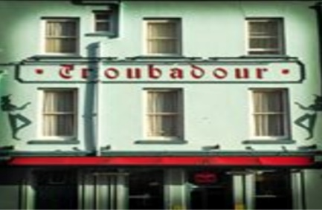

Summer 2017 Season

Week 4

19th April 2017

Doubles League

See – CEP Petanque website to see how Matt Pinel got on in the World Championships www.cep-petanque.com

LIBERATION SINGLES OPEN – SATURDAY 22ND APRIL 2017 – Entry Form on Website.

Kat Migala & Cassie Stewart playing in the Premier League for the first time, got off to a great start beating Ian Black & Luke Nightingale who suffered their second successive defeat as they struggle to adapt to the Premier league.

Mark & Jake got their first win of the season but in a close match with Brian & Paul 13-10, 13-8. Joey & Jonny picked up maximum points against Alice & Brigitte.

The clubs most successful doubles player Ross Payne has a new partner this year, Neil Selby and they played well together in their first match drawing with Matt Ryan & David Ibitson 13-12, 11-13, a close match!

Division 1, Alan & Mike continued their good start losing just 12 points against Alex & Jean for back to back wins. Paul Bell & Lauren Shipley came back well from week one to get their first league win, over Christophe & Iwona.

Ian & Jane Rondel also picked up their first ever league win over Harrison Marie & Richard Williams. Keith & Sue Pinel beat Karen & Eamonn.

Two draws with Alan & Craig v James & Tom and Colin & Steve v Brendan & Stefan.

NEXT WEEK

Singles League – Start Time 6pm

WEBSITE www.liberationpetanque.co.uk
EMAIL liberationpc@gmail.com

Kind Regards
Report Editor
Liberation Petanque Club

Summer 2017 Season

Week 5

26th April 2017

Singles League

Premier League - Geoffroy starts to build up yet another title challenge with a win over Brian as does Neil Selby beating Keith Pinel comfortably. Ross Payne got off the mark with a drew with Jake Romeril, Ross winning the second game 13-1!

Alice got her first point of the season drawing with Toby and Matt Buesnel just failed to beat David Ibitson who gained another valuable point. Matt Pinel still yet to play a match!!

Division one saw Briggite draw with Joey and Alex draw with Ian Foster. Callum Stewart won again to help his promotion charge, this time against Brendan Jones.

Paul Le Moine played his first match losing to Jonny Hill who moves into contention for promotion and Rob Gregory continues to improve with a draw over John McGaw winning the second game 13-3.

Division 2 saw the first Fanny certificate handed out as Jean Stewart beat Matt Hutchings 13-0, 13-10. Harrison Marie, made it back to back wins this time over Ian Black.

David Le Gresley won his first ever league match and doubles partners Cassie and Kat drew with each other.

NEXT WEEK

Melee 1 – Start Time 6pm

WEBSITE www.liberationpetanque.co.uk
EMAIL liberationpc@gmail.com

Kind Regards
Report Editor
Liberation Petanque Club

Summer 2017 Season

Week 6

3rd May 2017

Melee 1
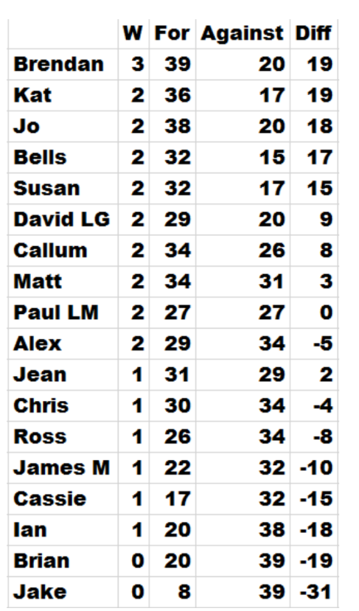

This seasons first melee was well attended with 18 members taking part.

3 matches were played with Brendan taking the spoils with 3 out of 3 wins with an impressive +19. Brendan was the only one with 3 wins.

Runner up was Kat Migala with 2 wins + 19.

Jake Romeril only score 8 points in 3 matches finishing bottom with 0 wins – 31, Brian Harris didn’t fair too much better though.

Next Melee on Wednesday 7th June

NEXT WEEK

Doubles League – Start Time 6pm

WEBSITE www.liberationpetanque.co.uk
EMAIL liberationpc@gmail.com

Kind Regards
Report Editor
Toby Northern
Liberation Petanque Club

Summer 2017 Season

Week 7

10th May 2017

Doubles League

This Weekend – Colin Welsh Memorial Trophy (Sunday 14th May) – See club website for details.

Just three matches played in the Premier league and Neil Selby & Ross Payne suffered a fanny against Matt Pinel & Richard Nevitt and lost the match. Matt Ryan & David Ibitson inflicted a heavy defeat on Callum Stewart & Andrew Bellamy.

Ian Black & Luke Nightingale finally got a point against Joey Le Clech & Jonny Hill.

Alan Oliveira & Craig Kelly almost achieved the unthinkable allowing Harrison & Richard just one point in two games winning 13-0, 13-1.

Christophe & Iwona finally got a league win, beating Colin & Karen. Well done both. Ian & Jane Rondel continued their fine form with another win this time over Alan & Mike.

Keith & Sue suffered a loss to David & Susan who have started the season really well. Alex & Jean got back to winning ways against Paul & Lauren.

NEXT WEEK

Singles League – Start Time 6pm

WEBSITE www.liberationpetanque.co.uk
EMAIL liberationpc@gmail.com

Kind Regards
Report Editor
Toby Northern
Liberation Petanque Club

Summer 2017 Season

Week 8

17th May 2017

Singles League

JPA – ISLAND DOUBLES CHAMPIONSHIP – Venue Jersey Petanque Club – Saturday 27th May 2017

Winter Premier league champion Toby Northern finally got his first win of the season, against the only person to beat him in the Winter League David Ibitson with Toby’s firing making all the difference.

Geoffroy Buffetrille and Neil Selby both with good starts to the season drew with each other. Alice Ibitson got another point this time against Brian Harris.

Matt Pinel finally played his first match of the season and won in style handing Matt Buesnel a Fanny certificate in the process.

Only one result in Division 1 saw Joey Le Clech get his first win of the season but how close was in against Alex Stewart 13-12, 13-12!

Harrison Marie made in 3 straight wins in division 2 beating Chris Le Gallais who replaced David Renouf in the league.

Susan Le Gresley is not far behind Harrison though with another win against Richard Williams but another game going to 13-12. David Le Gresley also won, taking three points against Mat Hutchings.

Cassie Stewart won her first match of the season taking three points off Ian Black who is struggling so far and Kat Migala beat Jean Stewart for her first win too.

NEXT WEEK

Doubles League – Start Time 6pm

WEBSITE www.liberationpetanque.co.uk
EMAIL liberationpc@gmail.com

Kind Regards
Report Editor
Toby Northern
Liberation Petanque Club

Summer 2017 Season

Week 8

17th May 2017

Singles League

JPA – ISLAND DOUBLES CHAMPIONSHIP – Venue Jersey Petanque Club – Saturday 27th May 2017

A full house of matches played in the Premier League. Two matches went 13-3, 13-2 as Callum & Andrew beat Matt & Richard and Geoffroy & James beat Brigitte & Alice.

Ross & Neil got a much needed win, but only just winning the second game against Kat & Cassie 13-12. Nathan & Matt Buesnel eased early relegation fears with a win over Ian & Luke.

Mark & Jake, were expected to win comfortably in the league but again failed this time drawing with Joey & Jonny. The last match saw another draw with David & Matt sharing the spoils with Brian & Paul.

Both Keith & Sue and David & Susan got the three points against Christophe & Iwona and Colin & Steve respectively.

Alan & Craig had a hard fought draws against Mike & Alan and Brendan & Stefan got a big win over Harrison & Richard.

NEXT WEEK

Doubles League – Start Time 6pm

WEBSITE www.liberationpetanque.co.uk
EMAIL liberationpc@gmail.com

Kind Regards
Report Editor
Toby Northern
Liberation Petanque Club

Summer 2017 Season

Week 10

31st May 2017

Singles League

LIBERATION DOUBLES OPEN – Saturday 10th June – Entry Form on the website.

A double fixture and a chance to pick up 6 league points in total. Andrew Bellamy Burt recovered from losing his first game against Keith Pinel to get a draw but beating Ross Payne in his second match for 4 points on the night.

Matt Pinel only got 1 point after drawing with Toby Northern and then losing to Brian Harris. Brian also drew with David Ibitson taking him to 8 league points and sits in the top half of the table.

Toby also drew with Jake Romeril and sits on 7 points. David Ibitson lost a very close match to Geoffroy 13-12, 13-11, with Geoffroy also beating Alice Ibitson for the maximum 6 points.

Keith Pinel also drew with Matt Buesnel who also drew with Jake Romeril for 2 league points all round.

Division 1 saw Paul Le Moine win one (against Ian Foster) and lose one (against Brendan Jones). Brendan also drew with Alex Stewart. Callum Stewart took 4 points beating Rob Gregory and drawing with James Mold.

James also drew with Jonny Hill who then drew with Brigitte as both players got two points on the night.

Division 2 was a single fixture week.

Well done to Chris Le Gallais who got hs first ever league win, as Richard Williams struggles to get any points. Harrison Marie’s 100% record finally fell with a draw against Cassie Stewart.

Finally Jean Stewart and Ian black shared to spoils with a good draw.

NEXT WEEK

Melee 2 – Start Time 6pm

WEBSITE www.liberationpetanque.co.uk
EMAIL liberationpc@gmail.com

Kind Regards
Report Editor
Liberation Petanque Club

Summer 2017 Season

Week 11

7th June 2017

Melee 2

LIBERATION DOUBLES OPEN – Saturday 10th June – Entry Form on the website.

A

NEXT WEEK

Doubles League (Double Fixture) – Start Time 6pm

WEBSITE www.liberationpetanque.co.uk
EMAIL liberationpc@gmail.com

Kind Regards
Report Editor
Liberation Petanque Club

Summer 2017 Season

Week 12

14th June 2017

Doubles League – Double Fixture

LIBERATION CLUB DOUBLES CUP – Wednesday 21st June – email club to play. (Start time 5.45pm)

This week was a double fixture week but only 4 out of 12 matches were played in the Premier League. Ian Black & Luke Nightingale probably wished they hadn’t played as the become the 2nd team this season to be fannied in a defeat to Mark Nicol & Jake Romeril. This win moves the pair back into contention for the title.

Callum Stewart & Andrew Bellamy-Burt went top of the table but could only draw with Kat Migala & Cassie Stewart. They did though beat Nathan Wheller & Matt Buesnel.

Matt Pinel & Richard Nevitt moved up the table with a comfortable win against Brigitte & Alice Ibitson.

Nine out of 14 matches were played in Division 1 with Keith & Sue Pinel coming out with maximum points moving up to 2nd in the table as a result.

Brendan Jones & Stefan Riccio also got two wins moving up to 4th and remain unbeaten so far. The pair beat Alan & Mike and Alex & Jean.

Karen & Eamonn Bougeard got 4 points with a draw against Harrison Marie & Richard Williams and a win over Alan & Mike who had a bad night results wise.

Ian & Jane Rondel are in 3rd place after beating Paul & Lauren, but its David & Susan Le Gresley who remain top with another win, its now 4 out of 4 played so far.

NEXT WEEK

Liberation Cup (Doubles) – Start Time 5.45pm

WEBSITE www.liberationpetanque.co.uk
EMAIL liberationpc@gmail.com

Kind Regards
Report Editor
Toby Northern
Liberation Petanque Club

Summer 2017 Season

Week 13

21st June 2017

LIBERATION CUP (Doubles)

CARREFOUR SINGLES OPEN – Sat 24th June 2017

Just 13 teams played this years competition after a few late withdrawals, but it didn’t affect the quality of the play on the day.

Matt Pinel & Toby Northern winners in 2015 (Matt also in 2012, 2013 and Toby in 2011) were off to the best possible start winning 13 – 0 against Jean Stewart & Chris Le Gallias.

A close match between Jake Romeril & James Gennoe v David & Brigitte with the latter just edging the win 13-11. There was a shock though with Last years winner Ross Payne being partner by his new league partner Neil Selby. They lost 13-10 to Harrison Marie & Richard Williams who are relatively new to the sport and joined the club this Summer.

Round two saw Harrison & Richard play Toby & Matt who went 12 nil up and despite Toby firing out Harrison’s boule Richard placed his last one on the coche to get a point (25 straight points for Toby & Matt), it ended there though as Toby & Matt to the match 13 – 1.

A really close match saw Andrew Bellamy-Burt & Callum Stewart get 2 points on the last extra end to make it 8 – 8 with Ross & Neil. So the final end was played and Neill missed 2 fires to give the match to Andrew & Callum.

Alan & Craig played really well to beat Joey Le Clech & Jonny Hill 13 – 2 and David & Brigitte Ibitson beat James & Jake 13 – 11 to move into contention.

Round 3 didn’t see any change as excellent placing by Toby & firing by Matt saw another 13 – 1 win over Matt Buesnel & Nathan Wheller.

Callum & Andrew played David & Brigitte which resulted in another draw after the extra end, meaning another one to get a winner, which again Callum & Andrew did.

The result of the round though was a fanny certificate handed out to Ross & Neil by Joey & Jonny, who had only scored 7 points in their first 2 matches.

The final round saw the two teams on 3 wins play each other and yet again Callum & Andrew took it into extra time this time against Toby & Matt, but it was the latter who won with boules to spare to finished no.1 ranked team.

Alan & Craig beat David & Susan Le Gresley 13 – 10 to finish 4th place this was due to David & Brigitte also winning 13 – 10 against Joey & Jonny this mean’t David & Brigitte missed out on a Semi-Final spot by 2 points on points difference.

Matt Buesnel & Nathan Wheller took 3rd place with a win in a close match 13 – 10 over Harrison & Marie who would have made the top 4 had they won.

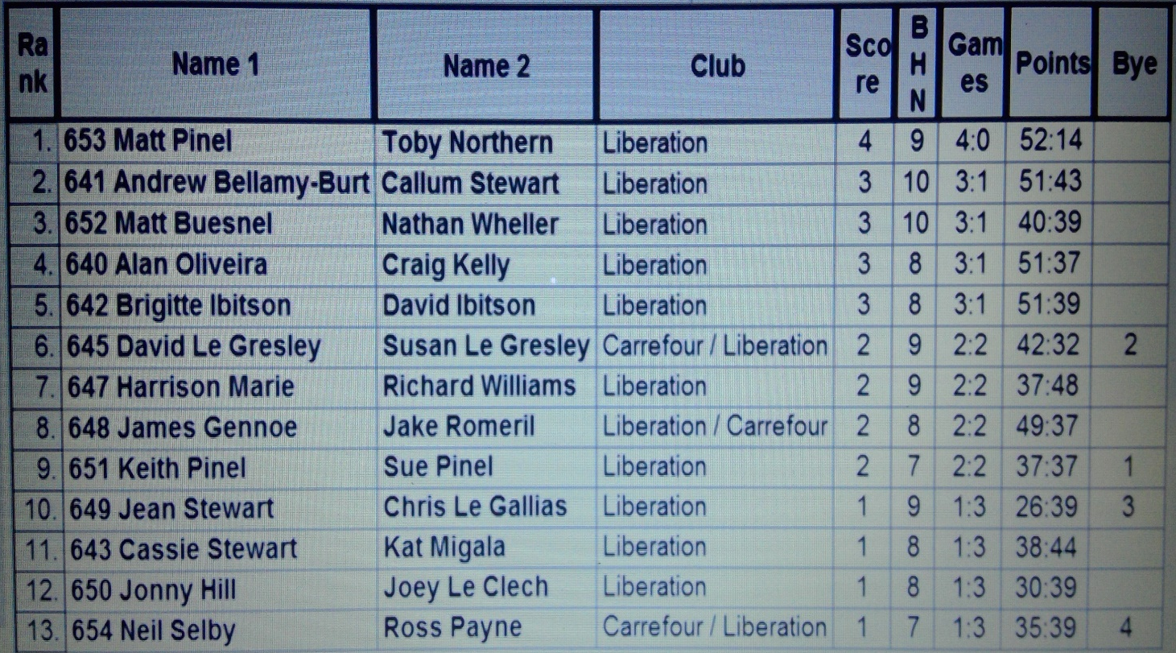

SEMI – FINALS
Ranked Ranked
1st Matt Pinel & Toby Northern v Alan Oliveira & Craig Kelly 4th
2nd Andrew Bellamy-Burt & Callum Stewart v Matt Buesnel & Nathan Wheller 3rd

Well its all about taking your chances and Alan & Craig would end up rueing the first two ends, as instead of being 6 or 7 points up were 3 – 0 down. It kept going that way as any boule anywhere near the coche was fired out time after time by Matt Pinel as himself and Toby went 12-1 up as they looked for another big score. But credit to Alan & Craig as consistent placing and firing and Toby placing deserting him, helped them back to 12-9 but Toby & Matt took the final point to make the final.

The second semi-final was nip and tuck at the beginning as they tied at 6 – 6, but the experienced pair of Callum & Andrew (who won the competition in 2014) took control to make the final.

3rd Place Play-Off

Alan & Craig took third place with ease as Matt Buesnel & Nathan Wheller struggled with the fading light and finishing at 10.30.

FINAL

Toby & Matt took early control of the final as Toby started to place really well and when Andrew did manage to out place him, Matt Pinel fired him out. Despite Callum also firing and placing well Toby & Matt went 12 – 1 up beforew Toby missed a chance to win it. Callum & Andrew did make it to 5 points before Matt’s firing proved the difference after Toby had outplaced 5 boules on the next end.

Matt Pinel increases his record of wins in the competition to 4 and the pair have now won 4 titles together (2 Liberation Doubles Cup and 2 Island Doubles Championships), not a bad record.

Thank you to everyone for taking part especially in the hot weather.

NEXT WEEK

Singles League – Start Time 6pm

WEBSITE www.liberationpetanque.co.uk
EMAIL liberationpc@gmail.com

Kind Regards
Liberation Petanque Club

Summer 2017 Season

Week 14

28th June 2017

Singles League

LIBERATION V CARRFOUR

Venue Carrefour Petanque Club.

Saturday 1st July 2017


Matt Pinel becomes the latest player to make the .

Matt is actually the 10th player to do so and has the highest win % out of the 10 players. See below player profile.

Andrew Bellamy-Burt in 2nd place in the Premier League was looking to catch up with Geoffroy Buffetrille at the top of the table but was playing 3rd place in the table, Neil Selby. This was to be Andrew’s first defeat in 35 matches, Andrew was just one point from taking the outright unbeaten record losing the second game 13 – 12.

Ross Payne, bottom of the league was taking on European Triples player Matt Buesnel, with both players really needing the maximum three points, but a draw is all they could manage as they both look in trouble.

The same was the case for Alice and David Ibitson, playing each other with Alice on 3 points from 6 matches and David on 5 points from 6 matches and another draw as these two players also look in trouble.

Brian Harris sitting in 4th place was looking to break into the top three with a win over Jake Romeril, but the latter eased his relegation fears win a win.

Division 1 saw top of the table Callum Stewart play bottom of the table Brigitte Ibitson, it was a close match but Callum retained top spot with a 13 – 9, 13 – 10 win.

2nd place Jonny Hill was playing his doubles partner Joey Le Clech who was relegated to Division 1 last Summer and is struggling in the division with just 5 points from 4 matches and -23, prior to this fixture. Jonny took the first match 13 – 11, before Joey recovered to win the second game comfortably 13 - 4.

Alex Stewart was looking to move into contention for promotion against Paul Le Moine who was at the opposite end of the table, but a return to form for Paul saw him win the match and move up the table as a result.

Harrison Marie was top of Division 2 prior to this week with 3 wins and a draw. He played Jean Stewart who wasn’t far behind in 3rd place, Jean took the 3 points comfortably 13 – 5, 13 – 6 for a great start to her first season at the club.

Matt Hutchings and Richard Williams were the bottom 2 players in the leagues so a win would give either player a vital 3 points as they bid to avoid the dreaded wooden spoon. The first game went all the way to 13 – 12, in favour of Richard, who then won the second game for 3 valuable points.

Both Cassie Stewart and David Le Gresley were looking for wins against Chris Le Gallias and Ian Black respectively to help their promotion bids and both got the wins they were looking for and both conceding 15 points to maintain the points difference between the two.

Continued below:

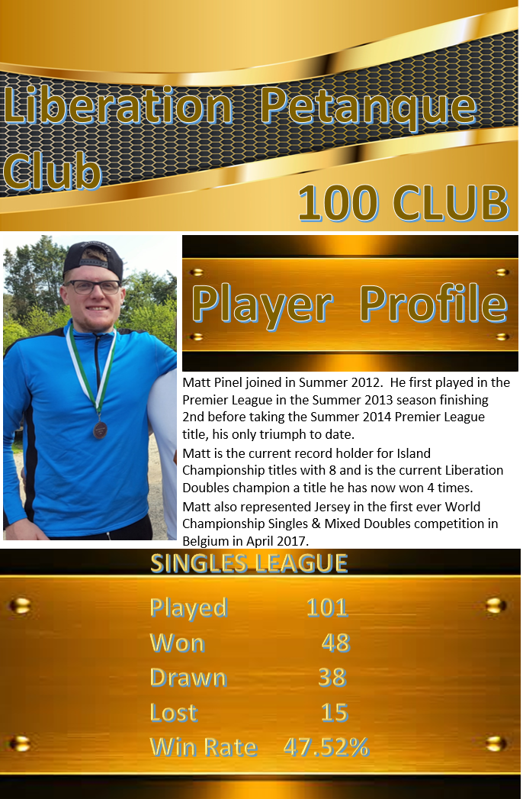

NEXT WEEK

Melee 3 – Start Time 6pm

WEBSITE www.liberationpetanque.co.uk
EMAIL liberationpc@gmail.com

Kind Regards
Report Editor
Toby Northern
Liberation Petanque Club

Summer 2017 Season

Week 15

5th July 2017

Melee 3

JPA ISLAND CHAMPIONSHIP – OPEN TRIPLES

Venue – Weighbridge – Saturday 8th July 2017

LIBERATION CLUB SINGLES CUP

Wednesday 12th July 2017

Email club to enter

A

NEXT WEEK

Club Singles Cup – Start Time 5.45pm

WEBSITE www.liberationpetanque.co.uk
EMAIL liberationpc@gmail.com

Kind Regards
Report Editor
Liberation Petanque Club

Summer 2017 Season

Week 16

12th July 2017

Liberation Singles Cup (Singles)

19 players took part in this year’s competition saw the clubs best players playing 4 rounds under the Swiss system as with all Liberations competitions.

Round 1 Geoffroy Buffetrille get a bye due to being late a decision that ultimately affected the result of the competition.

With the exception of 2 results in round one all the big hitters won their matches. It was Callum Stewart who lost to PES team mate Joey Le Clech and Ross Payne who lost to Paul Le Moine as the shocks of round 1.

Round 2 saw Geoffroy beat Andrew Bellamy-Burt 13-12 for two wins. Neil Selby also won his second match taking a very close one against Jake Romeril 13 – 12.

Paul Le Moine continued the shocks in Round two by beating Matt Buesnel, Jonny Hill also beat Keith Pinel. Toby also made it two wins beating Joey 13 – 4.

Round 3 saw Toby beat Mark Nicol 13 – 7 to make it three straight wins. Geoffroy also made it three wins beating Neil Selby 13 – 7. Andrew Bellamy-Burt lost again, this time to Jake Romeril and Paul Le Moine lost to Jonny Hill.

Matt Buesnel saw his hopes of making the knockout stages fail miserably short losing to Ian Black 13 – 12.

The final round saw several players still in with a chance of making the top 8.

Geoffroywon a really close match against Toby 13 – 11 to finish top of the rankings, with Toby finishing second. Mark Nicol recovered from his loss against Toby to beat Paul Le Moine 13 – 4 and finish third. Cassie Stewart finished fourth beating Neil Selby 13 – 3!

Ian Black was another surprise top 8 finisher beating Joey 13 – 8 for 3 wins ending 5th place.

Ross Payne recovered to finish 6th with a win over Jonny Hill 13 – 3 for 3 wins. Jake Romeril took 7th place beating a sorry Keith Pinel who ended up in 15th Place.

Neil Selby was the only player with 2 wins -9 to go through with the Swiss system aiding him with a BHN of 12.

Some big Premier League players missing out.
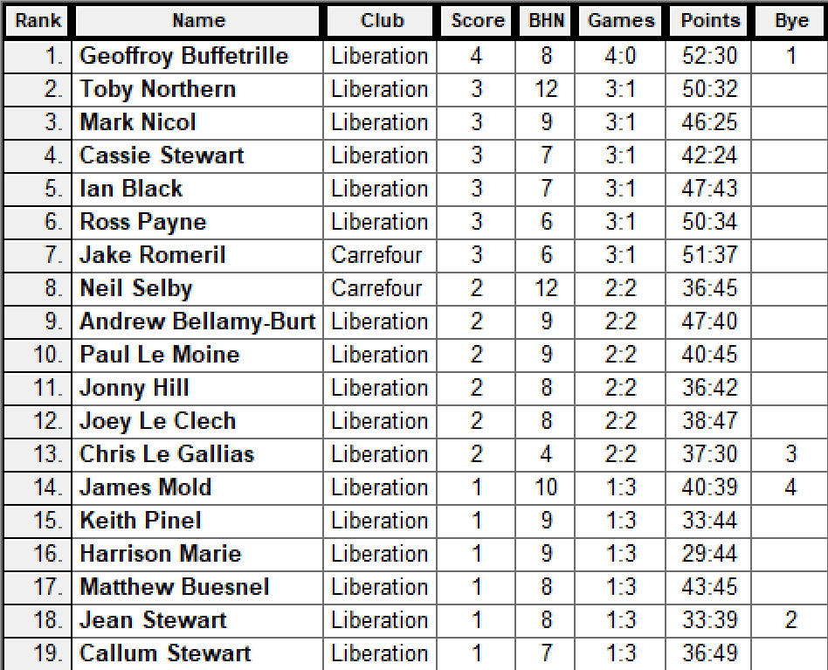

League Played In

Premier League

Premier League

N/A

Division 2

Division 2

Premier League

Premier League

Premier League

Premier League

Division 1

Division 1

Division 1

Division 2

Division 1

Premier League

Division 2

Premier League

Division 2

Premier League

The Quarter Finals were as follows:

Geoffroy Buffetrille v Neil Selby

Toby Northern v Jake Romeril

Mark Nicol v Ross Payne

Cassie Stewart v Ian Black

Geoffroy continued his fine form to make it to the Semi-finals and Jake Romeril cam back from 9-2 down to beat Toby 13 – 11.

Mark Nicol also made it through beating Ross Payne and Cassie Stewart the surprise Semi Finalist with a win over Ian Black.

Semi Finals

Geoffroy Buffetrille v Cassie Stewart

Jake Romeril v Mark Nicol

Geoffroy must have been rubbing his has at getting to player a Division 2 player in the semi finals, but Cassie didn’t make it easy for him. Despite playing well though Cassie couldn’t match Geoffroy’s skill.

Many people favourite at the start of the competition Mark Nicol made it to the semi finals with a defeat to Toby on the way. Jake Romeril though full of confidence after coming back well to beat Toby in the quarter finals handed Mark a shock defeat, not only out placing but out firing Mark.

Final

Geoffroy Buffetrille v Jake Romeril

This was going to be an interesting final. Geoffroy never having won one before clearly had this on his mind as he went 7 – 0 down. But credit where its due as Geoffroy dug deep to turn it around to win 13 straight points to win 13 – 7 for his first singles title.

3rd Place Play Off

Cassie Stewart v Mark Nicol

A close affair as Cassie pushed Mark all the way, but eventually losing 13 – 9, but a great tournament for Cassie, well played.

Congratulations to everyone who took part in another successful competition.

Thank you to everyone who helped prepare for this competition and the running of it on the day which takes a great deal of time and effort. If you like to help out at future competitions please let me know.

NEXT WEEK

Doubles League – Start Time 6pm

WEBSITE www.liberationpetanque.co.uk
EMAIL liberationpc@gmail.com

Kind Regards
Report Editor
Toby Northern
Liberation Petanque Club

Summer 2017 Season

Week 17

19th July 2017

Doubles League

Premier League new boys continue to up the pace with another win, this time over David & Matt winning the second game 13 – 1 as Mark & Jake top the league.

Ross & Neil still settling into their partnership improved this week with a good draw against Callum & Andrew who drop 2 points in their bid for the title.

James & Geoffroy had a big win over Ian & Luke 13 – 8, 13 – 1, but the closet match of the day was a 13 – 12, 13 – 12 win for Brian & Paul over Matt & Nathan, 2 points from 3 league points but ended with none, relegation looking likely.

Kat & Cassie won the battle of the ladies beating Alice & Brigitte as they move up the table and Matt & Richard beat Joey & Jonny to keep in contention for the title.

Division 1 was a double fixture with the worst possible result for any player or team and only the second time ever it has happened. Paul & Lauren suffered a double 0, 0 – 13, 0 – 13 to Alan & Craig but then recovered to beat Colin & Steve!!! Who had drawn with Keith & Sue.

3 draws Ian & Jane v Brendan & Stefan, Alex & Jean v Eamonn & Karen, Alan & Mike v David & Susan.

Alan & Mike did win one though against Christophe & Iwona but was very close, 13 – 11, 13 – 10. As did Ian & Jane beating Eamonn & Karen.

One team though took the maximum 6 points, and that was Harrison & Richard, who beat Christophe & Iwona and Colin & Karen.

NEXT WEEK

FREE WEEK

WEBSITE www.liberationpetanque.co.uk
EMAIL liberationpc@gmail.com

Kind Regards
Report Editor
Liberation Petanque Club

Summer 2017 Season

Week 18

26th July 2017

FREE WEEK

GOOD LUCK TO

LIBERATIONS EUROCUP TEAM

Thursday 27th to Sunday 30th July 2017

NEXT WEEK

Singles League – Start Time 6pm

WEBSITE www.liberationpetanque.co.uk
EMAIL liberationpc@gmail.com

Kind Regards
Report Editor
Liberation Petanque Club

SPONSORED BY

Summer 2017 Season

Week 19

2nd August 2017

Singles League

Neil Selby playing in his first Premier League season is in with a chance of the title, however could only draw with David Ibitson losing two valuable points in the process.

Matt Buesnel provided a shock as he hand Andrew Bellamy-Burt another defeat dealing the latters chances of retaining his Summer Premier league title a huge blow. It also improves Matt’s chances of staying up significantly.

Toby came back from losing the first game against Ross 13 – 3 and 10 – 0 down in the second game, Toby came back to win 13 – 10 for a valuable point and handing Ross a technical fanny.

Keith, who has not played many matches beat Brian Harris to aid his survival bid and current league leader Geoffroy just took three points from Jake Romeril winning the second game 13 – 12.

Just two matches played in Division 1 and both draws as John McGaw and Alex Stewart couldn’t be separated and the same for Brigitte & Ian Foster.

Division 2 promotion is hotting up as Cassie took 3 points off her mum Jean winning 13 – 12, 13 – 12! David Le Gresley also won a very close match 13 – 12, 13 – 10 over Harrison Marie. Chris Le Gallais & Matt Hutchings took a point each as did Kat Migala and Richard Williams.

NEXT WEEK

Doubles League – Start Time 6pm

WEBSITE www.liberationpetanque.co.uk
EMAIL liberationpc@gmail.com

Kind Regards
Report Editor
Liberation Petanque Club

Summer 2017 Season

Week 20

9th August 2017

Doubles League

GOOD LUCK TO ALL THOSE PLAYING IN THE HOME NATIONS THIS WEEKEND

A Callum & Andrew took an expected 3 points from Luke & Ian. Nathan & Matt also took 3 points and very valuable ones too beating Alice & Brigitte.

Ross & Neil failed to win again this time against Brian & Paul.

Division 1 saw James & Tom draw with Colin & Steve, with the latter struggling with the new terrain.

Title challenges Ian & Jane and David & Susan fought out a good match but Ian & Jane just won 13 – 10, 13 – 11.

Keith & Sue gain a another point with another draw against Harrison & Richard.

Christophe & Iwona are improving fast and making it tough for opponents but lost this time to Alex & Jean.

NEXT WEEK

Singles League – Start Time 6pm

WEBSITE www.liberationpetanque.co.uk
EMAIL liberationpc@gmail.com

Kind Regards
Report Editor
Liberation Petanque Club

Summer 2017 Season

Week 21

16th August 2017

Singles League

LIBERATION MIXED DOUBLES OPEN – Saturday 26th August

Entry form on club website

Andrew some how beat Toby 13 – 10, 13 – 12 as Toby missed chances to let Andrew in and Toby now desperately needs points to avoid relegation.

Bottom of the table Alice got her first win of the season against Jake, to give herself an outside chance of staying up.

Brian Harris got three massive points with a win over Ross, and now looks likely to break his Premier League relegation hoodoo.

Ross on the other is bottom, having just avoided relegation in the Winter by one single point (scored) needs points fast.

Two title challenges both got wins and both just with a 13 – 12 as Neil beat Matt Buesnel and Geoffroy beat Keith.

NEXT WEEK

Doubles League – Start Time 6pm

WEBSITE www.liberationpetanque.co.uk
EMAIL liberationpc@gmail.com

Kind Regards
Report Editor
Liberation Petanque Club

Summer 2017 Season

Week 22

23rd August 2017

Doubles League

LIBERATION MIXED DOUBLES OPEN – Saturday 26th August

Entry form on club website

Mark & Jake were just two points from a perfect match beating Cassie & Kat 13 – 2, 13 – 0 to continue their title form.

David & Matt just beat Ian & Luke winning 13 – 12, 13 – 10 and Callum & Andrew drew a very close match 13 – 11, 11 – 13 with Brian & Paul. This draw see’s Callum & Andrews title chances slipping away.

James & Geoffroy and Matt & Richard shared a draw to also slip further behind Mark & Jake.

Joey & Jonny heaped more relegation woe’s on Nathan & Matt but it was a close match.

Colin & Steve just can’t get a win with another draw (how many times has that been said) this time against Harrison & Richard.

Alan & Craig look good for the title with a win against title rivals David & Susan and a big win it was 13 – 4, 13 – 1. Al;an & Mike also aiming for the Premier League beating Keith & Sue.

Title challenges Ian & Jane also dropped points against Christophe & Iwona.

NEXT WEEK

Singles League – Start Time 6pm

WEBSITE www.liberationpetanque.co.uk
EMAIL liberationpc@gmail.com

Kind Regards
Report Editor
Liberation Petanque Club

Summer 2017 Season

Week 23

30th August 2017

Singles League

JPA ISLAND CHAMPIONSHIP – MENS & LADIES TRIPLES

VENUE - CARREFOUR PETANQUE CLUB

Saturday 2nd September 2017

Matt Buesnel and Toby couldn’t be separated as the pair continue to stuggle for wins and this was across the board in the Premier League as David drew with Jake and Andrew drew with Brian, handing Geoffroy the title advantage.

Callum took another step towards the Division 1 title and a return to the Premier League beating John McGaw. Brigitte kept her hopes of promotion alive with a good draw against Paul Le Moine who sits in third place as did Jonny Hill drawing with Alex Stewart with Jonny in second place.

Harrison Marie moved into second place with a big win over Susan who loses her place to Harrison as a result with both players on 13 points.

David and Cassie drew which leaves David top of the table by 2 points on 15, with 3 players on 13 points.

Richard Williams beat Ian Black to move out of the bottom 3 for the first time this season and Kat Migala drew with Matt Hutchings to keep out of the bottom three and leave Matt bottom and heading for the wooden spoon.

NEXT WEEK

Melee 4 – Start Time 6pm

WEBSITE www.liberationpetanque.co.uk
EMAIL liberationpc@gmail.com

Kind Regards
Report Editor
Liberation Petanque Club

Summer 2017 Season

Week 24

6th September 2017

Melee 4

A

NEXT WEEK

Doubles League – Start Time 6pm

WEBSITE www.liberationpetanque.co.uk
EMAIL liberationpc@gmail.com

Kind Regards
Report Editor
Liberation Petanque Club

Summer 2017 Season

Week 25

13th September 2017

Doubles League

The first casualty of the season as Ian Black & Luke Nightingale are relegated from the Premier league with a game to spare. Their fate was sealed despite winning their first match of the season against Brian Harris & Paul Le Moine as other results mean’t they could not make it.

Brigitte & Alice Ibitson also struggling 4 points from safety got a valuable point against Callum Stewart & Andrew Bellamy-Burt, which significantly reduces their chances of taking the title.

James Gennoe & Geoffroy Buffetrille gained a big win over Cassie Stewart & Kat Migala but still remain 5 points off the top of the league.

Neil Selby & Ross Payne shared the spoils with Joey Le Clech & Jonny Hill to remain in third. This gives more chances for Mark Nicol & Jake Romeril to take the title just beating Matt Buesnel & Nathan Wheller taking the second game 13 – 12.

A double fixture week in Division 1 and it was a great week for James Rondel & Tom McMinigal who took the maximum 6 points to double their league tally, beating both Harrison Marie & Richard Williams and Alan Mitchell & Mike Robinson.

Alan & Mike also drew with Colin Myers & Steve Simpkin with the latter moving out of the relegation zones as a result.

Ian & Jane Rondel (top of the table) could only draw with bottom of the table Colin & Karen Hidrio this means they are just 2 points above Alan Oliveira & Craig Kelly who have 2 matches in hand.

Alan & Craig winning comfortably against Christophe & Iwona Ait-Elhadj. David & Susan Le Gresley could only draw with Eamonn & Karen Bougeard which means they drop out of the promotion places and are replaced by Keith & Sue Pinel who beat Alex & Jean Stewart to move third.

Brendan Jones & Stefan Riccio still unbeaten but have only played 5 out of 11 matches as have Colin & Karen Hidrio and Paul Berll & Lauren Shipley playing just 6 matches. A lot of catching upto do as just 4 weeks until the end of the season.

NEXT WEEK

Singles League – Start Time 6pm

WEBSITE www.liberationpetanque.co.uk
EMAIL liberationpc@gmail.com

Kind Regards
Report Editor
Toby Northern
Liberation Petanque Club

Summer 2017 Season

Week 26

20th September 2017

Singles League

With Matt and Keith Pinel both having 4 matches outstanding prior to today’s matches and Matt away in the European Triples Championship in France as was Matt Buesnel there will be lots to catch up on.

This means Matt Pinel, Jake Romeril, Brian Harris and Matt Buesnel will all need to play matches that could ensure their Premier League survival.

Keith did play one outstanding match against Toby but despite winning the first game lost the second but a valuable point for both players.

Keith also played David Ibitson with both players needing 3 points to have a chance of staying up. David took the first game with easy, and will be think about a missed opportunity to ensure safety as he let Keith back into the second game for another draw.

Keith still has Ross, Alice and Matt Pinel to play needing 2 points for safety. David though is only on 9 points and must now win his last match against Matt Pinel to stay up.

Andrew Bellamy-Burt’s recent defeats (3!!!) means the expected end of season title decider against Geoffroy Buffetrille was not quite as important but Andrew could still affect the outcome if he could take points off Geoffroy, but it was a big win for Geoffroy 13 – 3, 13 – 10 which seals the title, Well done Geoffroy, he will certainly be the player to beat in 2018.

Neil Selby had two matches to play knowing he needed to win both and hope Geoffroy lost to have any chance of the title. Neil played Toby who needed the points to stay up, in stark contrast to Toby winning the Winter Premier League. Neil took the first game 13 – 8, but Toby fought back in the second game winning 13 – 2 for a draw which leaves Toby likely to be relegated and has to wait for several results from Matt and Keith Pinel to find out his fate.

Ross Payne and Alice Ibitson played with both sitting up the relegation places mean’t both must win to have a chance of staying up, Ross won comfortably leaving Alice needing to win her final two matches against Matt and Keith Pinel to stay up.

With any three of Alice, Ross, Keith, David, Jake, Toby, Matt P, Matt B all still at risk of relegation with a total of 10 outstanding matches still to play.

Keith Pinel v Alice Ibitson

Keith Pinel v Ross Payne

Keith Pinel v Matt Pinel

David Ibitson v Matt Pinel

Alice Ibitson v Matt Pinel

Neil Selby v Matt Pinel

Jake Romeril v Matt Pinel

Jake Romeril v Andrew Bellamy-Burt

Ross Payne v Geoffroy Buffetrille (game 1 played 11 – 13)

Division 1 had 7 outstanding matches which could have huge implications for promotion and relegation places.

Callum Stewart was sitting top with 4 points to his advantage but still needed a win out of his last two matches to secure the title with Jonny Hill waiting in the wings to steel the top spot.

These two had to play against each other, what are the odds on that, Callum just needing a draw to stay top and that’s a result he got.

James Mold took on Alex Stewart and another draw see’s James keep his unbeaten record. Rob Gregory played Brigitte Ibitson and despite losing keeps his head just above the relegation zone.

Brendan Jones had a bye and didn’t play any of the many catch up games he has!!!

Division 2

David Le Gresley was sitting top of the table but with Harrison Marie, Cassie Stewart, Susan Le Gresley and Jean Stewart all looking to take the title or promotion.

David played Jean with the latter knowing a win could catapult her to Division 1. It was a draw which leaves Jean 2 points off a promotion place with one outstanding match to play against Chris Le Gallais.

The draw keeps David top of the league but by virtue of points scored as he is now tied at the top with Mrs Le Gresley on 16 points as she beat Cassie Stewart, her first defeat which leaves her in 4th place.

Susan and David both on 16 points and +24 points difference so it is David’s points score of 197 beating Susan’s 167, but Susan has two matches in hand. David has no more matches to play so has to sit tight and hope for the results to go his way.

Harris Marie played Richard Williams who was just looking to consolidate his mid table position but Richard won his last match of the season to move three points away from the bottom three. This prevented Harrison from taking top spot.

Matt Hutchings needed to be at Ian Black to ensure the latter was the one winning the wooden spoon and he did just that but the second game was 13-12, so close. Ian Black guaranteed a bottom 3 spot and relegation.

If Kat Migala won her last two matches she could make the top three if results went her way so needed a win against Chris Le Gallais, but lost instead and drops into the bottom three with Chris moving clear.

Division 1 outstanding matches - 14

Brendan Jones v Ian Foster

Brendan Jones v Rob Gregory

Brendan Jones v Joey Le Clech

Brendan Jones v James Mold

John McGaw v James Mold

Ian Foster v James Mold

Rob Gregory v James Mold

Paul Le Moine v James Mold

Paul Le Moine v Joey Le Clech

Paul Le Moine v Rob Gregory

Jonny Hill v Rob Gregory

John McGaw v Joey Le Clech

John McGaw v Ian Foster

Callum Stewart v Joey Le Clech

Division 2 outstanding matches - 5

Matt Hutchings v Harrison Marie

Matt Hutchings v Cassie Stewart

Kat Migala v Susan Le Gresley

Ian Black v Susan Le Gresley

Jean Stewart v Chris Le Gallais

Below the latest player to make the 100 Club – Paul Le Moine

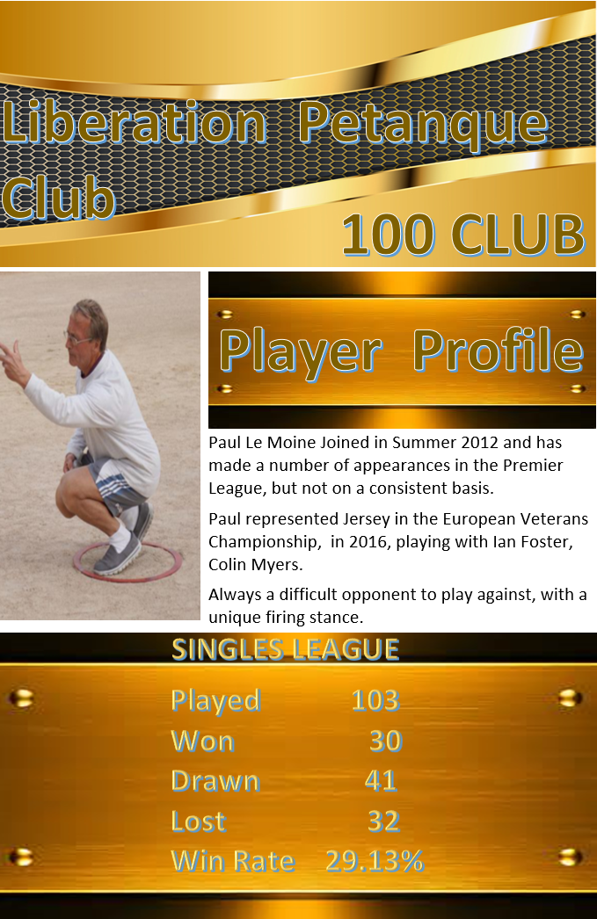

NEXT WEEK

FREE WEEK - Marathon

WEBSITE www.liberationpetanque.co.uk
EMAIL liberationpc@gmail.com

Kind Regards
Report Editor
Toby Northern
Liberation Petanque Club

Summer 2017 Season

Week 27

27th September 2017

FREE WEEK

GUERNSEY OPEN THIS WEEKEND, GOOD LUCK TO ALL THOSE PLAYING

NEXT WEEK

Doubles League – Start Time – 6pm

WEBSITE www.liberationpetanque.co.uk
EMAIL liberationpc@gmail.com

Kind Regards
Report Editor
Liberation Petanque Club

Summer 2017 Season

Week 28

4th October 2017

Doubles League

LIBERATION CHARITY TRIPLES OPEN

THIS WEEKEND – 7th October 2017

In aid of JERSEY CHILDRENS CHARITY

Please make every effort to support this great CHARITY

JERSEY PETANQUE ASSOCIATION – ISLAND CHAMPIONSHIP – VETERANS – Sat 14th October – Venue Jersey Petanque Club

ALL LEAGUE MATCHES TO BE PLAYED BY FRIDAY 13TH OCTOBER 2017.

Brigitte & Alice could only draw with Brian & Paul resulting in relegation with a match to play. Brian & Paul could also go down and have an nervous wait on results for Matt & Nathan and Kat & Cassie.

Mark & Jake took a big stride towards the doubles title with a big with over title challengers Ross & Neil, who now having completed their matches have a nervous wait sitting in bronze medal position, but not likely to keep it.

Callum & Andrew beat PC Pes team mates Joey & Jonny to give them the best chance of getting a medal sitting in 2nd place at the moment.

Matt Pinel & Richard Nevitt could win the title but they have to win all their remaining matches, 4 of them and hope Mark and Jake lose their last 2, but they do play each other.

Cassie & Kat did give themselves a big chance of staying up with a draw against David & Matt.

Division one has seen a lot of scheduled and catch up matches played over the last week.

Alan & Craig take the title and return to the Premier League with a match to spare and unbeaten in 12 matches. Also joining them will be Ian & Jane Rondel who are guaranteed 2nd place also unbeaten and have played all their 13 matches.

Sitting in the final promotion spot is currently James Rondel & Tom McMinigal on 21 points but this is only by points difference over David & Susan Le Gresley with both having one match to play. The only other team able to make third is Brendan & Stefan who were unbeaten in their first 6 matches but a rush to catch up has seen them lose 3 matches, but with 2 matches to play could finish on 24 points. All these 3 teams play teams in the relegation zone so should be a close finish.

Colin & Karen Hidrio look likely to finish bottom with only 4 points from 10 matches, but with just a week to finish not looking good.

Paul Bell & Lauren Shipley have three matches and a good chance to move out of the bottom three which could leave previous Premier League runners up Colin and Steve with back to back relegations.

NEXT WEEK

FREE WEEK – Start Time – 6pm

WEBSITE www.liberationpetanque.co.uk
EMAIL liberationpc@gmail.com

Kind Regards
Report Editor
Liberation Petanque Club

Summer 2017 Season

Week 29

11th October 2017

FREE WEEK

JERSEY PETANQUE ASSOCIATION – ISLAND CHAMPIONSHIP – VETERANS – Sat 14th October – Venue Jersey Petanque Club

ALL LEAGUE MATCHES TO BE PLAYED BY FRIDAY 13TH OCTOBER 2017.

A

END OF SEASON MEAL
VENUE –
DATE –
PRICE –
Email Club to confirm attendance

WEBSITE www.liberationpetanque.co.uk
EMAIL liberationpc@gmail.com

Kind Regards
Report Editor
Liberation Petanque Club

