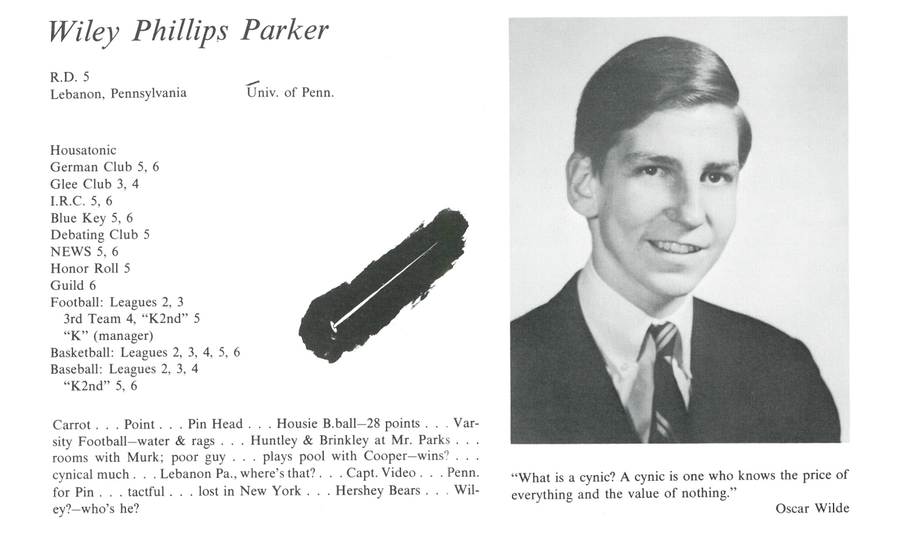

Wiley P. Parker

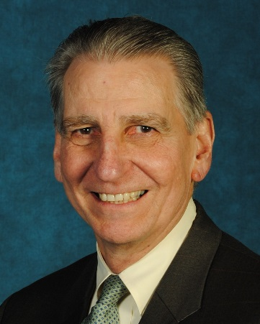After leaving Kent, I graduated from Penn, where I played lacrosse for a couple of years and did little to prepare for life by majoring in History. Oh, and then there was the draft lottery in which I rolled a “7”. That led me to enroll in Army ROTC during law school at the University of Wisconsin. When I arrived in Madison, it was the summer in which the Army Math Center had been blown up, and ROTC was not a popular extra-curricular activity. In fact, cadets were not allowed to wear their uniforms on campus because it was too dangerous. I was commissioned in 1973 and stayed in the Army Reserve until 1996 when I retired as a Lt. Col.

After obtaining my J.D., I returned to Lebanon where I was a public defender for several years. That job was where I learned the courtroom skills I’ve used during my years of practice (I’m still actively trying cases, but it’s getting tougher). My practice primarily consists of defending physicians in malpractice suits and general litigation.

I got married at the end of law school, but that ended badly. I have now been married to a very special woman, Jackie, for 32 years and she has made life a constant source of activity and amazement. We raised her 2 boys (now men) and one of our own, Max, who with his wife, Jess, just gave me **my** first grandchild, Anderson (I have 5 more of Jackie’s).

We’ve had a great time together travelling (Philippines, Hong Kong, China, Europe, Mexico, Canada, Cuba, and all over the US). We were both very avid runners and ran a number of half marathons until I earned a defibrillator about 6 years ago with a little heart hiccup. I now play golf (badly) and work out at the local Y. We are fixtures at the various athletic events of our grandkids, and have an annual week at the Jersey shore with the whole *Freundschaft*.

I’ve been active in my church to which I returned after about a decade and a half hiatus after law school, and I have been on the boards of a number of civic organizations including the Y and Lebanon Rescue Mission. I am the Chairman of the Lebanon City Council, a position I held for a couple of years even though I was the only Democrat.

Life has been much better to me than perhaps I deserved. I had mixed emotions about Kent after leaving 50 years ago, but decided to return for our 40th reunion, and I am so glad I did. Jackie (who seems to like the events at least as much as I do) and I have been able to (re)connect with so many people without all the adolescent bravado and angst of 1962-67. I never doubted the significance in my life of the education I got in the shadow of Mount Algo, and now I have a better understanding and appreciation of the people and the experience as a whole. See you soon.



______________________________________________________________

______________________________________________________________ ______________________________________________________________ ______________________________________________________________ ______________________________________________________________ ______________________________________________________________ ______________________________________________________________ ______________________________________________________________ ______________________________________________________________

Attach Picture in .jpg Format

______________________________________________________________

______________________________________________________________

___________________________________________________________________________________ _________________________________________________________________________________________________________________________________________________________________________________________________________________________________________________________________________________________________________________________________________________________________________________________________________________________________________________________________________________________________________________________________________________________________________________________________________________________________________________________________________________________________________________________________________________________________________________________________________________________________________________________________________________________________________________________________________________________________________________________________________________________________________________________________________________________________________________________________________________________________________________________________________________________________________________________________________________________________________________________________________________________________________________________________________________________________________________________________________________________________________________________________________________________________________________________________________________________________________

___________________________________________________________________________________