March Membership Meeting & Program

WHAT: RMGA MEMBERSHIP MEETING –

WHEN: March 13, 2023 – 5:45 pm – Networking, 6:15 pm –Program, 7:30 pm – Business Meeting

PROGRAM: Using IT to Enhance the Tour Experience for Your Guests

WHERE: Via ZOOM:
Join Zoom Meeting - https://us06web.zoom.us/j/87593570284
Meeting ID: 875 9357 0284
One tap mobile - +17207072699,,87593570284# US (Denver)
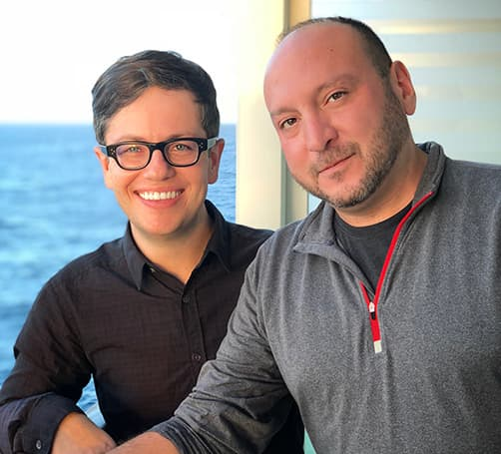
PROGRAM: The March program will feature Mitch Bach, co-founder of TripSchool in Brooklyn, NY. He will provide a talk on how to use information technology (you know, computer stuff) to enhance the tour experience for your guests. This is a shortened version of the talk he gave at the National Federation of Tour Guides Conference in San Antonio last month. We are very fortunate that his schedule allows him to join us. Even if you’re not that “tech savvy” there are some things you can do with technology that will enhance your guests’ tour experience – and maybe increase your tips!
Mitch Bach & Alan Armijo, co-founders of Trip School

GUESTS: Members are encouraged to invite potential members as guests to meeting.

MEETING NIGHT CONTACT: Mike Pearl, 303-868-0023; Zoom issues Tom Jensen 303-968-0515

