Navy, Marine Corps and Coast Guard Enlisted

Combat Aircrew Roll of Honor Merchandise
Ship To:
Mail Order to:
Roll of Honor
C/O Mike Dobson
Email: Phone 14272 HWY 99
Konawa, Ok 74849
Customer Service
Phone (907) 957-7169
Email: ninelives@gci.net

All merchandise subject to availability. Increases in prices will be billed to the customer, and when applicable, overpayments will be credited to member accounts. Non-member overpayments will be refunded.

To order, print this page, fill it out and mail it to the above address

Item | Color | S,M,L,XL | QTY | Price | XXL | XXXL | Total
GOLF SHIRT, Embroidered Logo (Roll of Honor Inductee) | BLUE |  |  | $35.00 | $40.00 | $40.00
GOLF SHIRT, Embroidered Logo (Member of ROH Board of Directors) | RED |  |  | $35.00 | $40.00 | $40.00
Roll of Honor Patch |  |  |  | $7.00
Method of Payment:
Check
Money Order
Make payable to ROH
Sales Order Number:
Date Shipped:

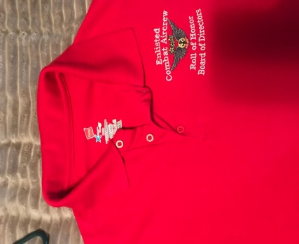
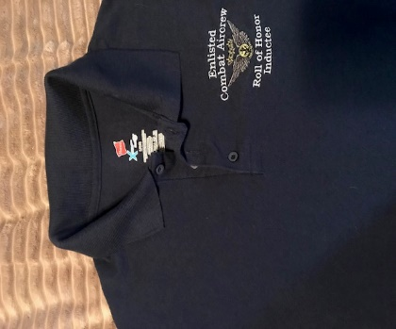
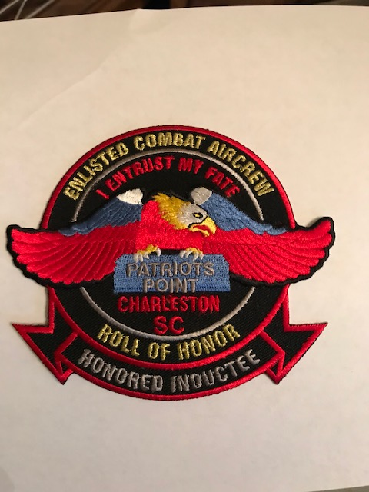

Roll of Honor | Golf Shirt, | Golf Shirt,
Patch | Embroidered | Embroidered
 | Logo, Blue | Logo, Red

To order, print this page, fill it out and
mail it to the above address

