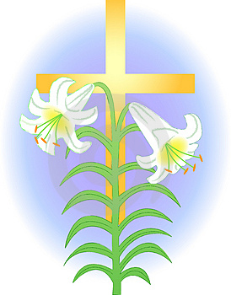
Easter Lily Memorial
St. Joseph’s Church

In Memory Of………
Andy Witkowski Given by Mary Lou Witkowski
Audrey & Charles Ewald Given by Susan Skidmore Linda & Peter Kozak Given by Susan Skidmore
William & Margaret Fontana Given by Clementina, John & Tina Hess
William A. Fontana Jr. Given by Clementina, John & Tina Hess
John F. Hess Given by Clementina, John & Tina Hess
Raye Spinelli Given by Chris & Sherry Wood
Jean K. Wood Given by Chris & Sherry Wood
Joseph W. & Grayce H. Ricciardi Given by The Bensley Family
Lawrence & Esther Bensley Given by The Bensley Family
Martin & Irene Snee Given by Irene Yakupcin & Family
Andrew & Wanda Yakupcin Given by Irene Yakupcin & Family
Ronald J. Yakupcin Given by Irene Yakupcin & Family
Barthly & Mary Hernon Given by Martin & Rosmary Hernon
Michael & Roseanne O’Hanlon Given by Martin & Rosmary Hernon
Jane & Alan Langford Given by Jim & Karen Colaiaco
James Colaiaco Sr. Given by Jim & Karen Colaiaco
Primo & Eleonor Carpana Given by Joann & Arthur Carpana
Hoffman & Nied Families Given by Bill & Clare Nied Georgene McDermott Given by The McDermott Family
Irene & Paul Leontzwich Given by The McDermott Family
Jean & Joseph McDermott Given by the McDermott Family
Deceased Members of the Schreiber Family Given by Jim & Pat McCooey Deceased Members of the McCooey Family Given by Jim & Pat McCooey
Nancy Vocci Given by Pat McCooey
Archie, Margaret & Diane Davis Given by The Davis Family
Joseph McCafferty Given by JoAnn McCafferty & Family
Susan Becker Given by William & Linda Becker Harold E. Smith Given by William & Linda Becker
David Mulcahey Given by Marge O’Connor

~over~
Easter Lily Memorial
St. Joseph’s Church

In Memory Of………

Nancy Williams Given by Alexina & Justin Hardy
Alan Peters Given by Mary Ann Peters
McAuley & Murphy Families Given by Betty McAuley Dolores Lippert Given by Betty McCauley
Walter Marcial Given by The Marcial Family
Robert Rombousek Given by Candace Rombousek
William & Mildred McCann & William R. McCann Given by Linda Kowal
Deceased Members of the Blackman & Peidelstein Families Given by
Cliff & Anna Blackman

Easter Candle ~ In Memory of John F. Hess Given by Clementina Hess & Family

Altar Candles ~ In Memory of Linda & Peter Kozak Given by Susan Skidmore

