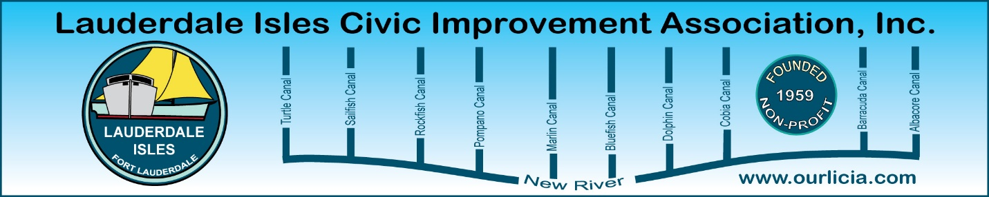
Minutes of the Lauderdale Isles Civic Improvement Association Board Meeting Zoom call October 17, 2024
The meeting was called to order by President Earl Prizlee at 7:05pm.
Roll call was taken.
Present: Earl Prizlee, Geoff Rames, Karen Rames, Diana Steeger, Dick Cahoon, Dawn Hanna, Julie Gordon, Glo Knowles, Penny Shea, Joann Kratky, Trent Simpson and Andrew Silverman.
Code Compliance: Matt Flesher advised there are 19 cases pending compliance, 14 closed cases and 4 cases complied with for the time period July 16-Oct 16. Cases include public nuisance (trash in carport) and 4 Vacation Rental without certificate. Several people provided Matt locations of cars on the lawn to check out as this has become a problem.
FLPD report: Officer Jackson advised that on Oct 3, there was a package delivered to a home on Gulfstream Lane and then the driver of a small blue SUV took it from their bin. Remember to call when you see anyone or any car you don’t recognize in our neighborhood that seems suspicious. There are 2 cameras collecting license plates on Riverland Road so if you have the time and the make of the vehicle, we may be able to find it on the camera.
September Treasurer report: Trent motioned to approve, Karen seconded and all approved.
September minutes: Dawn motioned to approve, Penny seconded and all approved.
November LIWMD/LICIA Waterway Cleanup: Karen asked if anyone else is available to volunteer and Trent and Penny will also be there so we are all set. Karen and Geoff are coordinating and will update everyone as we get closer. Thanks to the volunteers who agreed to help.
Community Center update: Earl said Marc Isaac is the Project Manager for our new community center. The Project Agreement has been approved for the design process to begin. There will be a kick-off call the next week or two along with the site evaluation in November or December. We should have a design to review by January. Earl and Geoff will attend meetings and report back to the Board. Marc to set up tour of Hoyt Park for Geoff and Earl and others that want to attend for ideas for our Community Center.
November General Meeting: The next General Meeting is on November 21. Mark Haggerty, Floodplain Manager, will be our Guest Speaker and explain how the Flood maps are determined. Geoff asked for approval retroactively to change the LICIA election process as he included that information in the last newsletter that was delivered and we will announce the 2025 Board at this meeting. Penny made the motion, Diana seconded and all approved.

New River School Traffic update: Diana mentioned that since the Police have not been visual lately, the backup of cars is where is was when the lanes were blocked. We will take up this issue with the Commissioner after the November election.
Building Height Amendment: Earl did a Public Information Request to find out why it was raised to 35 feet in our area. He has 350 emails to review.
Motion made by Geoff to adjourn the meeting. Dick seconded and all approved. The meeting ended at 8:10 pm.
Submitted by Karen Rames, Secretary

