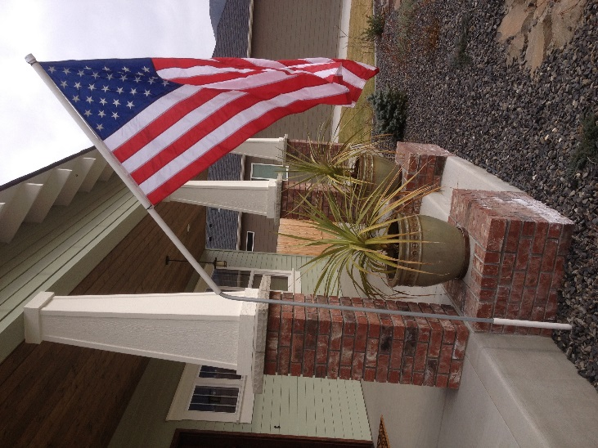****

Wenatchee Central Lions Club

The Wenatchee Central Lions Club Flag Program sells subscriptions to individuals and businesses to erect the United States flag five times a year in designated areas in Wenatchee and East Wenatchee. The yearly subscription cost is $50.

The five holidays are: Memorial Day, Flag Day, Fourth of July, Labor Day, and

Veteran’s Day.

Each display address has a 14 inch PVC pipe (sleeve) placed at ground level to serve

as a flag pole holder. The PVC has a yellow or red cap on top. Flags will be placed prior to the holiday and picked up after the holiday. The flag is placed by Lions at the appropriate times. The flags are manufactured in the United States, are all-weather and stand 12 -14 feet above ground level.

All revenue received from this project is used for charitable projects in the Wenatchee/East Wenatchee community and Lions International projects.

****************************************************************************************************

To enroll in the flag display project, please complete and return the information below

with your check.

DATE_______________________________ ____ ___________

NAME_ __________ ________ ________

ADDRESS_ ____

TELEPHONE_ ______________________ ________________

EMAIL________________________________________________

______ THIS IS A NEW INSTALLATION _____ THIS IS A RENEWAL

Indicate “FLAG PROGRAM” on the check, and mail to:

Wenatchee Central Lions Club

PO Box 135

Wenatchee, WA 98807-0135

Questions? email Marcia Miller at [marciamaloney@msn.com](mailto:marciamaloney@msn.com) or

Call Lion: @Phone: or Cell: