Know Christ! Grow in Faith! Serve Others!
Mission Statement of LTUMC (adopted 6/5/2024)

WELCOME—ANNOUNCEMENTS Mary Fulton
JOYS AND CONCERNS
INVITATION TO WORSHIP/OPENING PRAYER Pastor Rod
PRELUDE Jenny Claybaugh, Jane Wildermuth
SONG LEADERS Diane Lewis, Jason Brunson
LITURGIST Roberta Hart
* Indicates To Stand in Body or Spirit.
*Call to Worship (responsive) based on Psalm 81 and Ephesians 1.
L: Sing and celebrate to the LORD our strength, who delivers us from slavery to sin: the bondage that separates us from Him.
P: Let us worship our God forever with loud shouts and praises.
L: As He delivered His people from Egypt, He gave them a strong warning: “You must never have a foreign god; you must not bow down before a false god. For it was I, the LORD, who rescued you.”
All: Today, O LORD, deliver us from our tormenting enemies, and from the sin with which we still struggle.

*Hymn: Stand Up, Stand Up for Jesus #514UMH
Lead On, O King Eternal #580UMH

Unison Prayer: Kathleen Stephens from Disciplines 2019, page 319 modified
Holy God, when we seem focused on money and the temporary pleasures the world offers, help us fix an inexplicable hope on the things that are eternal—through faith in Jesus. Amen.

Scripture Reading: Ephesians 6:10-18

Prayers of The People: Jason Brunson
Lord’s Prayer: Our Father who art in heaven, hallowed be Thy name. Thy kingdom come, Thy will be done on earth as it is in heaven. Give us this day our daily bread, and forgive us our trespasses as we forgive those who trespass against us. Lead us not into temptation, but deliver us from evil. For Thine is the kingdom, and the power, and the glory forever. Amen.

*WORSHIPPING GOD WITH TITHES & OFFERINGS/DOXOLOGY
*Prayer of Thankfulness: Accept these gifts, O God, as testimonies of our love for You and our desire to serve You. Let these offerings be an affirmation that we are bound to one another as Your people. In Your generous name we pray. Amen.

Children’s Moments: Junior Church follows

*Hymn: Spirit of the Living God #393UMH

Prayer for Illumination:
Holy Lord, our God and Savior, we prove we are a gullible people as we often are deceived by our enemy over and over throughout our life. Open our eyes to the deceptions and temptations that he uses to draw us further away from You. In Christ we pray. Amen.

Scripture Reading: Galatians 5:1, 13-26
Sermon Series: “Windows, Doors and Gateways” week 4
Message “Windows: Babylon 2Desire, Wantonness & Temptation
Response As the Holy Spirit Leads Us

*Hymn: God of Grace and God of Glory #577 UMH

*BENEDICTION & SENDING: Our “World” Is Our Mission Field

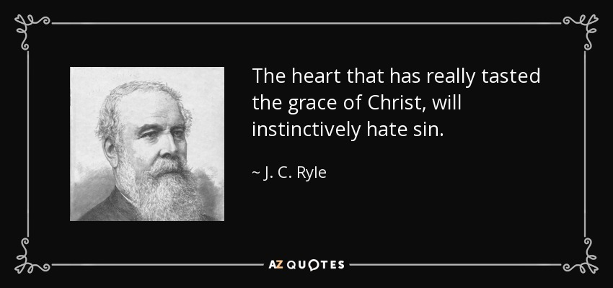
THOSE ASSISTING IN CREATING OUR SERVICE:
Musicians: Jenny Claybaugh, Jane Wildermuth
Sound/Video: Andy Wildermuth, Kathy Berg
Online: Tracey Notestine, Sandy Shaner
http://www.facebook.com/LewistownTrintyUnitedMethodistChurch
Church Office email: ltumc8088@gmail.com
Ushers: Don Lewis, Bill Fulton, Denny Stryker, Lynn Snipes, Mike Brunson, Jason Brunson
Please send Bulletin Insert information to Lorna Brunson.
Internet Prayer Chain: Lorna Brunson—doone533@gmail.com
All-Call Prayer Chain: Julia Armstrong—Call her at 937-844-7964
WIFI setting for the Sanctuary is: Mesh 25. Password is basiccartoon424. The Community Center is: TPLink_70B0. Password is 15310477. We apologize for any inconvenience in connecting. Please don’t use your internet during worship. It slows down our Facebook feed.
Adult Sunday School Class Leader/Lay Leader: Mary Fulton
Sunday School Superintendent/VBS/God’s Team: Diane Lewis



Lenten Sermon Series: Week 3
March 8, 2026
Thank You for Choosing to Worship Christ
with Us Today!
LEWISTOWN-TRINITY UNITED METHODIST CHURCH
In-Person Worship Service – 11:00 – 8088 CR 54, Lewistown
Address: P.O. Box 90, Russells Point, Ohio 43348
Worship with us on Facebook
http://www.facebook.com/LewistownTrinityUnitedMethodistChurch
Rod Brower, Pastor
His Contact Info: 740-727-9999 – pastorrodb@gmail.com
Know Christ! Grow in Faith! Serve Others!

