

**Redeemer Christian School**

**November 2020**

**Newsletter**

N

ewsletter

**Psalm 95:2 “Let us come into his presence with Thanksgiving; let us make a joyful noise to him with songs of praise!!”**

**LETTERS OF THE MONTH**:

**“C”**

**“T”**continued **“I”**

**November At A Glance**

**November 1st**

* Remember to Set your Clocks back 1 Hour!

**November 5th & 6th**

* NJ Teacher’s Convention – **No school**

**November 9th-12th**

* Parent Teacher Conference Week

**November 12th & 13th**

* Spirit Wear Days

**November 19th & 20th**

* Thanksgiving Feasts

**November 25th – 27th**

* Thanksgiving Holiday – **No school**

**Director’s Note**:

Thanksgiving is a wonderful time to show our RCS little ones that it is gratifying to help others and to make someone’s life brighter by helping them whenever we can. With all the happenings in the world these days, especially during this time of COVID, natural disasters, and conflict amongst groups of people, we know that we can rely on God to be there with us through it all. It is such a comforting feeling that God helps us each day and I love to tell the children in Music or in Thursday afternoon Chapel that God is always there to listen to us. He never leaves us!

We know it is important to tell the children that we are blessed to receive so much from God by having a family, parents who love us, a home to live in, clothes to wear, and food to eat. For this we collect donations of food for families in Roxbury who are in need of assistance. Last year I was so thrilled to be able to bring two large shopping carts of food filled to the top from donations made by RCS families to Roxbury Social Services! Is it so important that our children learn to help others in need by our examples shown to them! It is a wonderful feeling to help others!

The RCS classes will gather together at our “Thanksgiving Feast” to share a meal (small treats made in each class) and hear the story of the first Thanksgiving in Plymouth, Massachusetts. We will, of course separate our classes but still be “together” by having our tables spaced well apart.

We wish everyone a blessed Thanksgiving with your own families!

God Bless,

Cindy Stevens & the RCS Staff

**RCS Reaches Out!**

**Roxbury Food Pantry** - In the spirit of Thanksgiving and helping others, we will be collecting donations of food (anything canned, boxed, bottled (plastic), & bagged) for families in Roxbury who are in need of assistance. These items can be sent in your child’s tote bag if you wish to help.

We would like to drop off the donations

on Friday, November 20th.

Thank you so much in advance!

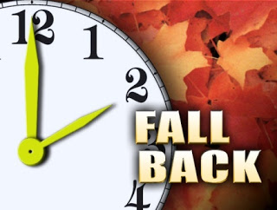

**RCS Fundraising Information**

Thank you to all our parents, families, friends, and RCS staff that supported our Fundraiser events this Fall. Fundraising is such an important activity here at RCS. The profits from each of the fundraisers allow the school to do improvements and updates in the classroom, fund fun activities for our students and families, and most importantly, the profits go towards purchasing all the required school supplies for our students to use in class!

It has been an amazing start to the year for our Fundraising events! Our littles had a pumpkin picking event at RCS provided by RCS Fundraising. As for the sales, the Mums Sale earned the school $978.25 in profits and our Spirit Wear Sale earned the school $295.82. Don’t forget, our KidStuff Coupon Book Sale is still active for online purchases to be shipped to your homes and will remain open until November 15th. Plus our Boon Supply Online Christmas Shopping Event is currently running through the first week in November.

RCS is still actively looking for a new Chairperson to head the Fundraising Team for next year!! Please reach out to the school or to Jessica Malcom, 862-266-0182, with your interests.

We thank you for all your support and cheers to an amazing year to come!

Sincerely,

Jessica Malcolm

RCS Fundraiser Committee

## Reminders to Parents

* **Birthday Parties** - You are welcome to send a fun snack (nut free) in with your child to share. Please check with your child’s teacher to choose a date. Below are suggestions for nut free candy and snacks, please feel free to use these suggestions. (**Dunkin Donuts are not considered “nut free”.)

Cheese and crackers Nabisco Teddy Grahams

Gold Fish Oreo Cookies

Ice Cream/popsicle Rice Crispy Treats

Sliced Fruit Sliced Vegetables

Jell-O and Jell-O Instant Pudding Cups

**PLEASE READ LABELS. There may be other products that are safe.**

* **Labeling** - All clothing (coats, hats, gloves, etc.) should be clearly labeled.
* **Change of Clothing** - Please make sure your child has an extra set of “weather appropriate” clothing at school in case of emergencies/spills. (Please include socks and underwear).
* **RCS Website** - [www.redeemerchristianschool.com](http://www.redeemerchristianschool.com) Please check our website to view our calendar and school news.
*  **Facebook** –Be sure to  us on Facebook- We occasionally post photos of school events!

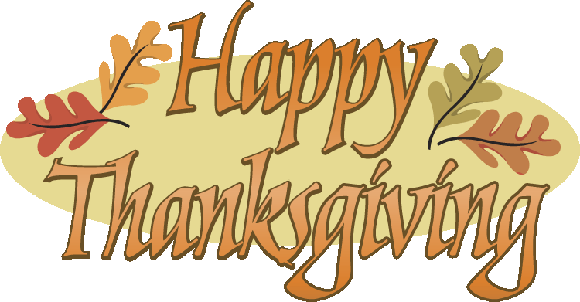

**Some details for November**

**Activites are as follows:**

**PARENT TEACHER CONFERENCES: Nov. 9th-12th**

You will be assigned a 15 minute conference time to talk with your child’s teacher. Please let us know if you cannot be here for your scheduled time. Phone conferences can be done if you are unable to come in. We know that being here during the weekday is not always possible. This is a nice visit to connect with your child’s teacher.

**SPIRIT WEAR DAYS:**  **Nov. 12th & 13th**

Show your school spirit by wearing your RCS spirit wear or blue to school!

**THANKSGIVING FEASTS: Nov. 19th & 20th**

The children come in our “Life Center” (gym) and sit at long tables, separated by each class, to hear the story of the First Thanksgiving with the Pilgrims and Native Americans. We say grace and enjoy our “feast” as each child is dressed as a Pilgrim or Native American. This is a wonderful time to acknowledge God’s blessings to all of us! **\*Please note this is a student only event.**