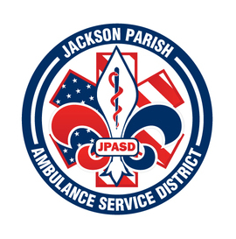

**JACKSON PARISH AMBULANCE SERVICE DISTRICT**

**115 Watts Street**

**Jonesboro, LA 71251**

**Office: (318)-259-2877 Fax: (318)-259-2099**

**jacksonparishambulance@jpasd.com**

**Aaron Johnson BOARD MEMBERS**

**EMS Director [ ] Newspaper** Allen Lindsay, Chairman

**Paula Parkerson , MD** [ ] **Minutes** Conchita Doyle, Vice-Chairman

Medical Director Joe Vail

Alma Williams

Deidre Hollis

**Notice Posted: Tuesday, April 08, 2025 @ 12:00pm**

**NOTICE OF PUBLIC MEETING**

**A public meeting will be held as follows:**

**DATE:** April 10, 2025

**TIME:**  12:00 PM

**PLACE OF MEETING:** Jackson Parish Ambulance Service District

115 Watts Street, Jonesboro, LA 71251

Public Meeting AGENDA

1. Call to Order

2. Roll Call

3. Invocation

4. Pledge of Allegiance

5. Recognition of Guests/Public Comments

6. Approval of Minutes from February 13, 2025, (March 13, 2025 cancelled)

7. Approval of Financials and payment of bills February and March 2025

8. EMS Director’s Report

9. Old Business

A) Open the “Surplus Bids” to sell item 1996 International Bus

B) Cancellation of Monitor Bid contract (Failure to deliver in time specified)

10. New Business

A) Consider and Accept purchase of ALS Monitors through SAVVIK Buying Group

B) Adopt the Resolution of Earmark Funds for specified purposes

11. Adjournment

***Reminder: Next Meeting: May 8, 2025 @ 12 Noon***

In accordance with the Americans with Disabilities Act, if you need special assistance, please contact Aaron Johnson, EMS Director at 318-259-2891 describing the assistance that is necessary. Due to the Covid-19 virus visitors are asked to not present to the meeting with fever, cough, diarrhea, or general weakness. Masks will be provided for visitors.