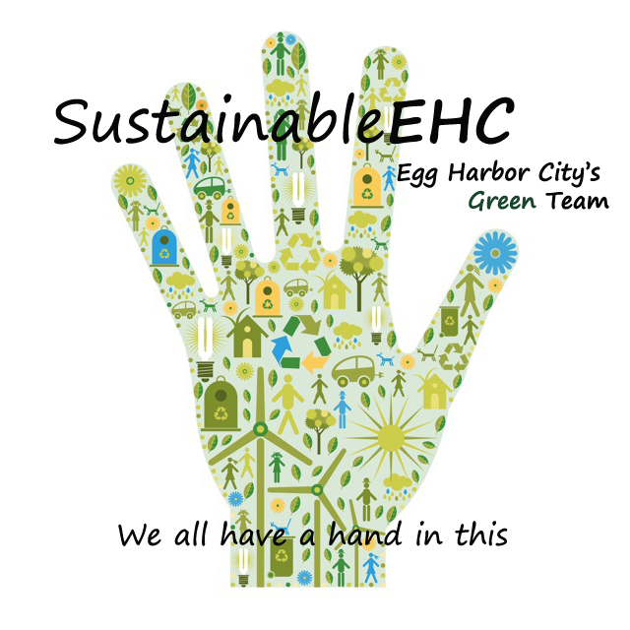**SustainableEHC**

**500 London Avenue**

**Egg Harbor City, NJ 08215**

[**www.sustainableehc.org**](http://www.sustainableehc.org)

**Arbor Day 2025 Photo Contest**

Arbor Day was founded by journalist and politican J. Sterling Morton in celebration of nature. The first Arbor Day occurred on April 10, 1872, in Nebraska. It’s estimated that nearly one million trees were planted that day.

Today, in New Jersey, Arbor Day is celebrated on the last Friday of April. A popular tradition is to plant a tree in memory or to honor a loved one. The theme for Arbor Day 2024 is “Plant Trees.”

“Other holidays repose upon the past;

Arbor Day proposes for the future.”

J. Sterling Morton, Founder of Arbor Day

**Contest Rules**

* Contest open to Egg Harbor City students and community members
* Categories: Middle, high school, adult
* Theme: Trees
* Photos must feature trees, preferably trees growing in Egg Harbor City
* Submit entry form and photos in jpg format, landscape ONLY 10 MB or less on the sustainableEHC.org website at <http://www.sustainableehc.org/photo-contest.html>
* Limit up to two (2) submissions per person
* Submit your own work not published elsewhere
* No AI generated or enhanced photos permitted
* If there are people in the photo, you must obtain a release
* Photos will be published on SustainableEHC website and SustainableEHC FB page
* By submitting photos, you grant SustainableEHC the right to publish photos in promotional materials. Credit will be given to the photographer.
* Photos will be judged anonymously based on adherence to theme, impact, composition
* Judges are high ranking amateur or professional photographers
* Awards: First place $100, second place $75, third place $50
* Public voting for Best in Show will be held at Arbor Day Celebration, 3-6 p.m. Friday, April 25, 2025 at Peace Pilgrim Park, 500-block London Ave.
* Deadline for submissions April 15, 2025



Edit 2.28.25