RSAI Legislative Update
April 29, 2021

In this RSAI Weekly Report from the 2021 Legislative Session, find information about:
- Status of budget bills: 1 down, 10 to go
- Picking up the Pace at the Statehouse: Big bills moving (Charter schools, Diversity training and Education Flexibility among them)
- Items Still Awaiting Action
- Bills on the Move
- Advocacy Action Steps This week and Connecting with Legislators During the Interim
Budget Bills Status in Both Chambers
The IALNS Newsletter reported the progress of budget bills required to be completed before the end of the 2021 Session. See the April 15 weekly report for details of HF 868 Education Appropriations, which has been on the Senate Calendar without further action since Aug. 26. As budget bills progress, the close of the 2021 Session is within sight. Daily per diem for legislators ends on April 30, which is the 100th day of the Session. Both the House and Senate adjourned without action early Thursday morning, indicating that agreement among the House and Senate Leaders and the Governor has not yet been reached.
SF 615 Standing Appropriations: this bill appropriates a total of $3.411 billion for State Foundation School Aid, which is an increase of $21.5 million compared to FY 2021. That total is well below the $53 million announced by Republican Leaders early in the Session and even further below the $95 million annual average increase of state resources for public education over the last decade. Within the appropriations to the DE, the following are reductions compared to current law, for a total reduction of $32.5 million for the three items combined (all of these are continued from the prior year):
  - Limits the FY 2022 General Fund appropriation to DE for nonpublic school transportation to $8.2 million and requires the appropriation to be prorated if the claims exceed the appropriation.
  - Suspends the General Fund standing appropriation of $14.8 million to DE for the Instructional Support Program for FY 2022, maintaining the state share at zero. (State law requires a 25% state funding for ISL, but that was never attained even when they were making a sizable contribution. It has been funded as zero since 2011.)
  - Reduces the FY 2022 State school aid funding to Area Education Agencies (AEAs) by $15.0 million. This continues the annual reduction which has been in place for more than a decade.
- Appropriates $27.5 million for transportation equity (increase of $850,000) which funds the policy change made in SF 269 School Funding which was signed by the Governor on Feb. 23.
The Bill was approved in the Senate Appropriations Committee on April 27, moving it to the Senate Calendar. RSAI is registered as undecided on this bill.
The Iowa Legislative News Service charts the progress on appropriations bills. Only one, the Administrative and Regulation Appropriations bill, has been approved in both chambers, sending it to the Governor. The other 10 budget bills await action in either chamber. Here is the status as of Thursday:
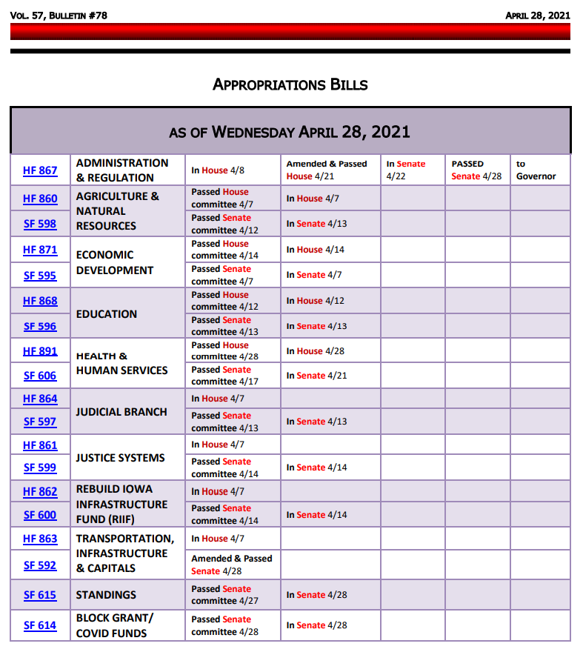
Picking up Pace at the Statehouse: Some Big Policy Bills Move
HF 847 Education Practices and Flexibility: this bill contains several provisions from the Governor’s school choice policy, but now, some other ideas from the legislature have been included. The bill was amended as approved in the Senate on April 28. Here are details (amendment details in italics):
- Flexibility: creates a Flexible Student and School Support Program (FS3), allowing schools to implement evidence-based practices for innovative ways to improve student learning. Adds Teacher Leadership and Compensation fending balances as transferable by Board action to the flex account. Requires unobligated Teacher Salary Supplement funds be paid to teachers by July 1, 2022.
- Tax Credits: Allows homeschoolers to use the Tuition & Textbook credit. Increases the credit to 25% of the first $2,000. Allows teachers to take a state tax credit similar to the federal credit for expenses. The Senate Amendment increased School Tuition Organization Tax Credits from $15 to $20 million beginning July 1, 2022 and retroactive to Jan. 1, 2021, increases the credit from 65%-75% of the contribution. This is a new provision not included in a prior version of the bill.
- Open Enrollment:
  - Makes changes in the custody/residence of the child and that the child’s school is in need of significant improvement as good cause for missing open enrollment deadlines.
  - Makes the deadline for pre-K students needing special education as Sept. 1.
  - Makes denials related to the inability of a school to meet a student’s need appealable to the state BOE.
  - Increases the eligibility of transportation assistance for open enrollment to at least 200% of the FPL.
- Open Enrollment Athletic Eligibility: the Senate Amendment peals back House’s original language and only allows a short window for one-time re-enrollment to district or school without 90-day waiting period to participate in varsity athletics:
  - “if the child was previously enrolled in the school or school district on the first day of the school calendar for the school year beginning July 1, 2020, then enrolls in a different school or school district for a portion of the school year beginning July 1, 2020, and then, before July 1, 2021, reenrolls in the school or school district in which the child was initially enrolled.”
- Weighting: Adds work-based learning coordinators and special education directors to positions that can generate operational shared weighting (3 students each). Reduces the supplemental weighting for various positions in FY 2022-2024 (lowers a 5 weighting to a 4 and lowers a 3 weighting to a 2).
- The Senate Amendment also amends HF 813 Charter Schools if enacted:
  - includes public records applicability to charter school governing boards (not the founding group, but the governing board would now be subject to chapter 22 Public Records.
  - requires the charter school administrators to be licensed administrators, licensed teachers or a third category of charter school administrative licensure, which the BOEE is required to create by December 31, 2021.
  - limits charter schools in the charter school geographic area to no more than 1 per 10,000 students (public and nonpublic students) K-12. So 1 elementary school per 10,000 K-12 students, 1 middle school per 10,000 K-12 students and 1 high school per 10,000 K-12 students. This limitation is repealed on July 1, 2026.
  - requires charter schools to submit an annual report (HF 813 says “may” and this amendment changes it to “shall”).

- Requires the Pledge of Allegiance be administered in grades 1-12 each school day.
- Allows a principal to waive face mask requirements for students attending in-person instruction if the school board gives the principal such authority.
The Senate approved the bill Wednesday, 42:6, sending it back to the House. RSAI is still registered as undecided.
HF 813 Charter Schools: the bill was approved without amendment (although the Senate Democrats offered 13 amendments, all were rejected or ruled not germane), sending the bill to the Governor. Here’s a brief summary of the bill’s actions.
- Allows the establishment of a charter school by founding groups under a school board or under the State Board and specifies application requirements.
- Requires the state board to create rules, including deadlines and application criteria
- Requires the majority of members of the charter school governing board (not the founding group) to live in the geographic area and for all to be Iowa residents.
- Requires the meetings of the governing board to be subject to open meetings.
- Requires the charters to be renewed every five years.
- Deems the decision by the State BOE to be not appealable.
- Requirements:
  - Includes length of time for a charter, various requirements on teachers, on non-discrimination, on operating as a non-religious school, on testing, instructional days and other matters.
  - Requires that performance evaluation measures, compensation and dispute resolutions methods for staff and for the educational provider be in the charter application.
  - Requires charter schools to specify what statutes and administrative rules with which it does not attend to comply and for the DE to assist in which statutes and rules can be waived.
  - Requires the budget be published online.
  - Requires that charter schools give the school district the necessary documentation for Medicaid claiming.
- Appropriations and funding:
  - District of residence pays to charter school the SCPP for the previous year, TLC per pupil, ELL weighting and the actual costs of special education. The Charter is required to pay PSEO costs. There is a standing appropriation for the DE to pay the costs of any students enrolled in the charter school not on the district of residence prior enrollment count.
- Requires the State Board to develop a protocol for charter school closings, including notice and transition.
The bill was approved without amendment, 30:18 on April 28, sending it to the Governor. RSAI is registered in opposition.
HF 802 Diversity Training and Curriculum Limitations: the bill from the House originally included limitations regarding divisive subjects, racism and implicit bias. The Senate amended the bill, which rewords significantly (instead of divisive concepts, it’s “specifically defined” concepts) and there’s a list of 10 of them followed by the definitions of race and sex stereotyping directly from the bill language:
(1) That one race or sex is inherently superior to another race or sex.
(2) That the United States of America and the state of Iowa are fundamentally or systemically racist or sexist.
(3) That an individual, by virtue of the individual’s race or sex, is inherently racist, sexist, or oppressive, whether consciously or unconsciously.
(4) That an individual should be discriminated against or receive adverse treatment solely or partly because of the individual’s race or sex.
(5) That members of one race or sex cannot and should not attempt to treat others without respect to race or sex.
(6) That an individual’s moral character is necessarily determined by the individual’s race or sex.
(7) That an individual, by virtue of the individual’s race or sex, bears responsibility for actions committed in the past by other members of the same race or sex.
(8) That any individual should feel discomfort, guilt, anguish, or any other form of psychological distress on account of that individual’s race or sex.
(9) That meritocracy or traits such as a hard work ethic are racist or sexist, or were created by a particular race to oppress another race.
(10) Any other form of race or sex scapegoating or any other form of race or sex stereotyping.
b. “Race or sex scapegoating” means assigning fault, blame, or bias to a race or sex, or to members of a race or sex because of their race or sex, or claiming that, consciously or unconsciously, and by virtue of persons’ race or sex, members of any race are inherently racist or are inherently inclined to oppress others, or that members of a sex are inherently sexist or inclined to oppress others.
c. “Race or sex stereotyping” means ascribing character traits, values, moral and ethical codes, privileges, status, or beliefs to a race or sex, or to an individual because of the individual’s race or sex.
- The bill includes the following provisions regarding school districts:
  - Allows school districts to continue training that fosters a workplace and learning environment that is respectful of all employees and students.
  - Requires the superintendent to ensure that any curriculum or mandatory staff or student training provided by an employee of the school district or by a contractor hired by the school district does not teach, advocate, encourage, promote, or act upon specific stereotyping and scapegoating toward others on the basis of demographic group membership or identity.
  - States that this subsection shall not be construed as preventing an employee or contractor who teaches any curriculum or who provides mandatory training from responding to questions regarding specifically defined concepts raised by participants in the training.
  - Also states that the bill is not to be construed to inhibit or violate first amendment rights of students or staff, is not to prevent districts from promoting racial, cultural, ethnic, intellectual or academic diversity or inclusiveness, provided such efforts are consistent with the provisions of this bill, does not prohibit discussing these subjects as a part of a larger course of academic instruction, does not create any right or benefit allowing suit of the state, and does not prohibit a court or agency from ordering an action containing discussion of these specifically defined concepts as remedial action due to a finding of discrimination. The Senate amendment added one more – the bill is not to be construed as prohibiting use of curriculum that teaches the topics of sexism, slavery, racial oppression, racial segregation, or racial discrimination, including topics relating to the enactment and enforcement of laws resulting in sexism, racial oppression, segregation, and discrimination.
  - Requires the school board to have rules (policies or regulations) incorporating all of the provisions of this bill, made available to staff and students.
  - Provides whistle-blower protections to employees/officials acting to protect a student under this section.
  - The bill states that the unfunded mandate statute does not apply to this bill.
  - The bill is effective July 1, 2021.
The Senate approved the amendment and the bill, 30:18, returning it to the House. RSAI is registered as undecided. We appreciate the work in the Senate to improve the bill.

Other Bills on the Move
HF 602 General Fund Transfer to Student Activity Fund: this bill allows the school board by board resolution to transfer from the general fund to the student activity fund an amount necessary, as recommended by the superintendent, to fund co-curricular or extracurricular activities for which moneys from student-related activities such as admissions, activity fees, student dues, student fund-raising events, or other student-related co-curricular or extracurricular activities fail to meet the financial needs of the activity as the result of restrictions placed on the activity related to the COVID-19 pandemic. The bill is retroactive to the budget year beginning July 1, 2020 and effective through June 30, 2023. This subsection is repealed July 1, 2023. The bill was approved 48:0 in the Senate (April 28) sending it to the Governor. RSAI is registered in support.
HF 744 Protecting Free Speech: this bill was amended in the Senate to include provisions regarding staff in charge of school newspapers and protecting student free speech, sending it back to the House. The House concurred in the Senate Amendment, sending it to the Governor. RSAI is registered as undecided.
HF 848 Broadband Grants: this bill sets up the policy for expansion of high-speed Internet services throughout the state and contains the following provisions:
- Definitions: Defines facilitate to mean a provider’s ability to offer communications service at a commercially reasonable price. Includes as a targeted service area crop operations or other areas identified by the Office of the Chief Information Officer (CIO) within a census block which lack broadband services meeting certain speeds.
- Other: Authorizes the CIO to adopt rules on whether it meets certain upload speed capabilities. Requires grants from the Empower Rural Iowa Broadband grant fund to be made to providers who will reduce or eliminate targeted service areas by building infrastructure which meets speed criteria. Strikes certain review requirements. Allows the use of 2.5% of funds for administrative costs and requires one CIO employee dedicated to evaluating grant applications. Caps grants based on project costs and available broadband speed in an area. Requires 20% of grants to be in hard-to-serve areas with no high-speed providers and to meet speed criteria. Strikes prohibiting grants after July 2025.
The House passed the bill 94-0. The Senate passed it 47-0. It was signed by the Governor, April 28, 2021. RSAI is registered in support.
SF 546 Home Schooling Matters: this bill primarily deals with home school requirements but does have some cross over in drivers’ education that impacts public school students. The bill does the following:
- Deems home schooling by a parent or guardian as competent private instruction and exempt from certain reporting requirements. Makes other changes on home schooling.
- Driver’s Ed: Includes home-schooling parents as teaching parents for driver’s education. Strikes the hours of instructional time and reduces the hours of driving time. Strikes certain hour requirements for instruction on RR crossings and adds requirements on sharing the road with bikes and motorcycles and distracted driving. Requires a teaching parent to have a clean driving record for two years.
- Amendment S-3146 by the House - Allows all parents/guardians with a valid drivers’ license to teach driver’s ed.
The House passed the bill as amended 59-33 (April 12). The Senate concurred and passed the bill as amended 33-15 (April 28); sending it to the Governor. RSAI is registered as undecided.
HF 201 Sex Offender Registry: this bill requires a sex offender who is required to register in another jurisdiction to register in Iowa while employed in Iowa or attending school in Iowa. It requires a person convicted of extortion to register as a Tier III sex offender if the court determines that the offense was sexually motivated. The House passed the bill 88-0 (Feb. 2). The Senate passed the bill 47-0 (April 28), sending it to the Governor. RSAI did not register on this bill.
Education Bills Still Pending: In addition to passing a budget, consensus on tax policy changes and other heavy lifts still on the statehouse agenda are pending. Here are a few education bills we are still watching:
- HF 532 Qualified Instructional Supplement: this bill is on Senate Calendar with amendment (includes PK fed funding). RSAI opposes the original bill but supports the Senate Appropriations Committee Amendment. Encourage your Senators to advocate for this bill to get consideration, vote yes on the Appropriations Committee amendment and yes on the bill, sending it back to the House. See advocacy actions for the week regarding this bill below.
- HF 318 PK for young 5s: this bill would allow districts to serve and count young five-year-olds in the statewide voluntary preschool program as a local control decision, however, the PK program is required to prioritize four-year-olds if there is limited space. It is on the Senate Calendar. RSAI is registered in support.
- SF 265 Parent Request to Retain: this bill allows a parent to request their student repeat a grade, due to lack of progress related to the pandemic year, with the request due by Aug. 15, 2021. That date is too late, so we are advocating for June 1 or the last day of school, whichever is later. Rep. Wheeler, floor manager of the bill, is open to amending the date if the bill moves, but it may not advance this year. RSAI is registered as undecided.
Advocacy Actions This Week
HF 532 Qualified Instructional Supplement and PK Authority: Ask Senators to support the Appropriations Committee Amendment to HF 532 in the Senate and approve the bill, sending it back to the House. Since this $27 million is allocated to districts based on enrollment served, it’s a good balance to the federal funds distribution formula based on poverty. Without the PK provisions, schools are effectively reduced by $7 million in preschool funding due to a drop in 4-year-old preschool enrollment due to COVID-19. We fully expect a regular number of preschools in the fall of 2021.
Gratitude: Pick one bill sent to the Governor that will help your district, and tell your legislators
THANK YOU for getting that done.

Connecting with Legislators:
Find biographical information about legislators gleaned from their election websites on the ISFIS site here: http://www.iowaschoolfinance.com/legislative_bios Learn about your new representatives and senators or find out something you don’t know about incumbents.
Find out who your legislators are through the interactive map or address search posted on the Legislative Website here: https://www.legis.iowa.gov/legislators/find
To call and leave a message at the Statehouse during the legislative session, the House switchboard operator number is 515.281.3221 and the Senate switchboard operator number is 515.281.3371. You can ask if they are available or leave a message for them to call you back.
Advocacy Resources:
To find Advocacy Resources such as Position Papers, RSAI Weekly Legislative Reports and video updates, RSAI Calls to Action when immediate advocacy action is required, testimony presented to the State Board of Education, the DE or any legislative committee or public hearing, and links to fiscal information that may inform your work, visit the RSAI legislative web page here: http://www.rsaia.org/legislative.html. Also, check out the RSAI Advocacy Handbook linked here, and also available on the legislative page of the RSAI website
Thanks to our RSAI Corporate Sponsors:
Special thank you to your RSAI Corporate Sponsors (and especially RSAI’s newest sponsor Apptegy) for their support of RSAI programs and services. You can find information about how these organizations may help your district on the Corporate Sponsor page of the RSAI website at www.rsaia.org/corporate-sponsors.html.
 | www.apptegy.com
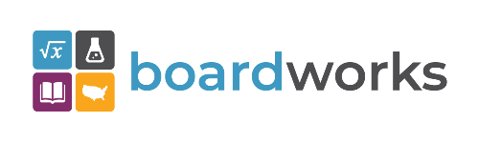 | www.boardworkseducation.com
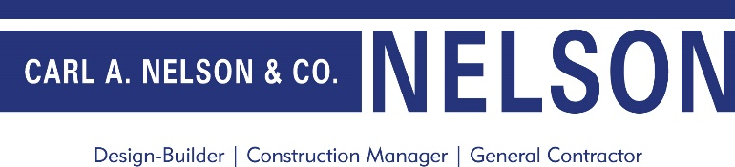 | www.carlanelsonco.com

Contact us with any questions, feedback or suggestions to better prepare your advocacy work:
Margaret Buckton, RSAI Professional Advocate, margaret@iowaschoolfinance.com , 515.201.3755 Cell

