Pleasant Township Board of Trustees Meeting Highlights
Date May 12, 2026______________ Next Resolution No._23 - 5-12-2026_ _

- Call to Order -- The meeting tonight will also be on WebEx.
Please stand for a moment of silence.
Pledge of Allegiance
Roll Call –
- Visitors – Rod Pritchard, Prairie Twp. Trustee and Jim Jewell, Prairie Twp. Administrator - report on The Darby Accord Watershed Master Plan and explaining why they will be the first to accept the updated plan.
- Minutes to approve- No minutes
- Financial Reports – Paula – 24 checks totaling $26,919.41, payroll - $84,127.85. Had an invoice for Fire Dept. for an event tent that included tax of $87.02, Paula reminded that we are tax exempt and should be done at time of purchase.
  - MOTION to pay expenditures.
- Department Reports –
  - Franklin Co. Sheriff’s Dept-Community Liaison, Deputy Adkins, 1120 Cell: 614-809-5843
- Road Department- Greg Gieger in for Robert Bausch
- Clean up – had a success clean up, 7 heaping full dumpsters
- Cemetery mowing
- Cemetery mower down
- Potholes
- Where are we with hiring summer help? Have not received any interest.
- Do you have enough flags to put on the Veteran’s graves for the Memorial Day Service? Will check and let me know tomorrow.
- Will you please put the flag up also for that weekend? Fire Dept will put the flag up.
- Fire Dept. – Chief Whiting
- Apparatus
  - General Maintenance of Apparatus
  - Boat 231 (reported 10-14-25)
    - Purchase in Process
  - Medic 231 Annual PM & Inspection done.
- Personnel
- Equipment
  - Upgraded I Pads for vehicles
  - Submitted information to Metro Parks
- Training
- Station
  - Working with Grove City on phone network (on-going)
  - Concrete front ramp (ongoing)
  - Block Repair (In the spring, the building will need to be painted once repaired)
    - Currently looking for a painter
  - EMS room-Quote to move electric & Plumbing -currently have two quotes
  - Waiting on a quote from the plumber
- CRR
  - Smoke Alarms
- Grants-Put in for a $10,000 grant for farm rescue equipment
- Cybersecurity Issue: Identity Theft Insurance for employees? What have we done?

- OTARMA-waiting to hear back from Wendy French on review – Chief has talked to Wendy and working on it.
- Mt. Carmel had a recognition service for two of our part-timers, Chase Coleman and William Jones. Great job!
  - Has the Sam's Club credit card charge of unknown origin in the amount of $399.10 on March 11, 2026 been resolved? No one at the township made this purchase, Paula has to go into Sam’s to get it reimbursed.
- Old Business-
  - Medical Insurance renewal coming up by June 1. So far our current medical is with Aetna which has an 8.80% increase. Currently we pay $34,436.42 per month the new quote is $37,467.25. An increase of $3,030.83 per month. Tony, (our broker) said if we do not market it he may be able to get 1 or 2 points knocked off. (from 2 meetings ago: Chief asked to have a committee. Do you have any info from your committee. We need to make a decision by next meeting which is May 12 to make the deadline before June 1.)
Resolution_23__to authorize our broker, Tony Palandrani with Rankin & Rankin Insurance Services, to renew the township’s medical insurance with Aetna authorizing him to negotiate the price of $36,777.74 per month.
(Tony was able to get 2 points off) (an increase of $2,341.32 over last year)
- New Business –
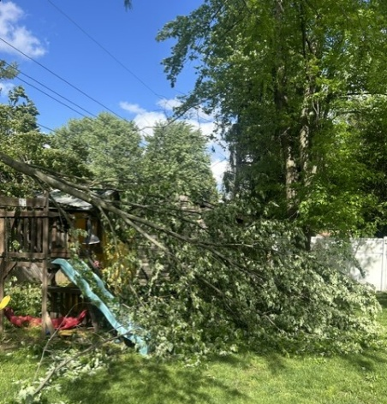
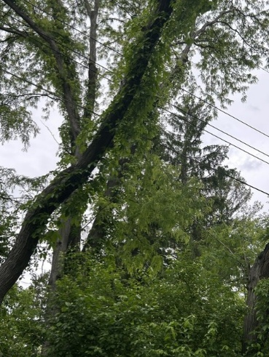
  - Received the following email:
I’ve contacted AEP in the past and they trimmed around their power lines. However I’m having trouble getting any help from ATT in regards to trimming branches around their telecom lines. ATT said to not trim them ourselves but nothing has been done. The trees themselves are on the neighbor behind us property. It is just a matter of time before the branches snap and take out the lines. But AEP And Aplund tree service didn’t touch them, they did come and do the power lines but not the telecom lines. We had one branch recently call, which I chopped up. But the long ones are grown into the telecoms wires. Pic attached. Alicia Geiger was in attendance and said AT&T reps were in Rolling Hills notifying residents they would be trimming trees in a month or so.
- Tavion our Twp. ghost hunter asked to renew his One-year permission to enter the
cemeteries after dark. He always notifies the Sheriff’s Dept.

- Announcements -.
  - Memorial Day Service at Oak Grove Cemetery, Monday, May 25, 2026 at 1:00 p.m.
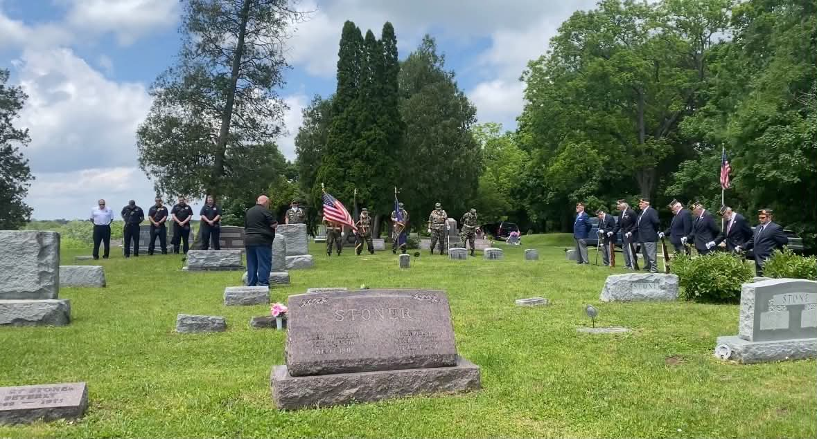
We want to thank, in advance, Joe Testa our guest speaker, members of West Jefferson VFW Post 7005 and members of American Legion – West Jefferson Post 201 for providing the Honor Guard.
Everyone is invited to attend, bring a lawn chair and reminisce with old friends or come to make some new friends, all are welcome.
- Clerk Updates- Paula
- Miscellaneous correspondence

- Speaker Sheets- (come to the podium to be heard on WebEx)

- Adjourn

