Sea Dragons JULY 2025  SUMMER!
SUNDAY |  |  | MONDAY | TUESDAY | WEDNESDAY | THURSDAY | FRIDAY | SATURDAY
 |  | 29 | 30 | 1 | 2 | 3 | 4 | 5
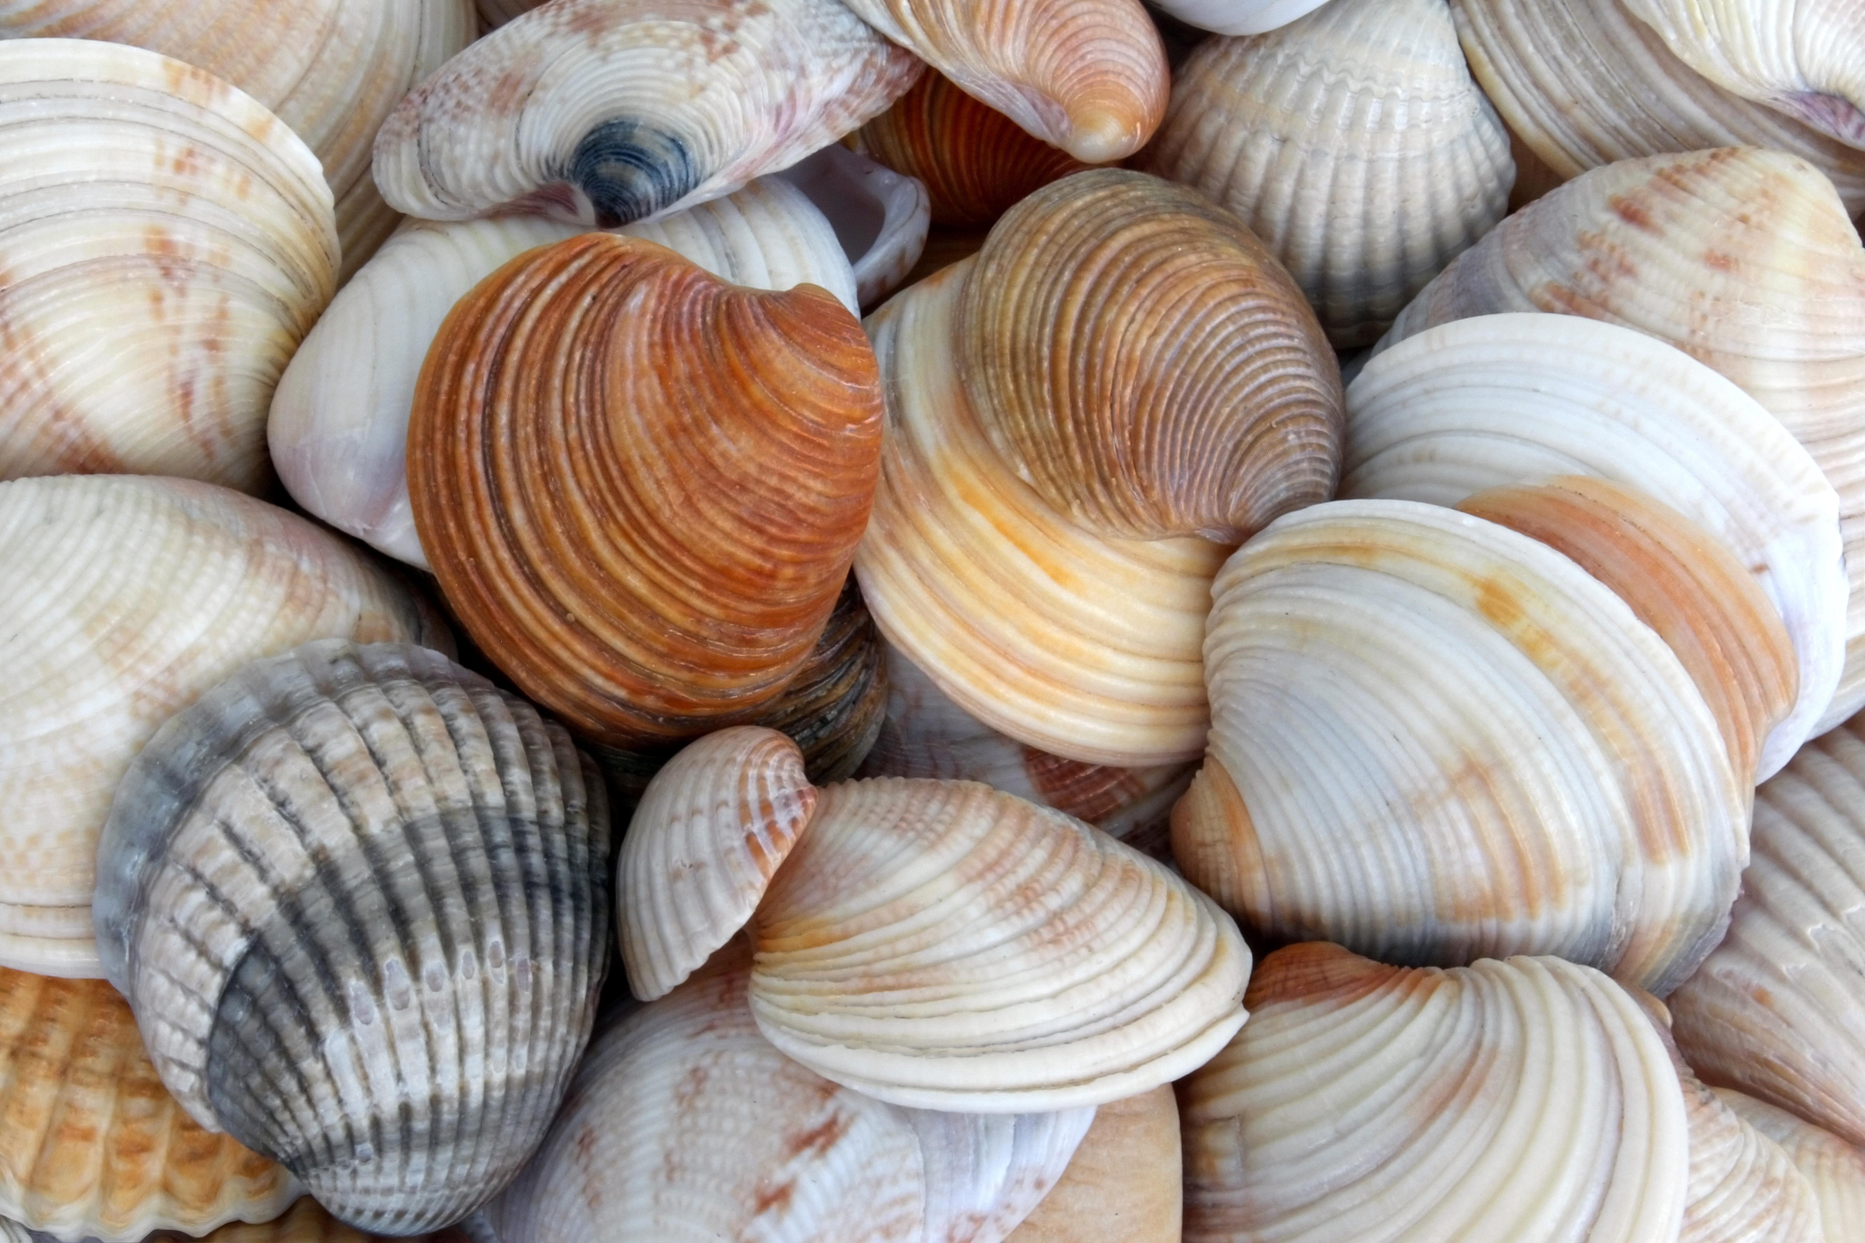 |  |  | GlenLake Water Park | Closed  Canada Day | Albert Head Beach | Esquimalt Water Park | Willows Beach
 | 6 |  | 7 | 8 | 9 | 10 | 11 | 12
 |  |  | Beacon Hill Park | Island View Beach | Beckwith Water Park | Fort Rod Hill  Lighthouse $3 | Aylard  Farm
 | 13 |  | 14 | 15 | 16 | 17 | 18 | 19
 |  |  | Sydney Water Park | Albert Head Beach | Peter Pan Water Park | Colwood Park Trails | Island View Beach | 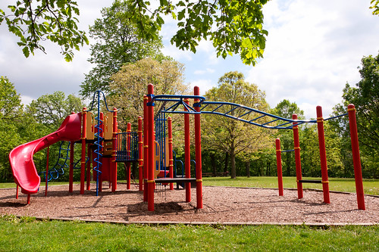  This Photo by Unknown Author is licensed under CC BY
 | 20 |  | 21 | 22 | 23 | 24 | 25 | 26
 |  |  | Central Saanich Water Park | Willows Beach | Esquimalt Water Park | Langford Water Park | Esquimalt  Lagoon
 | 27 |  | 28 | 29 | 30 | 31 | 1 | 2
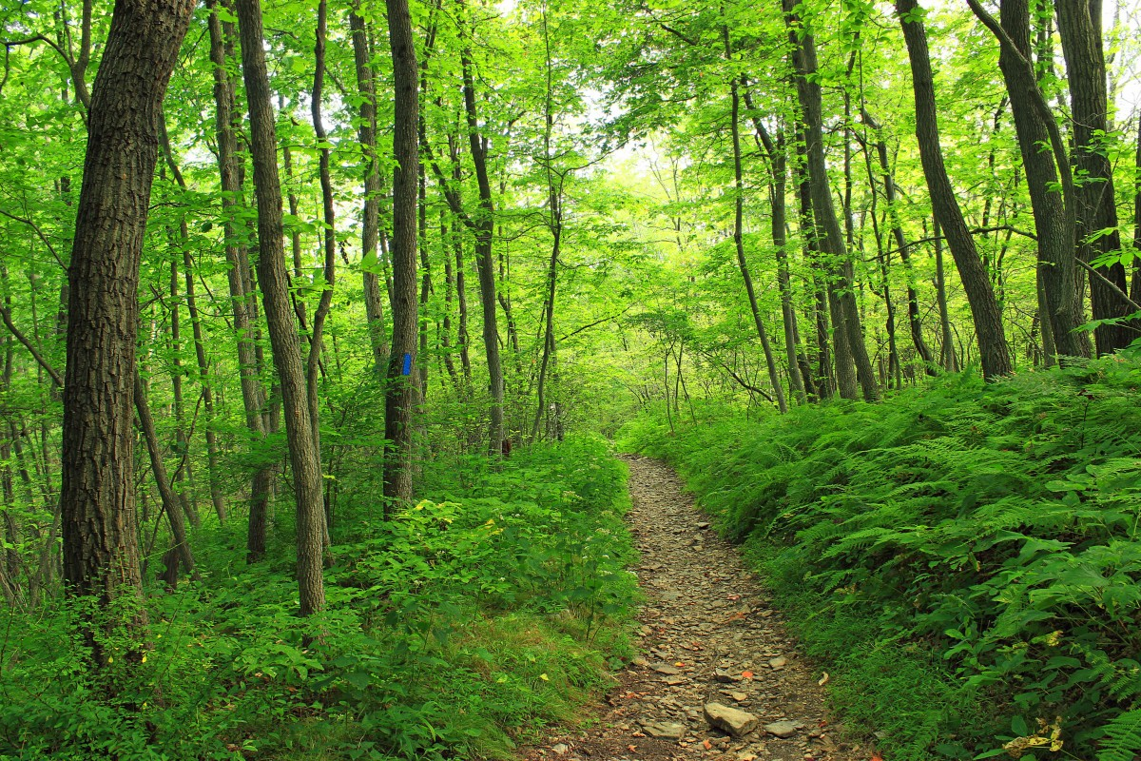 |  |  | View Royal Park | Gyro  Park | Devonian Beach | Royal Roads Trails | Royal Bay  Park

