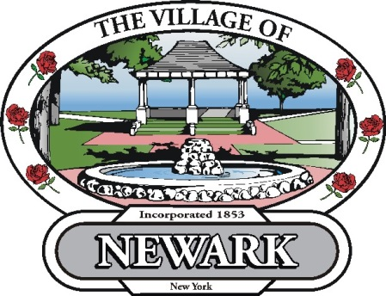
March 19, 2014

Re: Returned Checks/ Insufficient Funds Checks

Effective immediately, the fee for a returned check/insufficient funds check will be $35.00 per check. (If the returned check was for a water/sewer bill, and the shut off date for unpaid bills has passed, the bill will be considered unpaid. The water service will be suspended immediately and a total of $40.00 in fees for Water Shut Off and Water Turn On will be added to the bill. The water service will not be turned back on until the outstanding bill amount, the $35.00 check fee, and the additional water fees are paid in full with cash, money order or bank check – NEW).

Thank You.

Sincerely,
Steve Murawski
Clerk/Treasurer

