**ZONTONIAN NEWSLETTER**

**ISSUE 33 JUNE 2017**

**AUGUST 2015**

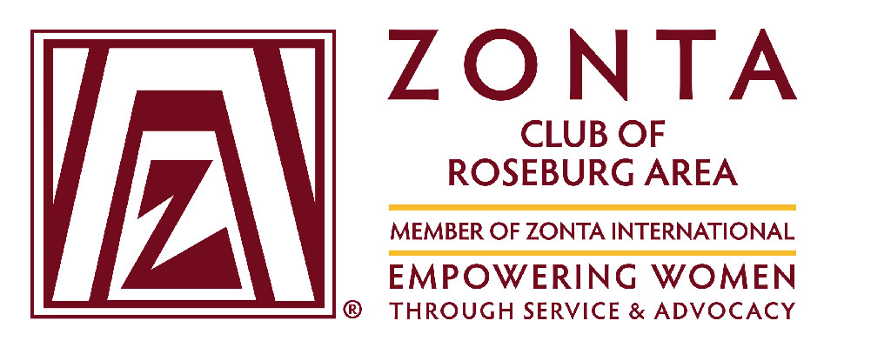

**Zontians of the Year- Co-Recipients**

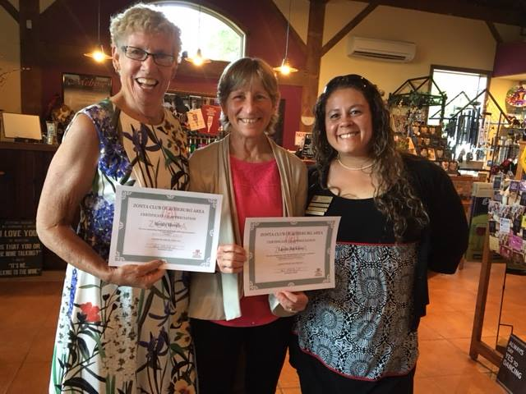

Surprised! That’s how we felt when we were awarded “Zontian of the Year” by President Rosa!

Normally the Zontian of the Year is awarded to a single individual. This year it was given to the group’s joined-at-the-hip friends, Laura Jackson and Sandy Hendy. Both Laura and Sandy are on the Public Relations and Advocacy committees. Together, they helped restart the group’s newsletter, and upgrade the website. They were able to get multiple news releases, kudos, and feature stories printed in the local newspaper to promote Zonta’s various events and fundraisers. Laura and Sandy also acknowledge Shon Garrison’s contributions to the Public Relations Committee for her work managing the group’s Face Book page and providing photographs of events.

For Advocacy, Laura and Sandy worked with Umpqua Community College (UCC) to use their display case. They were able to use the display case to inform people about the Zonta Says No campaign, advertise the Santa Run, and promote Women’s History Month & Gender Equality. Being relatively new members, Laura and Sandy also attended the Coos Bay Workshop in 2016 and the Portland all District Workshop this past April. The two have also volunteered to be the editors of the District 8 newsletter. Individually, Sandy has been on the Foundation Board for the Roseburg Club and stepped up to become the President Elect. Laura chaired the Rose Committee and helped the committee to honor the local individuals who have been instrumental in helping to stop and educate Douglas County about human trafficking.

On a personal note, Laura and Sandy just recently returned from Birmingham Alabama where they competed in the 30th National Senior Games (NSG). The NSG offers competition in 19 different sports for folks 50 and older. This year’s NSG attracted over 10,400 athletes. Laura and Sandy competed in the 5K and 10K bicycle time trial races. Sandy took 6th in her age class for both events while Laura won two gold medals. The two are already planning to qualify in 2018 so they can race in the next NSG in 2019!

Page 2 Zontonian Newsletter

**DISTRICT 8 SPRING WORKSHOP**

On May 6, nearly 100 Zontians gathered in Portland for the spring workshop. Lt. Governor, Jeanie Martin, started the workshop by outlining Zonta International’s (ZI) global membership drive. During the next year, ZI hopes increase membership by 5%. To do this they would like to see each club add one new member and each district to add one new club. ZI has a Social Media toolkit to help members have readily available information to promote Zonta. Members can access the information at the Zonta website, on the members tab. The information includes brochures, banners, and presentations. If you don’t already have a password to access the members page, write [member@Zonta.org](mailto:member@Zonta.org).

Stacey York, PhD, who works for the University of Oregon, talked about *Understanding and Overcoming Implicit Bias.* Bias is the filter each of us uses to sort information quickly. Explicit bias is done on a conscience level while implicit bias is subconscious. Bias is gained by our personal experience, yet the filters we use vary on a daily and even hourly basis. As an example of bias, researchers prepared identical resumes, one for Jenifer Smith and one for John Smith. The individuals in the hiring department consistently rated John as 14% more capable than Jenifer. If the name was changed to Juan or other name popular with minorities, the bias became even greater. This is one reason many employment offices now delete the names from resumes prior to review. For gender equality at the CEO level, it will take another 250 years before things are equal. Meanwhile women are 44% more like to get criticism for being strong or pushing a point. A male is viewed as “sticking to his guns,” while a woman is viewed as pushy or abrasive. But don’t assume only men are biased. Stacey, who is from a science background, implicitly stereo-types scientists as men. Part of that comes from being in a male dominated field—she’s surrounded by men therefore subconsciously thinks of men as scientists. Her husband was less biased on the subject. People can take a bias test at: Implicit.Harvard.Edu.

Next, the group went through an improv exhibition by Eric and Aden Nepom that demonstrated how messages get miscommunicated as they are passed along. They also showed how one sentence could be changed into different stories based on the makeup of the group.

The next speaker talked about the Guardian Group, which is a group to stop human trafficking. This group hires former elite military personnel to help partner with, and teach hospitality, travel and tourism industries about trafficking. They also collaborate with law enforcement agencies to teach them how to recognize and pursue the predators. The average age of the victims is 12 – 14 years old and trafficking is the nations’ #1 fastest growing crime. Over 80% of the law enforcement agencies lack training to manage trafficking incidents and less than 1% of the victims are reported. The group hopes to continue to teach more businesses and law enforcement agencies about this growing crime. For additional information go to: [www.theguardiangroup.org](http://www.theguardiangroup.org).

Next, Janice Krall, Area Manager of the Heart and Stroke Foundation, gave a presentation about fundraising. Her main keys to success are:

1. Know your organization---what do you want people to know about Zonta? Are you ready to answer questions about the club?
2. Know YOUR story—why do you belong to Zonta? How do you feel about Zonta’s impact?
3. Know your product—know what Zonta offers, be sincere.
4. Know your prospect—why would this person fit Zonta? Do your homework and use active listening while engaging the prospect or potential sponsor.

The workshop then had a panel to discuss starting Z Clubs. The biggest challenge is to find an advisor. Teachers and coaches can already be overextended, so look for other staff that may be willing to help. One successful way to ensure continuity in a high school club is to have only juniors or younger eligible for office. Have your election during the springtime, the new officers mentor all spring with the current offices, come fall—they are ready to lead the club. Z Clubs also like to help their community, so look for local projects. With the kid’s ability to use computers, they are quick to google issues, find contacts, look up permit requirements and roll with projects.

Page 3 Zontonian Newsletter

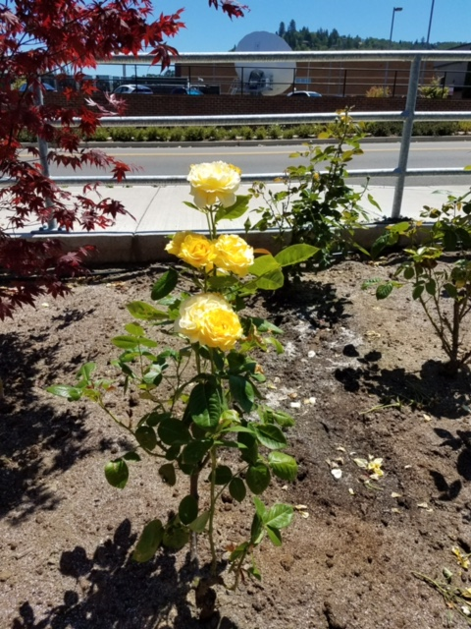

A picture containing person, indoor, floor, wall

Description generated with high confidence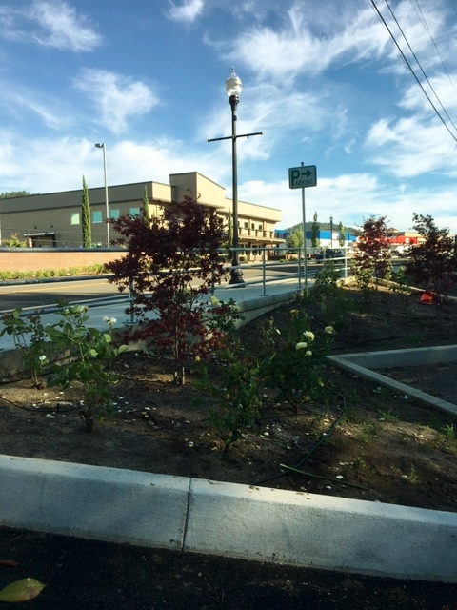

**Zonta Roses planted at Visitor Center**

**The Roseburg Contingent at D8 Workshop**

**District 8 Represented well in Washington DC!**

**CALENDAR OF EVENTS**

* **March 21 –Social event with ZI Parliamentarian**
* **March 22-Program meeting at Elmers**
* **(see below)**
* **April 1- Chair reports due**
* **April 1 -ZI Annual membership fees due**
* **April 12- local elections**
* **May 5-6-District 4 Clubs Workshop in Wilsonville**
* **May 24- Rsbg Zonta Installation celebration dinner**
* **June 2-4-North American Inter-District Mtg in Wash D.C.**
* [www.northamericanmeeting2017.com](https://d.docs.live.net/a73fd3c19ed9eedb/Documents/Sandys/Zonta/JAN%202017%20Newsletter/www.northamericanmeeting2017.com)

.

Zontians visit the US Capital and some of our legislators.

Also heard from current ZI President and President-Elect. See article for more details.

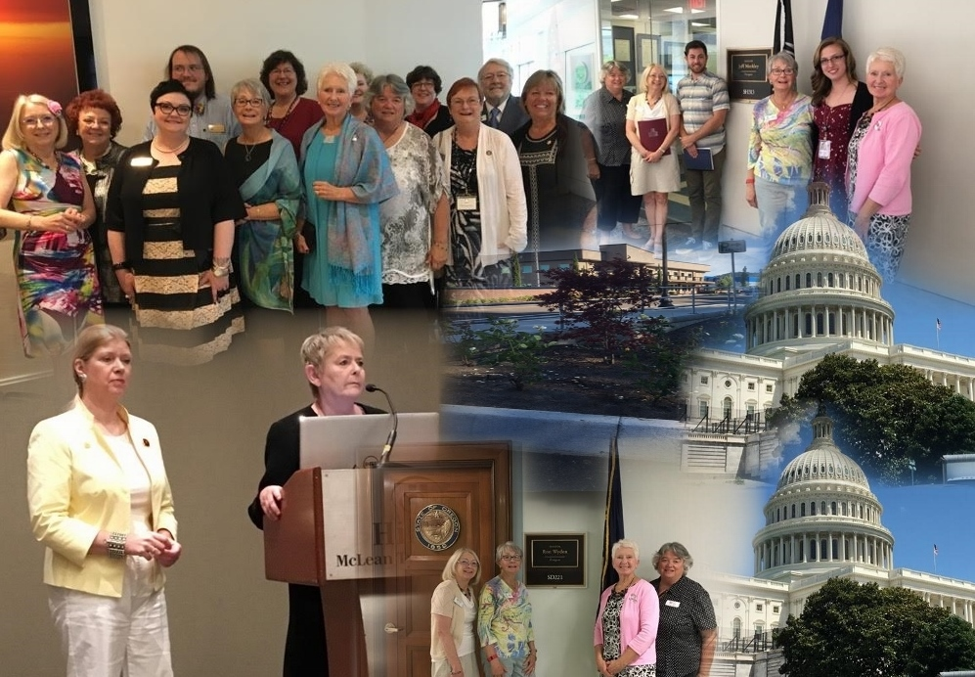

“Zonta Says NO to Violence Against Women” is a Zonta International campaign to raise awareness of and increase actions to end violence against women and girls around the world. The campaign, which began in November 2012, features the service and advocacy actions of Zonta clubs and districts to prevent and end violence against women and girls in their local communities.  It also highlights Zonta International’s ongoing efforts to end violence against women and girls through the Zonta International Strategies to End Violence against Women (ZISVAW) program and through Zonta’s partnerships with the United Nations and its agencies.

Throughout the 16 Days of Activism 25 November-10 December, the Zonta Says NO to Violence Against Women campaign invites all Zonta clubs and districts to participate by [sharing their new and ongoing actions](http://www.zonta.org/MediaNews/ZontaSaysNOtoViolenceAgainstWomenReport.aspx) to end violence against women and girls. These actions will be featured on the Zonta Says NO campaign at the international webpage and official [social media pages.](https://www.facebook.com/ZontaSaysNo) Below is the stance that Zonta is taking on this issue:

WHEREAS, the crime of gender-based violence against women continues to be the most pervasive human rights violation and a global epidemic, is due to systemic use of physical, emotional, verbal, sexual, psychological and economic control and/or abuse does not know any national nor cultural barriers and affects millions of women and girls of all races and socioeconomic backgrounds, in peacetime and conflict, violates an individual’s privacy, dignity, security, and humanity results in serious short-term and long-term physical sexual and reproductive, and mental health problems, including increased vulnerability to HIV.

Zontonian Newsletter Page 4

**2017 North American Inter-****District Meeting**

This year's meetings were held near Washington D.C. on June 2-4th at the Tyson's Corner Hilton Hotel in McLean VA. Members from 290 clubs across the United States and Canada were in attendance. District 8 was represented by 1 club from Alaska, 2 clubs from Idaho, 6 clubs from Oregon and 5 clubs from Washington.

The weekend began with an Advocacy event on Friday, June 1, where club members visited the offices of their state's senators to lobby for two bills: the Bi-partisan Campus Accountability and Safety Act (HB856) and the Equal Rights Amendment. All senators were in their home states that week, meeting with constituents and holding town hall meetings, so Zonta members met with their aides.

Prior to arriving in Washington D.C. registrants selected four breakout sessions which fit their club needs and interest. The four tracks for the breakouts were: Advocacy, Leadership, Membership and Service. Each session was led by a professional in the field. They were interactive, interesting and educational. Training for members is one of the goals for the Inter-District meetings while the International Convention is geared to the business of Zonta and the election of new leadership.

The guest speakers included **International President Sonja Honing Schough** who reported on her visit Madagascar Project Visit and **International President-Elect Suzanne von Bassewitz** who explained the plans for the Centennial Anniversary Celebration. We enjoyed an interesting and entertaining lunch speaker on Saturday, with Pat Wirth, who is the Executive Director of The Turning Point Suffragist Memorial. Saturday evening’s banquet included a presentation by Sophie Cruz, the Producer/Director of "Little Stones". "Little Stones" is an award-winning documentary of women healing from violence through the arts.

The workshop closed on Sunday after the last round of breakout sessions with brunch and invitations to the 2018 International Convention in Yokohama, Japan and to the 2019 Inter-District Workshop in Dallas, Texas

**Roseburg Area Zonta Host Ukraine Delegates for Lunch Meeting**

This year the Open World program hosted its 11th delegation from Ukraine (UK). Normally Open World has had delegates from the education field, however this year they came from the medical field. There were six guests and a translator. They included psychologists and MD’s. They each also worked in some aspect of social work. They appreciated seeing different ways to look at issues. One member noted how she was particularly impressed with how doctors, psychologists, and social workers work together at places like the VA. They also liked how with our military, we are declaring the mental and physical problems our soldiers have faced and are openly discussing the issue as we strive to solve it.

UK has about 40 million people. One issue they have is the lack of jobs. In many cases, employees in their 40s can’t find work or leave work to babysit their grandchildren; opening jobs for the younger generation. For the UK delegation, it was refreshing to see older folks radiate a healthy energy and remain active and busy in their communities.

UK doesn’t promote individualism, consequently things like the gift bags with their names on them are special. They were very impressed with the hospitably displayed by everybody they met. Their mission is to learn new ideas here and share them in UK. The group was very thankful for their experience here!

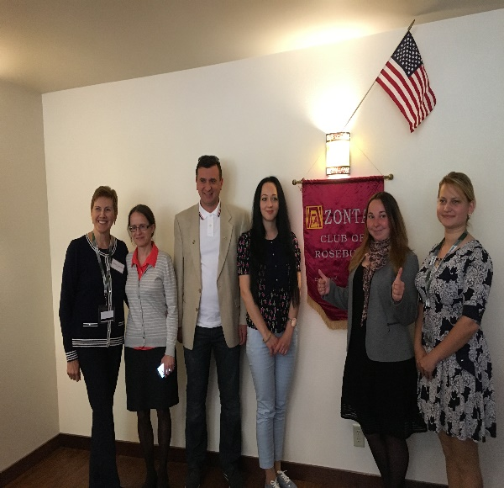

Ukraine Delegation visiting Zonta to share

cultures.

.



**Roseburg Zonta host Open World Delegation from Ukraine**

Zontonian Newsletter Page 5

**Calendar of Events**

* **June 28**—Speaker Marion Kotowski, Human Trafficking in Douglas County. Lunch meeting at Elmer’s.
* **July 1 – August 31**—Zonta’s 2nd Dignity Drop Drive.
* **August 30**—Summer BBQ and White Elephant event.
* **September 9**—Iron Woman
* **December 9** - Santa Run

**Newsletter Ideas or Comments?**

Contact: Editors: Laura Jackson, Sandy Hendy or Shon Garrison with your thoughts.

**Besure to visit our website:**

**Zonta Club Website**

<http://www.zontaroseburg.org>

Or check us out on Facebook

**2017-2018 Installation at Melrose Vineyards**

On May 26th, the Zonta Club of Roseburg Area hosted their installation of officers’ dinner at Melrose Vineyard. Past International Governor (PIG) Genelle Hanken, from Coos Bay Zonta, officiated the ceremony as the new officers lit their candles and said their pledge. There was only one attempt at turning the event into a real barnburner. This year’s officers are:

* Rosa Mohlsick—President
* Sandy Hendy—President Elect
* Gail Trimble—Secretary
* Karen Kohlman—Treasurer
* Laura Jackson—2 Year Board Member
* Alison Eggers—1 Year Board Member

President Rosa Mohlsick continued the celebration, noting that this year’s accomplishments included: an increase in public relations and social media, a successful Dignity Drive for Undergarments, and three successful fund raisers. She then challenged us with this year’s theme—“be the change you want to see and do something different. Be flexible, be encouraging, be empowering, be caring for each other, and take this opportunity to be united under one mission. Use this opportunity for true growth. Don’t focus on the negatives of those around you because life gives us too many lemons, that’s why I need you to sit with me and drink lemonade. Each of you are my hero. Not because of something heroic that you have done your own, but because of the work that we do together, changing lives as a united force. So, I challenge you to rise to the occasion! Here’s to one more imperfect year to do impeccable work, serving our community together for the betterment of *Empowering Women through Service and Advocacy*”.

Rosa then awarded each member of the club with a certificate of appreciation, acknowledging that the work of each individual. Being small in number, Rosa recognized that we each take on multiple committee roles. It is our capacity to multitask that makes us successful.

The dinner concluded with a birthday cake to commemorate the club’s 70th year of existence.

