WHAT: March Member Meeting
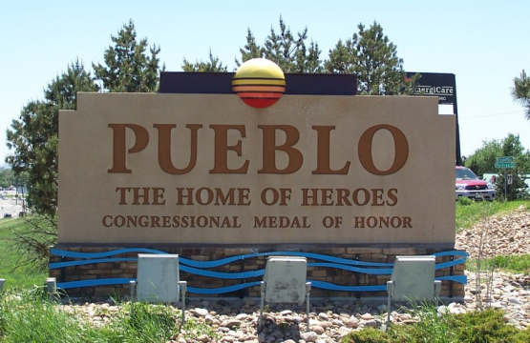
WHEN: March 8, 2021

6:00pm – Networking
6:30pm – Short Meeting
6:45pm – Program: Explore Pueblo

WHERE: via Zoom

PROGRAM: Join Linda Lutz from the Visit Pueblo Convention & Visitor's Bureau and her team as they invite us to experience the flavor of Pueblo

Explore Pueblo

Our mild winters and sunshine make us a great location for you to get reacquainted with your wanderlust spirit. Join the many walkers on the Historical Arkansas Riverwalk and learn how this has become the focal point of our community. Enjoy rich historical architecture and an evening stroll in Neon Alley. Shop our wide range of eclectic stores on Union Avenue. Learn how this area of the west was settled, or how Pueblo has become the Home of Heroes, in one of our engaging museums. Make a stop at one of our 5th generation farm stands, with produce right from the field and home-baked goods. Take a scenic drive to Lake Pueblo for bird watching and stop by the Raptor Center to view birds of prey that are rehabilitated and released back into the wild. No visit would be complete without eating at one of our culturally diverse eating establishments where the families of immigrants who came to work at the steel mill continue their cuisine traditions. Let Pueblo be your hub for venturing out to other great attractions such as the Royal Gorge
in Canon City or Old Ben’s Fort in La Junta.

REFRESHMENT: your call

DIRECTIONS: To Join the Meeting click on this link or copy it to your browser: https://zoom.us/j/97456397637 . You may start to join the meeting at 5:50 pm. click on “Join” in the invitation, enter the necessary codes, and wait to be admitted.

PARKING: Your garage, driveway, or curbside.

GUESTS: Members are encouraged to invite potential members as a guest to the meeting.

CONTACT: J. Mark Blaising, Program Chair 303-830-8440 (voice) 303-263-8647 (text)

