GEN-3230 (120V-3000W-38.4kW-60Hz-16yr) | Geneforce Emergency Power System
Product Features
Silent operation. Safe for indoors. No gas or emissions.
No Installation; No Maintenance; No Permits required
Arrives fully charged and ready to work.
Automatic & one-touch start. | 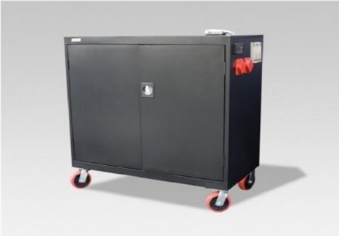
System Control Panel with Graphical 128 x 64-pixel, backlit LCD displays power reserves, amp hours consumed, fault conditions, solar panel output, charging, power consumption.
Overheat Temperature Sensor & Automatic Shutdown feature.
Built-in voltage regulation system for sensitive electronics.
Built-in 30A solar charge controller for solar panel charging.
Electrical Specifications | GEN-3230 (120V)
Output power (continuous) | 3,000 W
Surge power (AC amps) | 6,000 W
Peak output current | 80A
Output frequency regulation | 60 Hz +/- 0.2 Hz
Voltage regulation | 120 V +/-5% true RMS
Output wave form | True Sine Wave
Service Life | 12-16 years
Stored battery reserves | 38.4 kW (38,400 Watts)
AC input 1 | One (30A/125V) NEMA L5-30P input plug with 8 ft. cord
AC output 1 | Four (20A/125V) NEMA 5-20R isolated ground receptacles
AC output 2 | One (30A/125V) NEMA L5-30R female receptacle
Automatic transfer switch | 30A (Transfer time < 20 ms.)
Charge rate | 150 A DC
AC input voltage range | 85 - 140 Vac
Charge control | 3-stage (Bulk, Acceptance, Float)
Solar charge controller | 30A/12V (~360 W per hour/sunlight) *(60A/12V-24V) optional
General Specifications
Optimal operating temperature range | - 4°F to 140°F (- 20°C to 60°C)
Monitor | LED Display (reads V, DC amps, Power Share, etc.)
Product Dimensions (H x D x W) and weight | (51" x 24" x 46”) & (2295 Lbs.) 1043 kg.
Shipping Dimensions (H x W x L) and weight | Custom Pallet 60” x 36” x 60” (2395 lbs.) 1089 kg.
Construction | Strong Steel, Four Casters, Color-Black or Charcoal
Warranty | 24-month warranty on components; up to 4-years on batteries
Part Number | GEN-3230-120-3000-16
Regulatory Approvals & Protection
Safety - UL Listing | Components ETL certified to CSA 107.1, UL458 with marine supplement, FCC Part 15, Class B
Voltage Regulation | Over voltage and under voltage protection
Temperature & output | Over-temperature & overload protection
Electrical | Short circuit protection
Price | $18,797
Geneforce Incorporated www.geneforcepower.com Tel: (305) 215-5443 email: sales@geneforcepower.com

