Naunton Parish Council
Clerk’s Report for
Monday 16th September to 13th November 2024

Supporting documents for meeting on 18th November 2024
Please note that documents required for the meeting may be included as links to OneDrive. This is to reduce the number of pages and the size of the attachments.

Agenda item 3 | September minutes for approval and signing | 2 - 3
Agenda item 10 | Bench for Baptist burial ground | 4 - 8
Agenda item 13 | Audit fees and service | 9
Agenda items 14 and 15 | Budget and Precept setting | 10
Agenda item 16 (b) | Internal controls | 11 - 12

Naunton Parish Council
Clerk: Maxi Freeman, Charlwood, Kineton, nr Guiting Power, Cheltenham, GL54 5UG
www.nauntonpc.org

MINUTES: of the Annual Naunton Parish Council Meeting held on Monday 16th September 2024 at 7.00 pm.
PRESENT: Parish Councillors: Charles Hanks, Keith Russell, David Pickup, Nicki Gibberson.
APOLOGIES None
IN ATTENDANCE: Maxi Freeman, Clerk

MEMBERS OF THE PUBLIC: None

- To receive Declarations of Interest in items on the Agenda (Localism Act 2011) None.
- To hear representations from the public regarding items on the agenda. None.
- Approval of minutes of the previous meeting (July 2024) The meeting approved the minutes, and the Chairman signed them. Action: Clerk to post to website.
- Matters Arising (Clerk’s Report) The Chairman drew Councillors’ attention to the information in the Clerk’s Report for agenda items 8 and 10. The Clerk reported that a new planning application had been received between meetings. Action: Clerk to circulate for comment.
- Chairman’s Report. The Chairman reported that the plaque for the new bench had been sourced and would be delivered in the next week. The new bench seemed to have a crack in the rest. Action: Clerk to send photograph to suppliers to query the condition. The Chairman reported that Cllr Wilkins would be visiting the Ben Pauling race yard following an invitation.
- Declarations of Interest Councillors Hanks and Gibberson provided updated Declaration of Interest forms. Action: Clerk to forward to CDC Monitoring Officer.
- Planning applications
To comment:
24/02355/FUL Formation of a 3 furlong all-weather oval gallop, Summerhill Farm, Naunton Cheltenham Gloucestershire GL54 3AZ. Deadline 1st October 2024. Councillors voted to post a neutral comment. Action: Clerk to post to CDC Planning Portal.
24/02461/LBC Installation of through-floor lift, Lower Harford Farm, Lower Harford Lane, Naunton Cheltenham Gloucestershire GL54 3AG Deadline 26th September 202. Councillors voted to post a comment of support. Action: Clerk to post to CDC Planning Portal.
- Website and emails Councillors noted the changes to the accessibility rules but decided to postpone any switch to a gov.uk web address and gov.uk councillor email addresses until they became mandatory. Cllr Gibberson agreed to carry out further research
- Assets and Risk Assessment
Recreation field (including dog waste) & benches | Nothing to report .
Play area (including dog waste) | Cllr Hanks to carry out small works to some play equipment.
Flood Monitoring | Cllr Russell reported that the annual river clearance would take place on 26th October. There was considerable overgrowth on both sides of the river, which could increase the risk of flooding. Action: Cllrs Hanks and Russell would visit the site and decide whether professional advice was needed.
Village Hall | Cllr Russell reported that the drainage issues had been resolved and that the gullies had also been cleared. The hall was being well used.

- Finances
a) Councillors noted the current balances and the reconciliation, which the Chairman signed.
b) Baptist Chapel Bench. Councillors agreed unanimously to grant £150 to the Baptist Church to replace the bench in the burial ground in Naunton. Action: Clerk to let the Baptist Church know and ask for payment details.
c) Clerk’s wages. Councillors agreed unanimously to update the rate of pay to the current NALC rate. This would be back dated to April 1st 2024.
d) Councillors approved the following payments:
Epay | M Freeman | Clerk’s salary August/September @ £235.17 p m | LGA 1972 s.112 (2) | 470.34
Epay | M Freeman | Expenses (see receipts) | LGA 1972 s.111 | 14.68
Epay | M Freeman | Proteus Fittings Handrail | LGA1892 s.8 (1) (i) | 243.54
Epay | M Freeman | Brunel Engraving plaque | LGA 1972 s.137 | 50.94
Epay | M Freeman | Land registry search re boules | LGA 1972 s.111 | 3.00
Epay | M Freeman | Cyan Teak Garden Furn- Bench | PCA 1957 ss.1(1) & 7 | 527.50
Epay | GAPTC | Subscriptions for 2024 - 25 | LGA 1972 s.143 | 90.32
Epay | GAPTC | Annual Audit 2023 - 24 | LGA 1972 s.111 | 180.00
Epay | Community Heartbeat | Defibrillator pads | PHA 1936 s.234 | 59.94
Epay | Community Heartbeat | Defibrillator battery | PHA 1936 s.234 | 357.00

- Items for the next meeting. Councillors were interested in developing a Neighbourhood Development Plan but recognised that this would require considerable work together with resident support and participation. Further information was needed. Action: Clerk to contact Locality (a Government organisation which provides information, grants and other help with NDPs) for further information and a meeting. Also to send links to Locality to councillors.
Drones had been seen flying over the village at 2.30 a.m. Action: Clerk to find out what, if any, rules apply to flying drones over residential areas. Cllr Gibberson to contact the police to find out whether they were aware of the drones.
There being no further business, the Chairman closed the meeting at 20.05. The next Parish Council meeting will be held on Monday 18th November at 7.00 p.m. in the village hall.

Signed ………………………………………………………………….
Chairman Date 18th November 2024

Agenda item 10 Baptist Burial Ground – latest emails

Tim Chowns

to me, Jenny

Hi Maxi

That sounds acceptable to the BUC but please note we will need to see a copy of the full invoice before we can release any funds.

Many thanks.

Tim

From: Maxi Freeman <nauntonpc@gmail.com>
Sent: 13 November 2024 17:56
To: Tim Chowns <TChowns@baptist.org.uk>
Subject: Re: Bench at Naunton Baptist Chapel

Hi Tim

The next meeting of Naunton Parish Council is on November 18th. I will add this to the agenda and ask councillors to choose which, if any they approve and whether they are prepared to pay half the cost. The Chairman is happy to do the work of removing the old bench and installing a new one so that should save quite a bit. Is that acceptable to the BU?

Regards

Maxi Freeman
Parish Clerk and RFO
Naunton Parish Council
07736 706805

Possible benches are shown below.

Cyan Teak Balmoral 4ft bench £330 inc VAT 5ft version is £365. Balmoral 4ft Solid Teak Park Bench – 1.2m
Accessories:
GA003
Soft Ground Anchors with installation tool – Garden Furniture Security

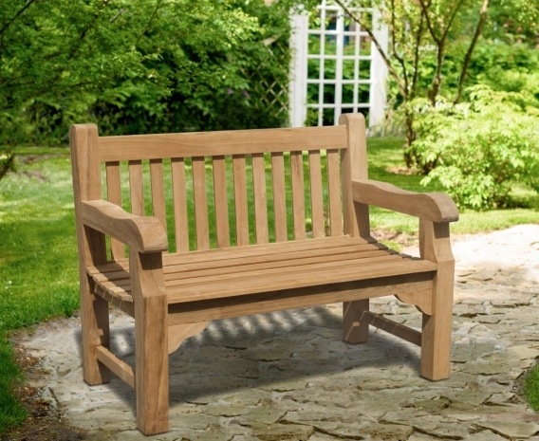

Cyan Teak Windsor 4ft bench £215 inc VAT Windsor 2 Seater Teak Garden Bench, 4ft Park Bench – 1.2m 5ft version is £235
Accessories:
GA003
Soft Ground Anchors with installation tool – Garden Furniture Security

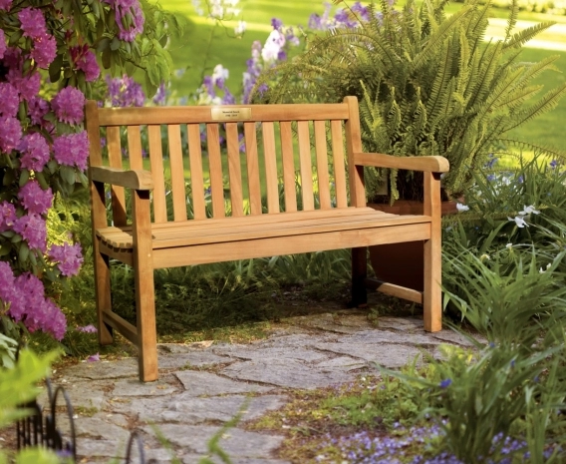

4 ft Acacia bench (flat pack) £155 inc VAT Garden Life Wooden Bench Acacia Hardwood Pre-Treated Water Resistant Furniture : Amazon.co.uk: Garden 5ft version is £162.

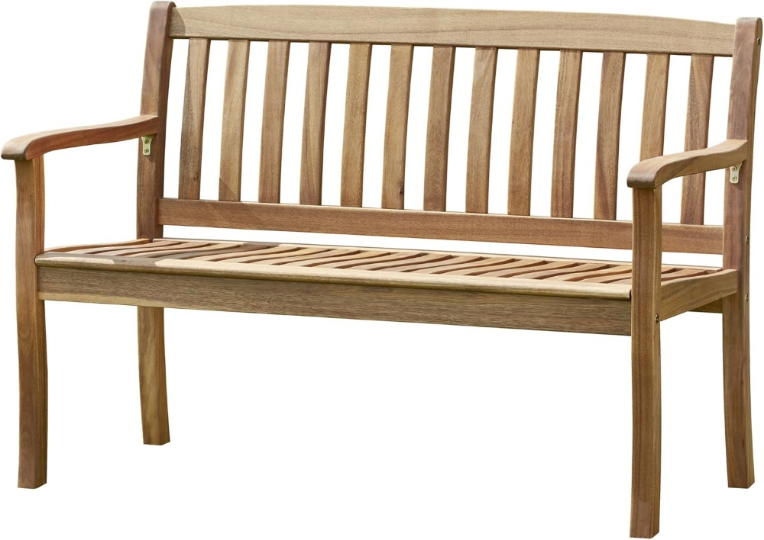

Westminster flat arm 1.2m bench Westminster Flat Arm Teak Bench 2 Seater 1.2m £249 inc VAT AVAIL FROM 20/1/25 Accessory: Anchor kit soft surface £100 1.5 m version is £299

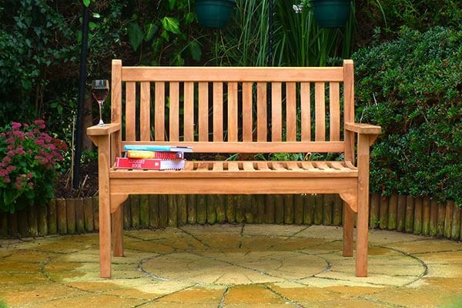

Braemar 4ft teak bench Braemar 2 Seater Teak Garden Bench - 1.2m ‘Built to last’ £350
5ft version is £365 inc VAT

04-GA003
Ground Anchor Kit for Soft Surfaces Including Installation Tool

£80.00
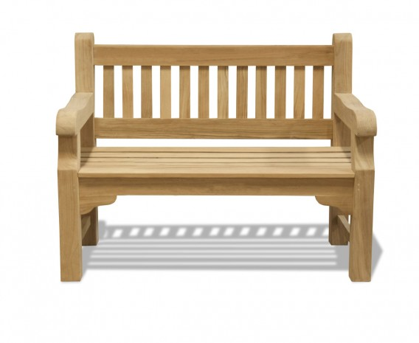

Agenda item 13 – Internal auditor rates for GAPTC

The Internal Audit reviews the working of the Council’s internal controls. The council’s internal control system comprises the whole network of systems established within the council to provide reasonable assurance that the council’s objectives will be achieved, with reference to:

- The effectiveness of operations
- Compliance and applicable policies
- Procedures, laws and regulations
- The safeguarding of assets and interests from losses of all kinds, including those arising from fraud, irregularity and corruption.

Councillors should assure themselves that the service is independent and qualified. Regarding the independence of the GAPTC audit service:

The main determinant of the effectiveness of Internal Audit is that it is seen to be independent in its planning and operation. To ensure this, the Internal Audit Service will operate within a framework that allows:

- Unrestricted access to the officers of the council
- Reporting in its own name
- Segregation from the day-to-day operations of the council

Every effort will be made to preserve objectivity by ensuring that all Internal Auditors are free from any conflicts of interest and do not undertake any non-audit duties on behalf of the council.

The Independent Audit Service provided by GAPTC has been restructured and repriced.
The basic price for an audit is now £210 (for PCs where the higher of the income or expenditure is between £5001 and £25,000), where no additional documents / visits / zoom calls or mileage charges are needed. Lengthy processes for providing requested documents will be charged at £35 per hour. Meetings will be charged at a minimum of £45 for the first 1.5 hours and £35 per hour thereafter. Mileage will be charged at 45p per mile.

Agenda items 14 and 15 - Budgeting and Precept setting

The budget is based on expected income and expenditure. The spreadsheet below shows draft figures. The full set of data is included in this spreadsheet: Budget planning 2025 26.xlsx

Naunton Parish Council
Agenda item 16 (b)

