**Christmas – Holiday Yard of the Month**

The Farm at Creekside 2018 Christmas – Holiday Yard of the Month selection is 2515 Eagleview Circle, belonging to Dwayne and Gloria Strong. Strong’s front and side yard displays lots of color including a lighted spruce tree in the south, side yard. The first-floor roofline features strings of icicle lights intermingled with colored lights accentuated with illuminated snowflakes. The front porch gable displays a large illuminated wreath surrounded by more snowflakes. The porch is wrapped with illuminated pine garland including an illuminated Christmas Star that hangs in the middle of the porch. The front entry features more garland and multi-color lights. Wreaths accentuate the front entry door and each side of the garage. Shrubs in front of home are decorated with multi-color lights. Although it is somewhat difficult to see in the photos, a laser light projector illuminates the large Maple tree in the front yard giving it the illusion of being decorated with hundreds of twinkling lights. Strong’s do a nice job every Christmas – Holiday season. This year is no exception. Congratulations to Dwayne and Gloria.

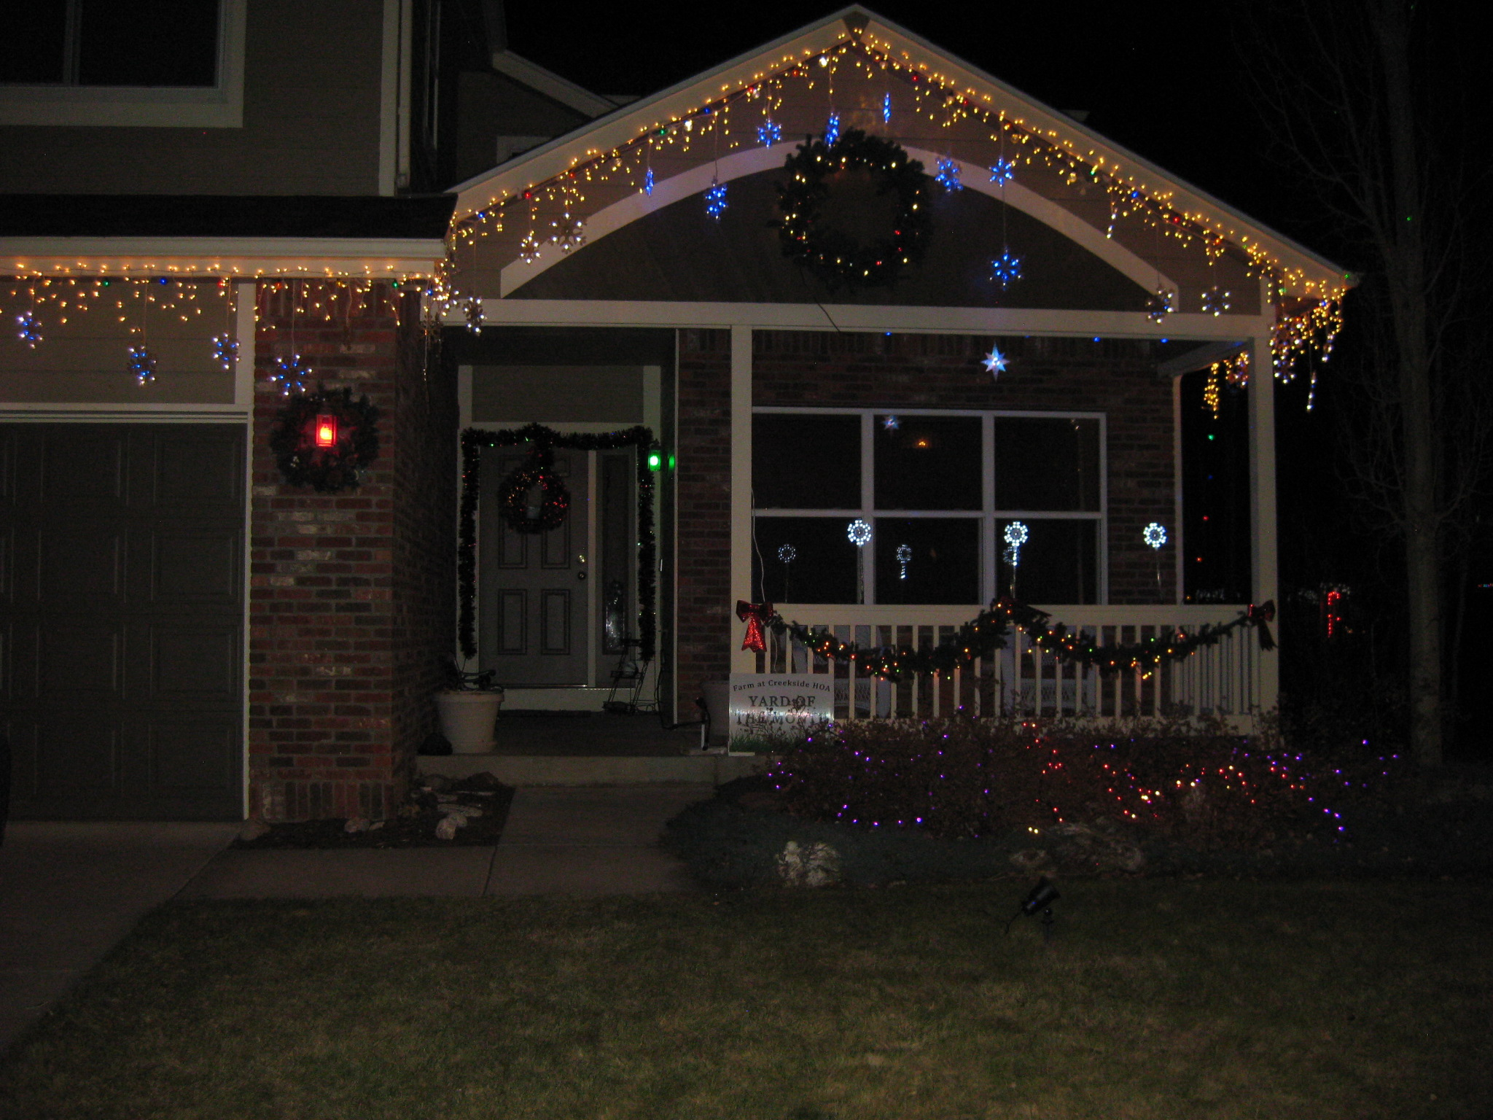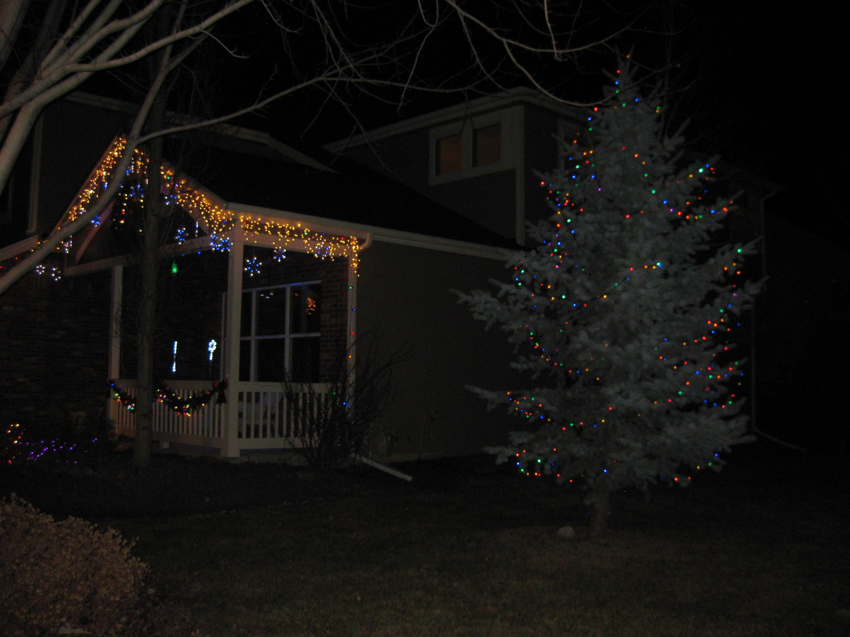

**Upcoming Vacant Board Positions**

The board is currently planning on holding the next annual meeting around the March timeframe, as we have in the past. There will be 2 vacant positions. The terms for Vann, our current treasurer, and Adam, our current president, are expiring and we will need to find 2 additional board members to replacement them on the board. New members will not immediately take over those positions, the board will vote on new positions after the annual meeting. Email [hoa@fachoa.org](mailto:hoa@fachoa.org) if you are interested in learning anything more or pay attention to the newsletter for more information about the annual meeting.