Mars UP Church

Apostles’ Creed
I believe in God the Father Almighty, Maker of heaven and earth; and in Jesus Christ His only Son our Lord; who was conceived by the Holy Ghost, born of the Virgin Mary, suffered under Pontius Pilate, was crucified, dead and buried; He descended into hell; the third day He rose again from the dead; He ascended into heaven, and sitteth on the right hand of God the Father Almighty; from thence He shall come to judge the quick and the dead. I believe in the Holy Ghost, the holy catholic church; the communion of saints; the forgiveness of sins; the resurrection of the body; and the life everlasting. Amen.

Gloria Patri
Glory be to the Father, and to the Son, and to the Holy Ghost. As it was in the beginning, is now and ever shall be,
world without end.
Amen. Amen.

Come Holy Spirit, Come
Before the Service – Speak to God!
During the Service – Let God speak to you!
After the Service – Speak to each other!

(*Please stand, if able)
Welcome and Mars Messages

Prelude

Call to Worship adapted from Psalm 103
Leader: Bless the LORD, O my soul, and all that is within
me, bless his holy name.
People: Bless the LORD, O my soul, and do not forget all
His benefits

Leader: who forgives all your iniquity, who heals all your
diseases, who heals all your diseases, who redeems
your life from the Pit, who crowns you with
steadfast love and mercy.

People: The LORD works vindication and justice for all
who are oppressed.

Leader: The LORD is merciful and gracious, slow to anger
and abounding in steadfast love.

People: He will not always accuse, nor will he keep his
anger forever.

Leader: He does not deal with us according to our sins, nor
repay us according to our iniquities.

People: For as the heavens are high above earth, so
great is his steadfast love toward those who
fear him;

Leader: as far as the east is from the west, so far he
removes our transgressions from us.

People: As a father has compassion for his children,
So the LORD has compassion for those who
fear him.

Opening Prayer

*Hymn 3
“Holy, Holy, Holy, Lord God Almighty”

Scripture Matthew 18:21-35

Children’s Chat
The
Lord’s Prayer

Our Father,
who art in heaven,

hallowed be Thy
name,

Thy kingdom come,
Thy will be done,
on earth
as it is in heaven.

Give us this day
our daily bread;

and forgive us
our debts,
as we forgive
our debtors;

and lead us not
into temptation,
but deliver us
from evil.

For Thine
is the kingdom,
and the power,
and the glory,
forever. Amen.

The Doxology

Praise God
from whom
all blessings flow;
praise Him
all creatures
here below;
praise Him above,
ye heavenly host;
praise Father, Son,
and Holy Ghost.
Amen.

*Hymn (You Tube Video)
“Big House”

Morning Message Rev. Brian Hauser
“The Patience of Forgiveness”

Prayers of the People and Lord’s Prayer

Offering
Offertory

Doxology

Affirmation of Faith Apostles Creed

* Hymn 327
“The Old Rugged Cross”

*Benediction

*Postlude

Church Staff
Rev. Brian Hauser
Pastor
pastor@mars-up.org
724-689-3412

Mrs. Shelly Bocheff
Administrative Assistant
marsup@mars-up.org

AV TEAM
Alma Staskiewicz, Lisa Barbour, Marie Matthews, Bill Guesman, John Ivory, Mike Bocheff, Herb Wellman

Mars United Presbyterian Church

232 Crowe Ave
PO Box 805
Mars, Pennsylvania 16046
724-625-1365
www.mars-up.org
marsup@mars-up.org

Church Office Hours:
Mon -Thurs from 9 a.m. -2:30 p.m.

On Saturday, September 23rd at 7:00 pm. The Cranberry Men’s Chorus will present a concert of accapella music from the 1950’s – 80’s at the North Catholic High School on Route 228. They will also be joined by the Fabulous Gemtones band. If you’d like to attend, you can get tickets from Paul Aiello. His email address is chapaiello@aol.com. Tickets are $20 for adults and $15 for students age 18 and under. Its going to be a wonderful evening of oldies music that you’ll definitely recognize.

Morning Worship:
10:00 am

16th Sunday after Pentecost

Prayer of Preparation
Lord, we come to you today with so many things on our hearts.

You call us to be in relationship of trust and love with you and you offer healing to us for those portions of our lives that are broken and injured.

Help us to be open to your mercy and healing love. For we ask this in Jesus’ Name.
AMEN.

Mars United Presbyterian Church
Welcome!

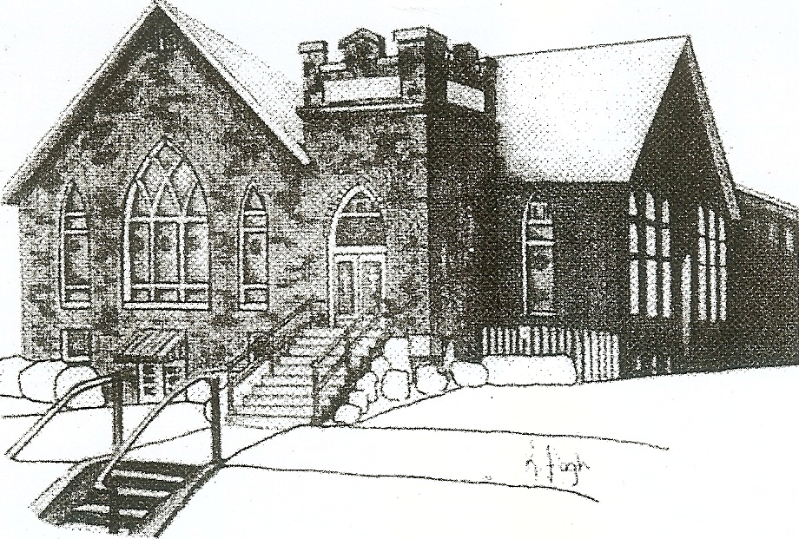
We are your hometown church: Faithful to Tradition, Loving in Fellowship, & Reaching for Tomorrow!

September 17, 2023

We welcome you and we are glad you’ve chosen to Worship with us today!

CALENDAR: September 17th – September 24th

Church Office Hours: Monday -Thursday from 9 a.m. – 2:30 p.m.

Today, September 17, 2023
VOLUNTEERS☺

LAST SUNDAY’S In-House ATTENDANCE: 39

LAST SUNDAY’S OFFERING:
Operating Funds: $2350.00
Kindness: $100.00
Mission: $10.00
Bldg. Improv. $10.00
Parking Lot: $3050.00
Total: $5520.00

Tarry N Talk Hosts
Stewardship Committee
9:00 am Sunday School Hour
10:00 a.m. THE MORNING WORSHIP SERVICE
11:15 am 80+ Luncheon
Monday, September 18, 2023
6:30 pm Griefshare Begins
Tuesday, September 19, 2023
9:00 am Ateam
7:00 pm AA Meeting
Wednesday, September 20, 2023
9:00 am Material Girls
9:00 am MOPS
Thursday, September 21, 2023
7:00 pm Session Meeting
Friday, September 22, 2023
Saturday, September 23, 2023
7:00 pm Cranberry Men’s Chorus Concert
Sunday, September 24, 2023
9:00 am Sunday School Hour
10:00 am THE MORNING WORSHIP SERVICE

Welcome to all who are Worshiping with us today!

Guests
We sincerely hope our service is a blessing to you. We ask that our guests please take a few minutes to complete one of the Connect Cards found in the pew holder.

Should you have questions regarding any aspect of our church, including membership, please contact Pastor Brian or the church office during the week at 724-625-1365. Thank you for being with us today.

PRAYER – JOYS & CONCERNS
Lou Beckwith Paige Lauten
Paige Barbour (daughter of Andrew and Steph Barbour) Sandy Wahl
Reid Christopher Hall (June Stirling’s nephew)
Lindy McCartney (Lisa Barbour’s Sister)

ANNOUNCEMENTS
Bulletins are printed Thursday mornings; let us know if you have an announcement…

VOLUNTEERS NEEDED Beginning TODAY/ Sunday Sept. 17th nursery care (kids through kindergarten) will be available for the entire Church hour if parents so desire. Children may also come down to the nursery after the Children’s Chat or remain in Church if parents prefer. The nursery will be staffed by an adult and a teenage helper. Rev. Brian will be putting out a sign-up genius for adult volunteers to sign up. Please support this effort and volunteer!

GRIEFSHARE FALL MEETINGS The Fall/Winter Session of Griefshare will start again. Meetings will be held on Monday evening in the Board Room of the Church. The fall session will start on September 18th at 6:30 For more information, please contact Denise @ ddemarco5@yahoo.com

APPLEFEST will again be held in Mars on the 1st Saturday of October, this year it is October 7th . This is an important event in our community and has always been an exciting opportunity for MUP to be involved in. Christian Education/Mission and Outreach is the committee tasked with spearheading the effort, but many, MANY hands are needed for this effort to be a success! Applefest is officially from 10:00 am to 4 pm on Saturday, October 7th, but we need people to help with set up and clean up as well as help during the actual Applefest hours. This year we will once again share out booth with My School Preschool volunteers. They will have a craft for children. We will be making a new treat “walking apple pies” and the ever-popular pixie stix.
QUIET HOUR DEVOTIONALS The Fall edition of the Quiet Hour is available in Tarry N Talk for your daily devotion. Please feel free to take one.
YOUTH GROUP will begin on Sunday, October 8th at Mars UP Church. Youth Group will meet every other Sunday from 1:00pm to 2:30pm. Mars UP Church will be working together with St. John Lutheran Church to bring Youth Group to all youth in the community. For further info, please contact Pastor Brian or the office.

