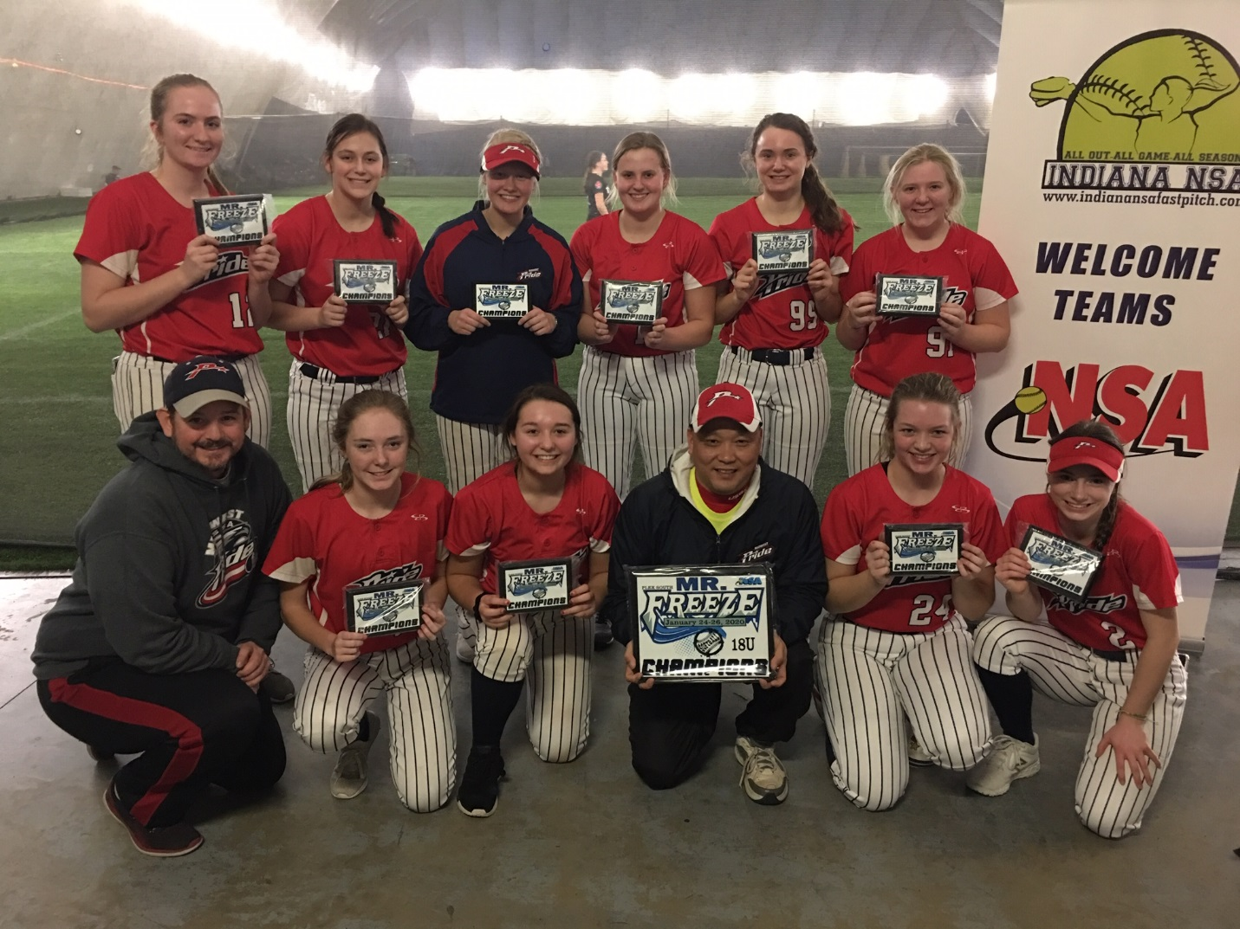
18u Champions Midwest USSSA Pride

