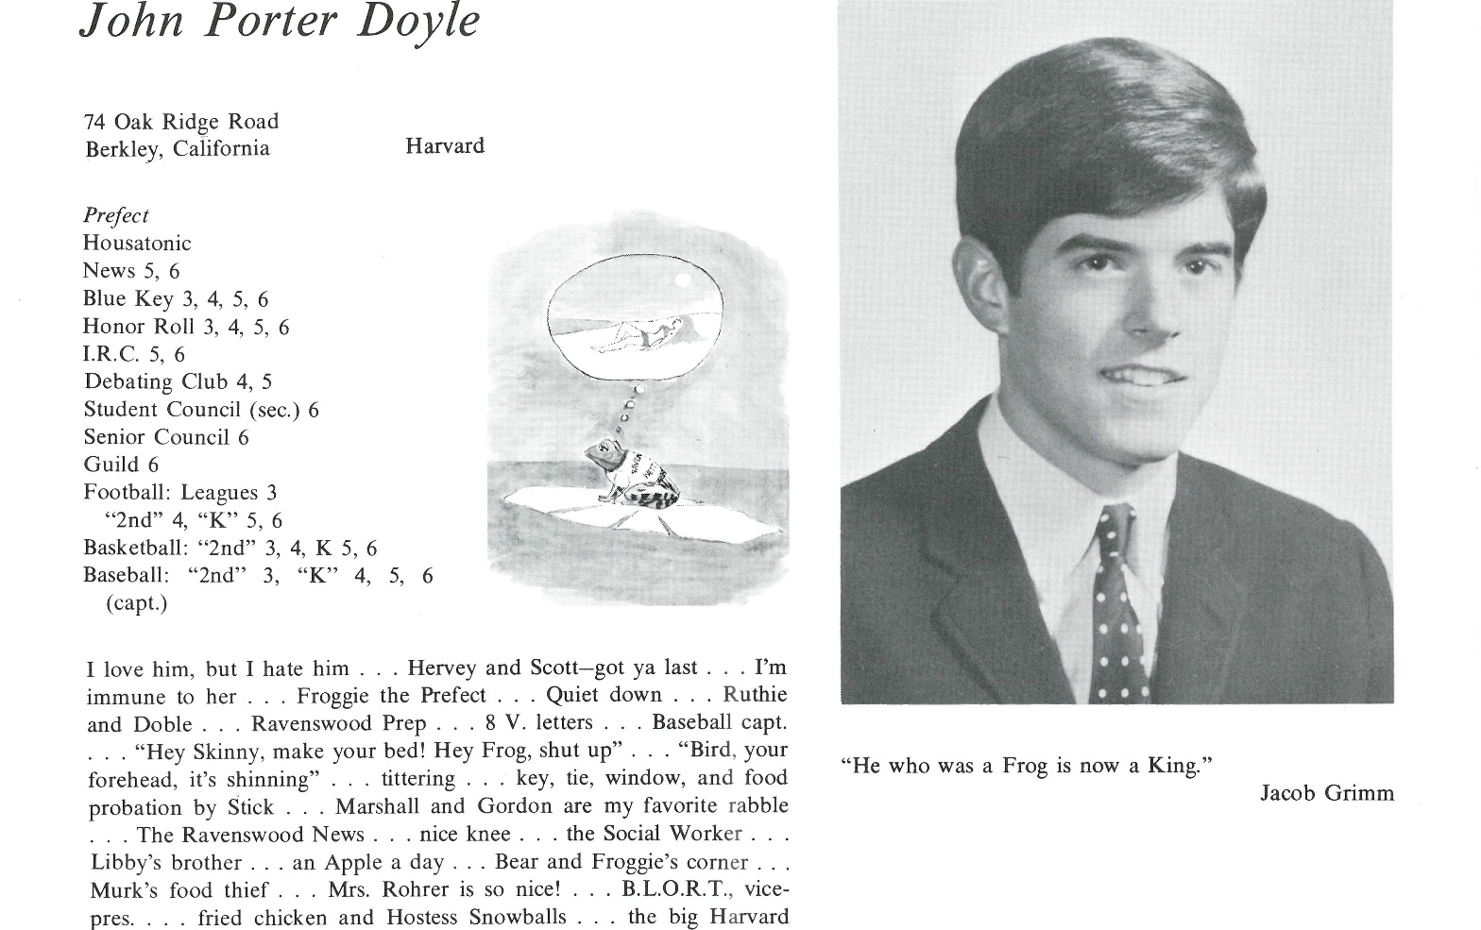

Judge John P. Doyle

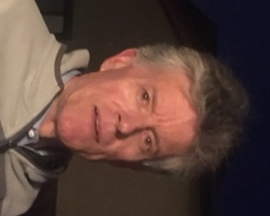The salient update begins with my marriage to Carol Chase (UCLA ’75, UCLA Law School ’78 ) in 1984, and the births of our three children: Warren in 1986 ( Pomona College ’08, Marshall University School of Medicine ’15, currently a Resident Physician in Emergency Medicine at the Penn State Medical Center in Hershey, Pa., to be married in November to his med school classmate, Sara Lilly, now a Resident Physician at Penn State in Pediatrics); Meredith in 1988 (Claremont McKenna College ’11, Pepperdine Law School ’14, now an attorney at a plaintiffs’ antitrust law firm in San Francisco); and Harrison in 1991 (Claremont McKenna College ’13, now a Financial Analyst at Procore, a so-called cloud-based developer.

I have been a Superior Court Judge (state court) in Los Angeles since 1996, and I am now working in a Civil Department at the Central Courthouse (Mosk Courthouse) in downtown Los Angeles. I have loved my work and have no immediate plans to retire.

Carol and I “downsized” in 2014 to a townhouse a few paces from the beach in Oxnard, CA. We love living there, beach walking, taking excursions north on the Central Coast of CA to places like Ojai, Carpinteria, Santa Barbara, the Santa Ynez Valley (wine-tasting!), and San Simeon. We have tried to travel more, and enjoyed a great trip to Scandanavia last year, and are looking forward to a trip to Peru and Ecuador in July this year, including Machu Picchu and the Galapagos Islands.

We have had the good fortune to take about a dozen trips to London over the years where Carol and I have taught at the Pepperdine Law School London Program on many of those occasions. All family members are enthusiastic supporters of the Fulham Football Club, to which we were introduced in 1993 when--between jobs for me--our whole family lived  in a flat on the top floor of Pepperdine University’s beautiful Georgian Row House in South Kensington literally just a couple of buildings away from the Victoria and Albert Museum on Exhibition Road.

When I think about Kent School, I am so grateful for the opportunity—on a sliding-scale scholarship—that I had to be there for those four years, 1963-1967. While no place is poetic in all respects, of course, and while  I certainly “stumbled  my fair share” during those growing-up years ( which I think were perhaps above-average difficult years overall, what with—for example-- the Age of Aquarius  delivering all sorts of new cultural challenges for young people ), my overwhelming feeling at this point is that there is simply no place on earth quite like Kent School, and I mean that in an entirely positive way, “bumps in the road” aside. Kent was a great gift for me and my sister, Libby.



______________________________________________________________

______________________________________________________________ ______________________________________________________________ ______________________________________________________________ ______________________________________________________________ ______________________________________________________________ ______________________________________________________________ ______________________________________________________________ ______________________________________________________________

Attach Picture in .jpg Format

______________________________________________________________

______________________________________________________________

___________________________________________________________________________________ _________________________________________________________________________________________________________________________________________________________________________________________________________________________________________________________________________________________________________________________________________________________________________________________________________________________________________________________________________________________________________________________________________________________________________________________________________________________________________________________________________________________________________________________________________________________________________________________________________________________________________________________________________________________________________________________________________________________________________________________________________________________________________________________________________________________________________________________________________________________________________________________________________________________________________________________________________________________________________________________________________________________________________________________________________________________________________________________________________________________________________________________________________________________________________________________________________________________________________