Messy Church is a fresh way of experiencing church.
It’s about creating, worshipping and sharing together. It’s also:
- For all ages
- Fun and interactive
- Family friendly

Find out more at www.messychurch.org.uk

Looking for a family friendly way to start the Easter season? Look no further…
Come and experience Messy Church at St Mary’s.

Our next event is an Easter celebration. This includes:
- Craft activities
- Lunch for all the family
- Coffee and Sunday papers for the adults
- A short and interactive reflection
- Music and a sing-a-long
- Goodies to take home

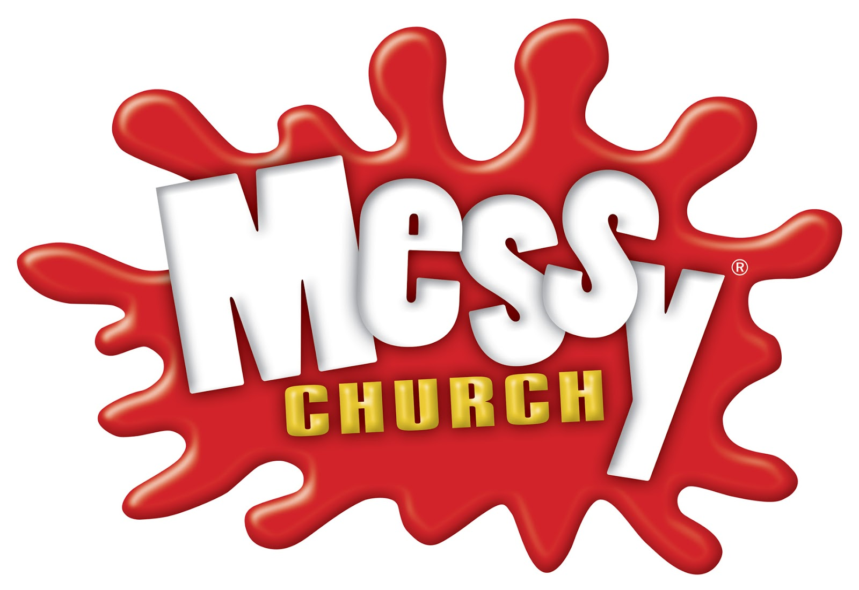
Easter

St Mary’s Messy Church is fun for the whole family!

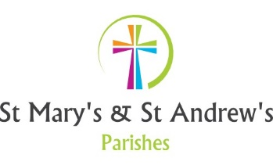

Easter Messy Church details are as follows:

Sunday 14th April 2019

10am – 12 noon

At St Mary’s Church, Alveley

No charge for events and no need to book. However, if you have a particular dietary need, let us know you’re coming so we can cater effectively for you.
For enquiries, please email: stmary01church@outlook.com

Watch out for details on all of our Messy Church events on:

www.alveleyandquattparishes.co.uk

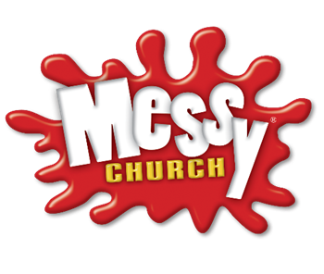

Sunday 14th April.

10am – 12 noon

St Mary’s Church, Alveley.

