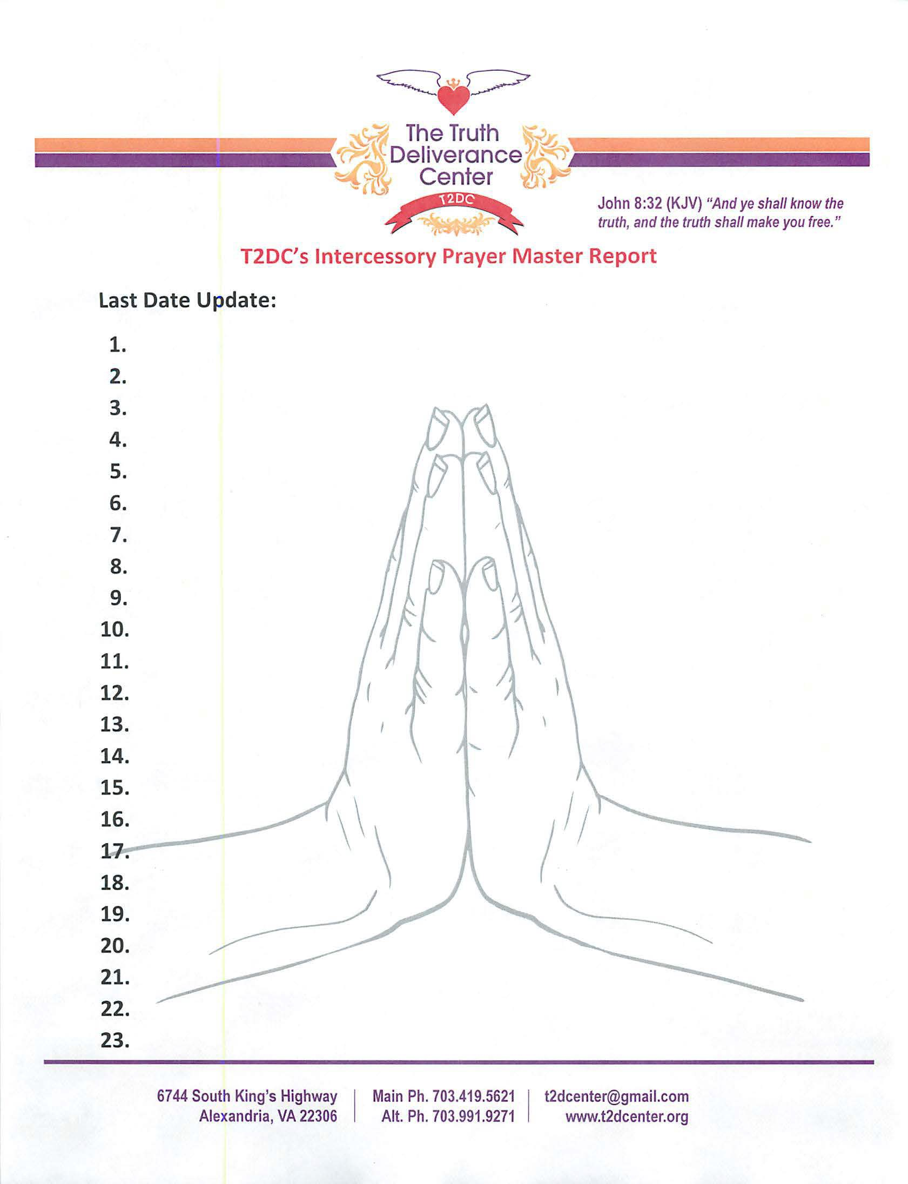

01/08/2019

T2DC's Global Sons and Daughters come from the four corners of the earth. T2DC's Regional Sons and Daughters in the National Capitol Region flow in to T2DC
Elder Diane-health/restful sleep/

Elder Diane/Salvation for Rayvaughn McKinney

Elder Diane- Minnie Burton needs a job/pray for God Mom Louise is not feeling well/Pam Caregiver
Melanie - promotion/house/husband/dissertation proposal/supernatural debt cancellation /Jerry H. Cancer
Melanie- Grandma’s friend with breast cancer
Pastor Oliver- membership/people take their positions/praying for people to come/Godly men
Roslyn- aunt in New York with family issues/guidance for David and Davia/family relationships with mother
All- Against division in households

Michael - surgery on 10 Jan 19 for nerve damage and finances and Godly relationship

Vivian- work situation/ prayer for grandchildren and son in law
Verlena - health and finances
Anita's- health and finance

Verlena - restore garnished finances

Pray for Tia and Kaylaah not feeling well, praying for school for Kayla
Roslyn- comfort Portia husband and brother passed away
Apartment for Tia & Kaylaa, God to release finances that belong to them
Pastor Oliver -contract job with increase/meet husband
Pastor Oliver -church grows multiculturally/god floods gate with godly men to our church

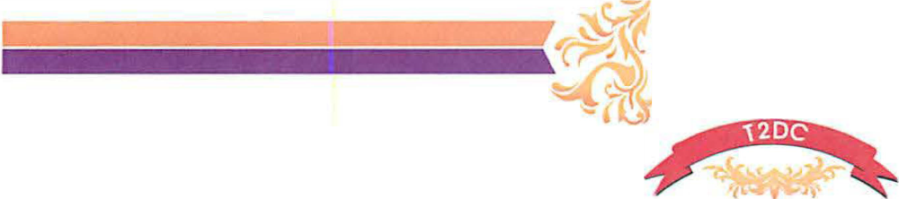
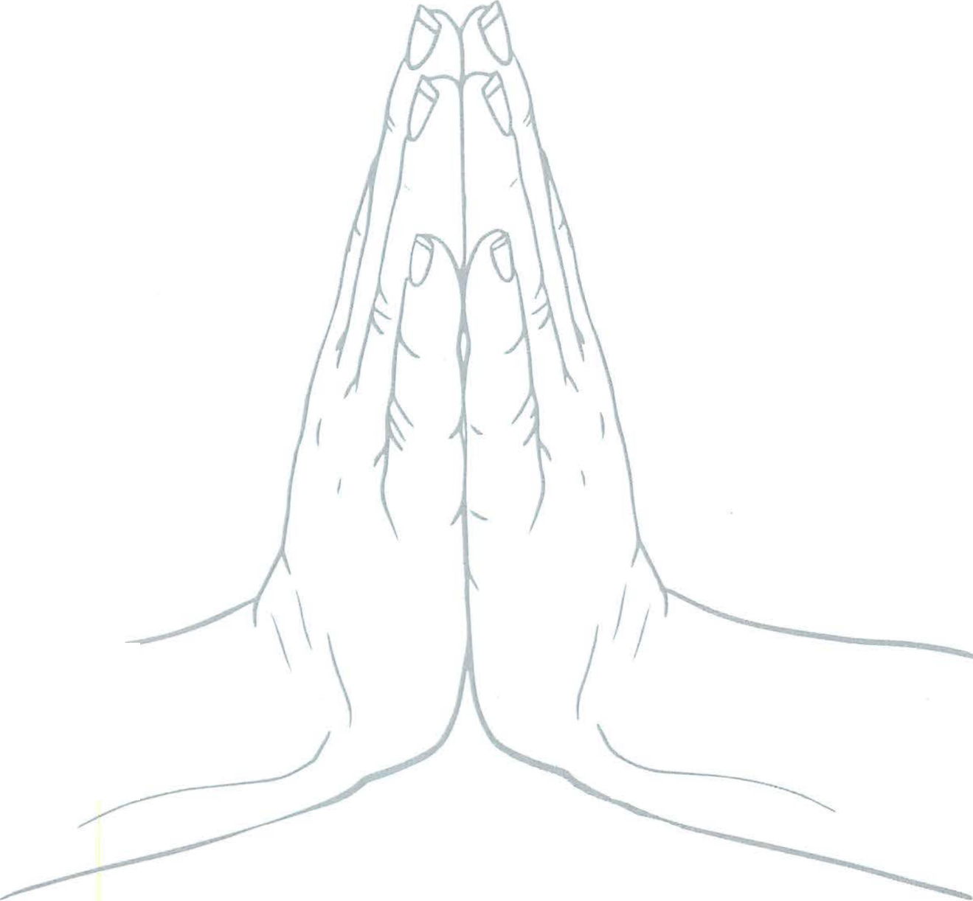

The Truth � -----------
<:.:<p
Deliverance .. Center �.-
John 8:32 (KJV) "And ye shall know the truth, and the truth shall make you free."

- Toi for pain to go away / her mother Tonia
- Pastor Oliver - balance everything/husband/get manual done/remember zoom
- Kaylaah - pray for mommy, grandma, daddy, pops
- Pray for Jordan's strength as result of the loss of both parents
- Pray for Denise D's tongue and to stop cursing
- Continue to pray for salvation for Sharon E and Denise D
- Keisha surgery to remove fibroid tumors
- Pray for those who lost jobs because of gov shutdown
- Remember Lynette and her strength
- Bruce who overdosed in jail
- T2DC's membership increase by 15 members monthly-100% tithers
- All T2DC's military members from all bases in VA, MD, & DC to come now to T2DC
- Dominus and ageusia power fall fresh on T2DC and everyone connected to it
- Pam and Maurice conceive their baby
- Increase in Pam and Maurice’s real estate business/Kimberly healing from thyroid surgery
- Gabriel healing of the left eye stigma
- Tiffany’s transition into civilian life.
- Supernatural growth for T2DC’s membership and partnership
- Roslyn- understand and separate God’s will for me vice what I desire
- Pastor Oliver – T2DC grows corporately in love for one another
- Garris – Blue diamond – healing and direction

6744 South King's Highway Alexandria, VA 22306

Main Ph. 703.419.5621 t2dcenter@gmail.com Alt. Ph. 703.991.9271 www.t2dcenter.org

