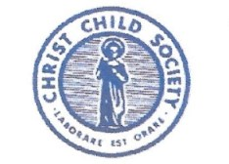
MEMBERSHIP RENEWAL FORM

Membership Renewal for July 1, 2026-June 30, 2027
Please pay dues by July 15 to be in the Membership Directory
Asterisked * items are required
*Full Name

*Street Address

*City, State, Zip

Phone, Home

*Phone, Cell

Email Address

Home Parish

Parish Family

Husband’s Name

Please select status and make your check to Christ Child Society of Dayton, Inc.
Send this form and payment to Martha Pascale, 705 Yankee St., Centerville, OH 45458
CCS Status | CCS Dues | Dues  Paid
Active: Active members are encouraged to volunteer at least 30 hours $50

Provisional: In the process of becoming active; Required 30 service hrs per year $50

Supporting: Members may volunteer but it is not required; they want to support our work $70

Patron: Members who want to see the work of CCS spread further $90

Life Active: This membership only exists for those who were granted it several years ago $40

Optional: Help defray all or part of the National Dues of $40 and electronic transfer fees
(extra donations are appreciated)
Total Dues Paid

Scholarships are available to pay dues, if needed and always confidential.
Contact Martha Pascale for more information.

