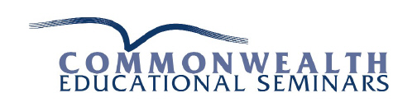

Post-test:
Substance Abuse Treatment:
Addressing the Specific Needs of Women Post-test
1. Rather than primarily comparing women with men, the knowledge, models, and strategies presented are grounded in women’s experiences and their unique biopsychosocial and cultural needs.
True False
2. Women with substance use disorders have unique biopsychosocial needs that should be addressed if their treatment is to be successful.
True False
3. Women do not become intoxicated after drinking smaller quantities of alcohol than men.
True False
4. Women who are abusing or are dependent on alcohol or other drugs may not realize they are pregnant.
True False
5. For many women, including those with substance use disorders, use of alcohol, tobacco, and/or illicit drugs significantly decreases after becoming aware of their pregnancy.

True False

6. Alcohol problems are ordinary events among the elderly, and estimates of the prevalence of heavy drinking or alcohol abuse range from 2 to 20 percent for this population.

True False

7. Women are socialized to assume more caregiver roles and to focus attention on others.
True False
8. Few residential programs allow mothers to have their children with them, and outpatient programs often do not provide services for children or child care.

True False

9. Although alcohol is still the primary substance of abuse, women are less likely than men to be in treatment for drug use.
True False
10. Use elements of African American heritage or adopt an Afrocentric perspective to provide a more culturally responsive treatment program.
True False
11. For Native American women, you should take time to invest in the individual female client’s Native community and learn its perceptions toward non-Native counselors.

True False

12. For women in rural areas, you should develop partnerships among other local agencies and neighboring communities to share resources to aid in the delivery of services in remote areas.

True False

To take this test, please visit our site at
www. Commonwealthseminars.com
Click on Home Study, then Home Study Articles. Find the Title of this program and click on Purchase Test.
Commonwealth Educational Seminars
1020 West Barnstable Rd
Marstons Mills, MA 02648
800 376-3345
commonwealthseminars@gmail.com

