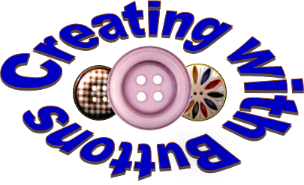
Introducing Button Craft Workshops and Tutorials

Introducing Button Craft Workshops & Tutorials throughout the year for National Button Society members only! The National Button Society is providing four button craft workshops and eight tutorials in response to its members’ increased interest in using their uncollectible buttons in artistic ways. This collection of “No-Harm” button crafts supports the National Button Society’s mission to preserve all that is beautiful and historic in buttons. See what’s new this month through the link below:
http://www.nationalbuttonsociety.org/resources.html

NEWS FLASH!
National Button Society Button Craft Tutorials
The first three of the button craft tutorials are available to all button lovers at:
Threaded Button Necklace:
https://youtu.be/l8mc6XVO_co

Framed Button Bouquet:
https://youtu.be/4yth5AQMi24

Button Lampshade:
https://www.youtube.com/abfabf26-602b-4fd7-8539-fc021a80fc30

Susan Weinrebe, NBS Creating with Buttons Committee
Please help spread the word. Share in your Zoom meetings, social media, among friends & family, among your craft connections, quilting guilds, kinit shops, youth clubs, etc.
Another great benefit of joining the National Button Society!
www.nationalbuttonsociety.org
Click on Membership to join

