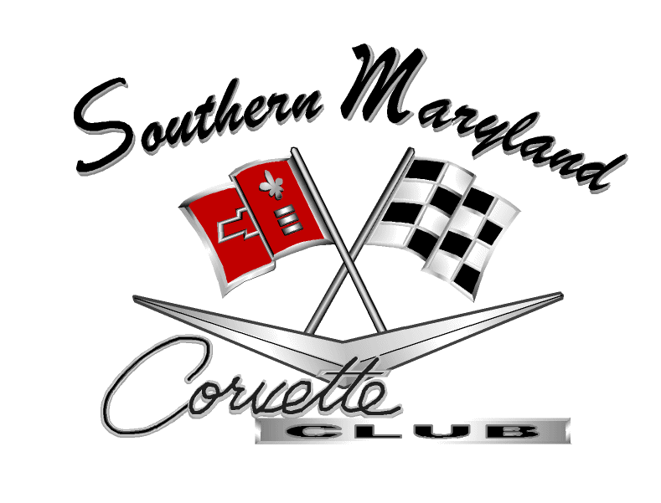

Meeting Minutes

Southern Maryland Corvette Club

February 13, 2012 Meeting Minutes

- Attendees: Seventeen (17): Ben and Susie Mendoza, Rick Davis, Vince Merz, Donnie Bateman, Dennis Lyons, Leila and David Grimsley, Patrice Hopkins, Mike Doncevic, Charles Wheeler, Sam Lupi, Ray and Linda Smith, Don Byrne, Matt Ayre, and Tom Santangelo were noted on the sign-in sheet.
Guest: There was one (1), Jim Jacobs, who became a member at that evening. Welcome Jim.

- Where/When: Meeting held at the Leonardtown Commissioners' Office on Monday February 13, 2012 and called to order at 7:00 PM by Club President Ben Mendoza.

- Welcome membership: Members and guests were welcomed by President, Ben Mendoza.

- Birthdays: President Ben Mendoza recognized birthdays, in the late arrival of our secretary.

Happy Birthday to Charles Nicholson (2/8), Anna Dailey (2/11), Leila Grimsley (2/16), Vince Merz (2/18), and Ray Smith (2/28)

- Treasurer’s ((Patrice Hopkins) Report as of February 13, 2012:

- Balance in the checking Account as of January 9, 2012: $ 9,101.59
- Expenditures: Refund to Vince Morelli (Website Services) $ 156.00
- Deposits: January 9, 2012 Membership dues $ 50.00
- Total balance on hand, this date $ 8,995.59
- Funds available for general use when accounting the Reserved Funds below: $ 6,945.59

Reserved Funds:

- Scholarship Fund $ 1,000.00
- St. Jude Children’s Hospital $ 250.00
- Hospice of St.Mary’s $ 250.00
- Wounded Warrior $ 250.00
- Fundraisers $ 300.00
$ 2,050.00

- Motion for approval January, 2012 SMCC Treasurer’s Report: A motion was made and seconded. The club approved the February 13, 2012 report by voice vote.

- Committee Chair Reports (Note: Minutes reflect only those Committee Chairs that needed to report)

        - Membership Chair (Vince Merz): Mr. Merz reported 46 active members, fourteen (14) have not rejoined. We need to update our birthday lists, sign-in sheet and distribution list. President Ben Mendoza noted that through out conversations with previous members, they all wished to receive our e-mail to keep up with the club’s news.

        - Activities Chair (Mike Donovich): Mr. Donovich acknowledged the following events and reminded club members to drive their Corvettes to the events:

- Thanked all who attended the Valentine Day Cruise and Brunch on February 12.
- Cheeseburger in Paradise Sunday Cruisin’, every Sunday afternoon cruise time is 5:00PM.
- 25th Annual Coming Out Car & Bike Show, April 15th 8:30 AM - 3:00 PM , Southern Knights Rod and Custom
- Spring Fling XXVII Car Show on the Leonardtown Square, Sunday April 29th.
- Corvette of Carlisle, August 24 – 26. If any would like to cruse up to PA, let me know.
- The Mid America Corvette Fun Fest. September 13 -16, in Illinois
- President Ben Mendoza added the comment if anyone would like to see or go to somewhere new, contact him or Mike.

        - Web Site (Scott Bear) – There is 40 to 50 updates with current pictures that yet to be completed. It was recommended having an event calendar that will allow us to link to the flyer or additional information. President Ben Mendoza noted that Matt is a recent retiree and is presently looking for employment. As a result, our web site as been on the back burner. He plans to meet with Matt to help in any way he can. He has also contacted Dave Grimsley to assist him.

        - Merchandise - Upon speaking further with Scott Bear, President Ben Mendoza said that Scott’s wife, Angela has volunteered to take over this chair. She plans to join SMCC before taking over the chair. Ben will be happy to turn over everything he has in stock.

        - Scholarship (Charles Wheeler) - Mr. Wheeler reported the cruise to the “ 54 Museum” was a great event. He made the initial step and went to the Technical Center. As the representative of our club, I explained the Scholarship process and answered questions from approximately 35 students. Most just dropped by and picked up our information. There were other organizations represented that day; however, we were the only social club. I went over to Winegardner Chevrolet to see if they could match our $1000 scholarship so we can award to tool chests. I have not heard back from them as of yet. We had 20 applications last year and gave away one, so it would be great if they would match our funds.

- Secretary’s ( Leila Grimsley) Report as of January 09, 2012:

Read and reviewed meeting minutes. The secretary apologized for not only being late but not getting the January minutes distributed in a timely fashion. Key points as follows:

- Twenty-two (22) was noted on sign-in sheet.
- Vice-President, Rick Davis presided over the meeting, which started at 7:00 PM and ended at 7:25.
- The Treasurer’s Report in the minutes quoted having a balance of $ 9,159.51. This was without the benefit of the current report. The Treasurer corrected the figure should have been $ 9,101.59.
- Rick Davis explained the purpose of our State Farm Insurance policy.
- Ken Dixon became a new sponsor.

- Motion for approval January 9, 2012 SMCC Meeting Minutes: The club voted and approved the minutes with a motion made by Denise Lyons and seconded Charles Wheeler.

- Old Business:
- No old business at this time

- New Business:5

- A copy of the original By-Laws dated 12 November 2001 and Revision (H), dated 12 March 2012 was disseminated. We would like everyone to take some time to review the proposed changes. Five articles are going to be revised concern:

- Dues and Duties of a member
- Board of Directors members and meetings
- Election Procedures
- Meetings
- Revenue

Questions and comments are welcome. The Board will continue to review aand make any changes necessary, during our board meetings. A possible revision of the By-Laws may develop based on the membership comments. Final revision for voting will follow 30 days thereafter.

- We need to decide when we should proceed with sending the charity donations.

- We should also decide if we are going to conduct any fundraisers for this fiscal year. If we do decide to have any fundraisers, should we reserve funds for it?

- Our President plans to develop a spreadsheet to set into motion plans for monthly get together events, as well as volunteering to bring snacks to our monthly meetings. The club has talked before about wanting to get together socially on a monthly basis whether it be going to someone’s home or going out to a restaurant. Our club is about corvettes and camaraderie.

- The Technical Center wants our club to bring back our mini car shows in the spring and fall. We used to drive our corvettes into the auto bays and set them up for display. We also provided a lot of corvette information, answered questions, allowed the students to sit behind the wheel and for excitement, revved our engines! The students loved it. We plan to coordinate with the school as soon as possible.

- Tom Santangelo provided us his excellent detailed brief from the Corvette News. The C6 Registry announced that there would be two models for the 2013-year, the collector addition and the 60th anniversary addition. Go to www.C6registry.com for more information. This will be the last year for the C-6; C-7’s will be coming out in 2014.

- Other Items:

- Doris Bateman’s mother passed away last month. Patrice, thank you for sending condolence card.

- Leila Grimsley volunteered to bring the refreshments for next months meeting.

- Next SMCC Meeting: The next meeting will be on Monday March 12, 2012 at 7:00 PM, in the Leonardtown Commissioners' Office, 41660 Courthouse Drive, Leonardtown, MD 20650.

- Motion to Adjourn: Motion was made to adjourn, seconded and passed by a voice vote. The meeting ended at 8:15 PM.

Minutes Recorded by: Leila Grimsley, Secretary
Southern Maryland Corvette Club, February 13, 2012

