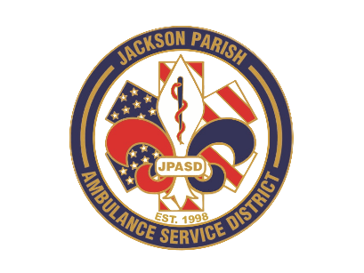
Aaron K. Johnson, Jr - EMS Director

Paula Parkerson, MD - Medical Director

Governing Board
Allen Lindsay, Conchita Doyle, Joe Vail, Alma Williams, Deidre Hollis
Jackson Parish Ambulance Service District
115 Watts Street
Jonesboro, LA 71251
Office: (318) 259-2877
Fax: (318) 259-2099

jacksonparishambulance@jpasd.com

Meeting Minutes for Regular Scheduled Board Meeting: Thursday, September 11, 2025@ 12:00 noon

MEETING CANCELLED

Next Regular Board Meeting will be held:
Thursday, October 9, 2025 @ 12:00 noon Aaron Johnson /Secretary-Treasurer
@ JPASD – 115 Watts Street – Jonesboro, LA Unofficial Minutes

