 Triple T Sports Center 
Summer Sports Day Camp
2017 Registration
H= Half Day; F=Full Day
 | SB | WK 1 | WK 2 | WK 3 | WK 4 | WK 5 | WK 6 | WK 7 | WK 8 | WK 9 | WK 10 | WK 11
CAMP WEEKS | APRIL 10-14 | June 19-24 | June  26-30 | July 3-7 | July 10-14 | July 17-21 | July 24-28 | July 31- Aug 4 | Aug 7-11 | Aug 14-18 | Aug 21-25 | Aug 28 - Sep 1
Mon | H | H | H | H | H | H | H | H | H | H | H | H
 | F | F | F | F | F | F | F | F | F | F | F | F
Tues | H | H | H | X | H | H | H | H | H | H | H | H
 | F | F | F | X | F | F | F | F | F | F | F | F
Wed | H | H | H | H | H | H | H | H | H | H | H | H
 | F | F | F | F | F | F | F | F | F | F | F | F
Thrs | H | H | H | H | H | H | H | H | H | H | H | H
 | F | F | F | F | F | F | F | F | F | F | F | F
Fri | H | H | H | H | H | H | H | H | H | H | H | H
 | F | F | F | F | F | F | F | F | F | F | F | F
Triple T Sports Center Summer Sports Day Camp Open To Ages 4-12
*Full Day Camp Hours 6:00am-6:00pm / Half Day Camp Hours 6:00am – 1:00pm
*Late fee will be charged if campers are not picked up on time, $10, and $5 each additional 15 mins.
*Half Day Campers Bring 1 Snack & Lunch / Full Day Campers Brings 2 Snacks & Lunch

I hereby authorize the staff of Triple T Sports Center to act for me according to their best judgment in any emergency requiring medical attention and hereby waive & release owners, agents, volunteers, and staff of Triple T Sports Center from any and all liability for any injuries or illnesses incurred while at camp. I understand that participation in gymnastics and other sports/activities involves motion and as such carries with it the risk of injury or death. Triple T and camp staff are not responsible for personal items that are lost, stolen or damaged. All medical expenses as a result of injury or illness during all camp activities are the responsibility of the parent or guardian of registered camper. In lieu of medical certificate signed by a medical doctor, I have no knowledge of any physical or mental impairment that would be affected by the named camper’s participation in the camp program. I also understand and agree that camp retains the right to use any photographs, videotapes, motion picture recordings, or any other record of this event for publicity, advertising or any legitimate purpose.
________________________________ _______________
Signature Date

Child’s Name______________________________________ M/F Age___________ DOB_________________
Medical Conditions/Allergies __________________________________________________________________________

Parent’s Name ______________________________________________________________________________________
Home Phone (_____) _______-________ Cell Phone (_____) ______-________Work Phone (_____) ______-_________
EMAIL: ___________________________________________________________________________________________
Camp Registration Fee and $25 Deposit (each week) Required at Registration-**No Refunds on Camp Registration or deposit**
I authorize my credit card to be charged for balances due for Triple T Summer Sports Day Camp the Wed before camp week.
______________________________________________ ____________________
Signature Date
*This is a legal document and must be signed by parent or legal guardian only. By signing above you are stating that you fulfill this requirement.

Registration ___$35 / $50 Non Member_____Deposit_($25 x number of weeks)_$__________ Amount Due at Reg $ ___________
Total Paid ____________ Form of Payment ___________ Date ____________ Rec’d by __________ Forms Complete ______
Shirt Size______ Extra Shirts $(15x # shirts) $_____ Tshirt(s) rec’d _____________

Required Forms: Birth Certificate ________ Shot Record _______ Most Recent Physical ________
Triple T Sports Center
Day Camp Medical Release Form
(All Information Very Important-Please Fill Out Completely)

Child’s Name
______________________________________ DOB ___________ Age __________

Medical Conditions / Restrictions / Allergies: _____________________________________________________________________
_____________________________________________________________________
Medications: __________________________________________________________
Special Instructions: _____________________________________________________________________
_____________________________________________________________________

Physician ___________________________________ Telephone # (_____) _______-_________
Dentist _____________________________________ Telephone # (_____) _______-_________

Primary Email: __________________________________________________________________

Father:_______________________________________________________________
Address ______________________________________________________________
City _____________________________________State__________ Zip___________
Home (____) ______-______ Cell (____) _____-______ Work (____) _____-______

Mother: ______________________________________________________________
Address (if different) ________________________________________________________
City _____________________________________State__________ Zip___________
Home (____) ______-______ Cell (____) _____-______ Work (____) _____-______

Code Word ______________________________________________________________
(This word is used to verify your authorization for them to pick up your child when you cannot. Persons other than parent will be required to produce driver’s license as identification)

Insurance (Copy of Insurance Card—Front and Back Required)
I certify that my child is up to date on all state required immunizations.
I am fully aware of and appreciate the risks of catastrophic injury, paralysis and even death, as well as damages and losses, associated with participation in gymnastics and other sports. I further agree that Triple T Sports Center, corporations, employees, agents, officers and directors shall not be liable for any losses or damages occurring as a result of camper’s participation in the “Summer Sports Day Camp”.

I hereby give consent for Triple T to provide customary medical/athletic attentions, transportation and emergency medical services as warranty in the course of my child’s participation at Triple T. I will maintain and uphold up-to-date primary medical health insurance during the entire camp enrollment at Triple T Sports Center.

_____________________________________________________ ______________________________
Parent/Legal Guardian Signature Date

Triple T Sports Center
Summer Sports Day Camp

Day Camp Registration Fee: $35 / $25 add’l children (includes camp t-shirt required for field trips, additional shirts may be purchased at registration if available for $15 each)
Non-Member Registration: $50.00 / $40.00 Additional Children
Day Camp Rates: 5 Day Full Day $125 / $150 Non-Member
3 Day Full Days $90.00 / $105.00 Non-Member
5 Day Half Day $90.00 / $105.00 Non-Member, $10 add’l fee for fieldtrips
10% Discount for each sibling

Cash, Check, Debit Cards, MasterCard, Visa, Discover Accepted
Camp Hours 6:00am – 6:00pm Half Day 6:00am – 1:00pm

Deposit: A $25 deposit is due upon registration to hold your child’s space in each camp week. This is applied to the total due for the week. Balances must be paid on the Wednesday before each week they are attending. Your credit card will be charged for the balance for the week on Wednesday after 6pm if payment has not been received. If payment is not able to be made your child will not be able to attend camp until payment is received. ***Full week will be charged unless 2 week written notice is given to release the spot.***

Licensed/Non Licensed Areas: I understand that there are licensed and non licensed areas of Triple T Sports Center. The licensed areas include the lobby, kitchen/party room, dance room, and back karate room. I give Triple T staff my permission to sign my child in and out of licensed and non-licensed areas during camp based on the activities they are participating in.

Campers will not be allowed to participate if tuition is not current.
Payment must be received by the Wednesday before your child’s camp for each week. A guaranteed form of payment in the form of a credit card for day camp is required. If payment is not received Wednesday by 6pm your child’s camp week will be charged to your credit card on file. Without valid Credit Card on file – camper cannot be dropped off without payment in full for the week, no later than Thursday. You will be responsible for payment of the time registered for.

Very Important: Signing your child IN and OUT of camp is very important. The child is not allowed to sign themselves in or out. Only the parent or authorized person is permitted to Sign in and Sign out. If an authorized person is picking up your child please note this on the sign in form and notify the front desk when you sign in. If a person is picking up that is not on the authorized persons list we will not release the child without written permission from the parent or correct code word is given.

Credit Card # ________- _______-________-_______Exp Date__________ (MC Visa Discover)

Authorized Signature _________________________________ ___________________________
Signature Print Name

I have read and understand the Triple T Camp policies and agree my credit card will be processed for the amount due for the current week of day camp if not paid. This will be processed on the
Wednesday after 6pm before your child’s camp for the following week.

Signature Date

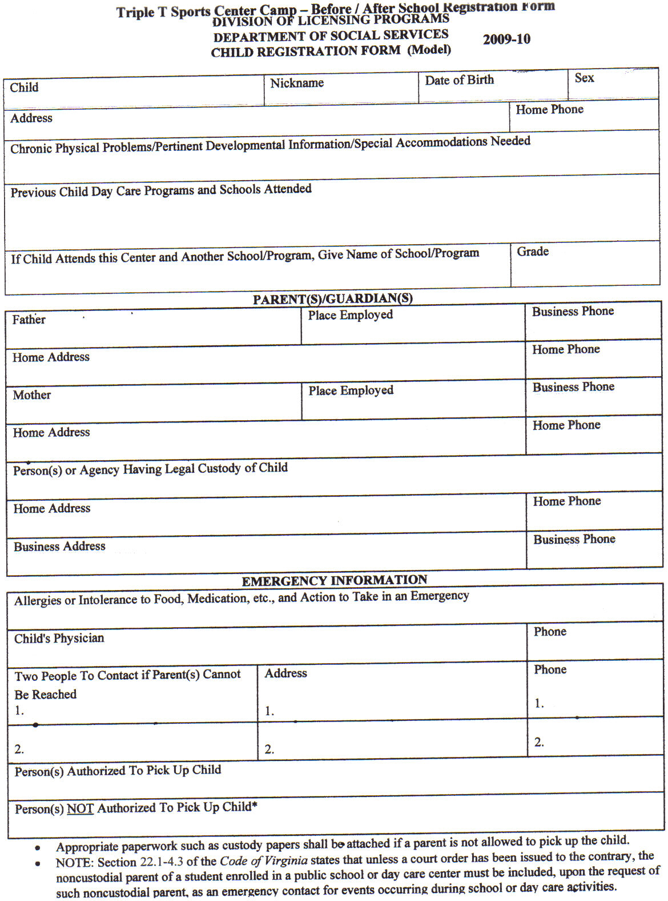

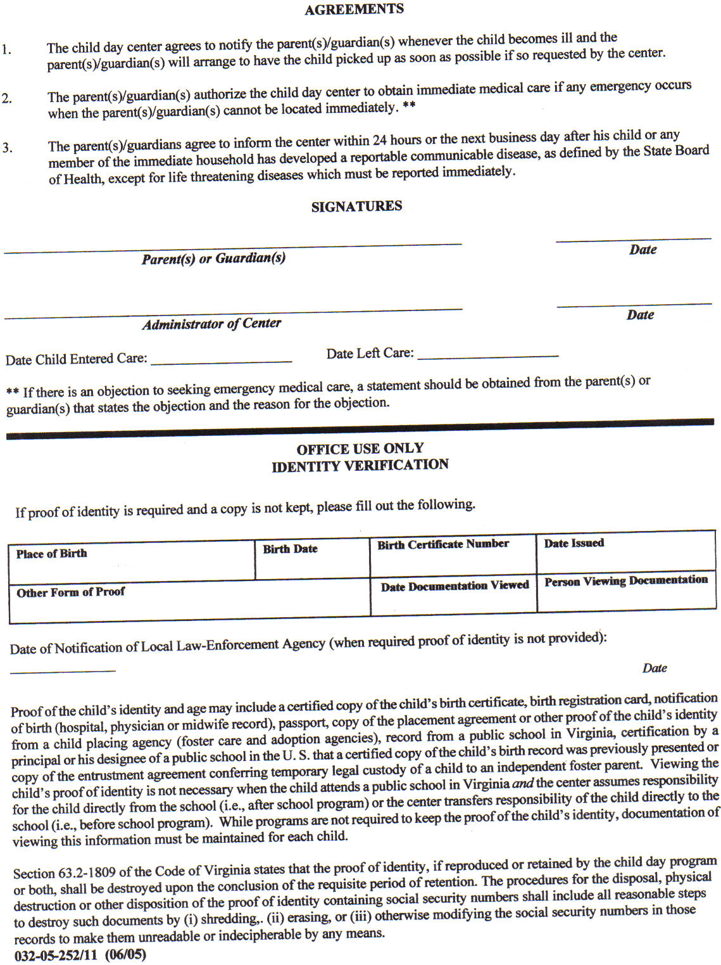

Triple T Sports Center
Summer Sports Day Camp Policies & Procedures

1. Sign In-Sign Out
Signing your child IN & OUT of day camp is very important. The child is not allowed to sign themselves in or out. Only the parent or authorized person is permitted to Sign In and Sign Out. If an authorized person is picking up your child please note this on the Sign In Form and notify the receptionist when you Sign In. If a person is picking up that is not on the authorized persons list we will not release the child without written permission of the parent or verification of code word by the person picking up.
2. Structured Camp Activities 9:00am-5:00pm, extended care 6am-6pm is included
3. Pick Up
Pick up time for 1/2 day camper is 1:00pm
Pick up for full day is 6:00pm
4. A Late Fee of $10.00 for late pick ups after 6:00pm, $5 each additional 15 mins.
5. Day Camp Forms
Please make sure that all forms are fully completed upon registration for day camp. Partially completed forms will not be accepted. This includes shot record, physical, birth certificate, credit card release form, rules and policies sheet, and the camper information forms. Please be sure to fully complete all pages to insure your child’s space in the camp. Space in camp is reserved upon receipt of registration forms and payment of deposit. No spaces will be held
6. What is a member
Members are children enrolled in a class (gymnastics, tumbling, ninja, tkd, cheer, or dance) or enrolled in our before and after school program throughout the school year.
7. What to wear
Most activities require no shoes. Bare feet are recommended. Sport shorts and t-shirts are recommended. (Please no zippers or snaps) No Jean Shorts please.
If your child is younger and prone to bathroom accidents please make sure the child has an extra set of clothing with them each day or we may have to call you to pick up your child early if your child has a potty accident. We have lockers available to store the spare set of clothes if you prefer to leave them here at the gym.
Also girls with shoulder length hair or longer need to have hair tied back – NO balls ties please.
8. Lunch & Snacks
Full day campers bring lunch, 2 snacks and drinks. Mark all items clearly with campers name and date. Morning half day campers need lunch and 1 snack and drink, afternoon half day only need 1 snack and drink. Our camp consists of non-stop sports, games and activities, therefore each child needs to have a healthy lunch and snacks for the energy they need. Please refrain from junk food to help your child have the energy they need each day.
9. Medication
If your child is on medication you will be required to fill out medication forms that may require your doctor’s signature. All medication must be given to the office staff with directions and medication form. Leaving medication with the child is strictly forbidden and could be hazardous for other children. This includes cough drops, Tylenol, etc.
10. Procedures for sick children
The staff will have the child to sit out for a while to see if they start feeling better. Sometimes a child will say they do not feel well if they are unsure of the activity. After they watch for a while and feel comfortable they will join the activity. If they are truly sick we will contact the parent to pick the child up. It is recommended that arrangements be pre-set for your child to be picked up by someone else if it is impossible for you to leave work. We will not accept children that are visibly sick into camp. Children with a fever, diarrhea or vomiting need to be picked up within the hour. Child must be symptom free for 24 hours before returning to the care.
11. Accidents
Due to the nature of our day camp accidents do sometimes happen. Our staff is trained to handle accidents. We will contact you to advise you of any accidents. Younger children (4-6) you may want to keep a change of clothes at the gym to prevent having to make a trip to drop off clothes if needed.
12. Celebrating Birthdays
If you child would like to celebrate their birthday it is recommended you bring cake, cupcakes or cookies. Please also bring all the paper goods needed. Boxed drinks are permitted. You may contact us for the number of campers we expect on the day you wish to celebrate your child’s birthday. We will celebrate birthdays during snack time.
13. Missed Days:
Camp tuition covers the week registered for – due to limited space, campers are not allowed to make up missed days in a different camp week. ECC card users, you will be responsible for payment directly for missed days.

14. Payment Policy
A guaranteed form of payment in the form of a credit card for day camp is required. If payment is not received on the Wednesday before your child’s camp week balance will be charged to the card on file on Wednesday after 6pm. Your receipt will be put in an envelope with your child’s name on it and placed by the sign in sheet.
15. Field Trips
We will be scheduling field trips during camp this summer. The field trip schedule is posted in the lobby and on our website at TripleTGym.com. Please keep the field trip schedule provided handy as a reminder of what days the fieldtrips will be so your child will be prepared. Children that do not go on the field trip will remain at the gym for regular scheduled activities. If your child is not going to be participating please notify the office staff in writing by end of the day on Monday of that week so we can staff appropriately. Parents are welcome to come on the field trips with the campers for an add’l fee. Please let us know if you wish to attend so arrangements can be made. Campers will be assigned to a camp staff person and constant supervision will be given by the camp staff person, parents will not be responsible for supervision. You cannot take your child out of the group during the fieldtrip. Field trips are a privilege and will be taken away if child does not behave properly or comes without proper attire which includes camp T-shirt and closed toe shoes. This is for their safety and exceptions will not be made.
16. Behavior Procedures
In an effort to provide the best environment for the Triple T Summer Sports Day Camp, behavior procedures have been implemented to ensure that each and every child has the best possible experience at the Triple T Day Camp. Behaviors such as: using bad language repeatedly, not following instructions that will result in harm to themselves or others, fighting, continuous disrespect to staff, etc.
The following behavior procedures will be enforced.
1st Offense Time Out
2nd Offense Parent will be notified of the situation by camp staff at pickup or via phone call if necessary.
3rd Offense Meeting with the child, parent, and child care management.
4th Offense Dismissal from further participation in the Triple T Summer Sports Day Camp if staff and management feel harm will come to the child and or/others if participation in camp continues.
17. Video / Quiet Play Time
The full day camper will be watching an age appropriate theme related movie from approximately 1:30-2:30pm. With the amount of physical activity in camp this time provides a chance for the children to rest between AM and PM activities. Campers will also be allowed to play passive games; such as: board games, checkers, puzzles, etc if they do not want to watch the movie.
18. Group Divisions
We have 2 age groups that children are separated into. Ages 4-7, and 8-12. This is to allow each group to participate in age appropriate games and activities. Please do NOT request for certain campers to be together or separated. The only exception that will be made is if an older child is not behaving correctly and may be temporarily moved to a younger group. Preschool group (ages 3-4) will have nap time from 1:00-2:30.
19. Teacher/Student Ratios
Teacher/Student ratios vary depending on the activity. Gymnastics classes are 8/9 students to teacher ratio. For sports, games and dance the ratio can be 15 and higher because the sports and games usually require a larger number of students and dance/karate/cheer class will range from 15-20 depending on the age. Ratios of staff to children during care: Preschool (ages 3-4) 1:10, School Age (5-12) 1:18 are the state mandated ratios however due to the structured activities that are done at Triple T our school age ratio is generally closer to 1:12.

20. Triple T Contact Info
619 E Constance Rd Suffolk, VA 23434
(757) 923-5150
(757) 923-5185 Fax
tttgym@msn.com Email
tttgym.com website

Triple T Sports Center Summer Day Camp Policies

Parent/ legal guardian must initial next to each statement verifying that they have been informed of the following policies.

__________ I understand that a $25 non- refundable deposit is due upon registration for each week I reserve.

__________ I understand a 2 week written notice is required to remove my child from summer camp. If notice is not given the balance in full will be charged to the credit card on file for the remaining weeks. I understand that if notification is not received I will be liable for the balance as well as payment of fees associated with collecting on the account. Deposits are non refundable.
__________ I give permission for my child to participate in all regularly scheduled fieldtrips. However, I understand that fieldtrips are a privilege and not a right, even if additional fee is charged. Campers will be kept from participating in the fieldtrip if they are not dressed appropriately (camp t-shirt and closed toe shoes) or not behaving appropriately. Triple T wants all campers to participate however if it presents a safety hazard to themselves others they will not be allowed to attend. The field trips that require an additional fee are purchased far in advance and we cannot get a refund if the child does not attend. (Water Country, Ocean Breeze, Spirit of Norfolk) If child does not bring an appropriate lunch (non - microwavable on fieldtrip days) and one has to be provided you will be charged a $10 fee.

__________ Registration includes 1 camp t-shirt. If you would like to order additional shirts upon registration the cost is $15 per shirt. T-shirts are ordered based on the students registered, a limited number of additional shirts are ordered. However we cannot guarantee that there will be any available for purchase if you forget yours on field trip day. Please plan ahead and be sure your child’s shirt is clean and available on fieldtrip day, days are listed on the fieldtrip schedule.

__________ Some fieldtrips are divided by age. I understand this is the age on the day of the fieldtrip. This is for the safety of the children and no exceptions will be made.

__________ Unfortunately when large numbers of children get together there may be times that arguments, fights, or hurt feelings will occur. Our staff is trained to handle these situations when they arise. You will be notified if your child is involved in any incident. We will not discuss the other children with you and you are strictly forbidden to approach any child (includes CITs) other than your own to address any issue directly. If your child is having a problem with another child or staff member please report the issue to Cheryl Burks, Administrator/Owner and the problem will be addressed in whatever manner needed. If issue cannot be resolved with the children then both sets of parents will be called in for a conference with Mrs Burks.

_________ Electronic devices such as ipods, DS, or other games can be brought to camp. The students have certain times of day to play with these, during quiet play times. The rest of the day the device is locked in a locker. I understand that bringing them is a privilege and if my child argues about putting them away or begging to play with them then they will no longer be allowed to bring them. I also understand that bringing any device is at my own risk and that Triple T is not responsible for any loss or damage done to the device. Cell phones are not permitted in camp. If you need to contact your child please call the gym at 923-5150 or Cheryl Burks directly at 839-9108.

__________ It is my responsibility to be sure and pack a full, healthy lunch, drinks, and 2 snacks for my child. Snack Accounts are optional for campers however office is not always open and cannot be counted on to purchase snacks. Any money left with the camper is not Triple T’s responsibility if lost, stolen, or misplaced. See the front desk for details on how to open an account for your child.

__________ I understand there are licensed and unlicensed areas of Triple T Sports Center and give my permission for the staff to sign my child(ren) in and out of these areas.

__________ Parents using ECC cards, you must swipe your child in and out daily and put your receipt in the black gym tuition box. If you do not clock your child in and out you will be responsible for payment of the prior day or receipt showing they were signed in/out before returning. Absences: you will be responsible for payment out of pocket.

I have read the above statements and fully understand the policies and procedures of Triple T.

___________________________________ __________________
Signature of Parents or Legal Guardian Date

Triple T Sports Center
Summer Camp 2017
June 19-Sept 1st

Register now for the entire summer or for only the weeks you would like your child to attend.

Our coaches will be teaching Gymnastics, TaeKwonDo, Dance, and Cheer along with several school teachers and counselors that will be helping with the educational activities, arts & crafts, computer skills, field trips, games, and more!! Space is limited to 55 campers per week so sign up early to save your child’s spot!

Week
# Date Theme Fieldtrip
1 June 19-23 Ahoy Mateys! Sail the Seas Capt. Jacks Pirate Ship Adventures
2 June 26-30 TTT’s Top Secret Agents Despicable Me 3 (Fri)
3 July 3-7 Party in the USA Water Day & American Picnic (Thrs)
4 July 10-14 Under the Sea Virginia Aquarium
5 July 17-21 Wipe Out!! Williams Farm rec center (8-12)
Portsmouth Spray Park (4-7)
6 July 24-28 Mad Scientist Children’s Museum of Virginia
7 July 31-Aug 4 To Infinity and Beyond VA Air & Space Museum
8 Aug 7-11 Superheroes Laser Quest (8-12) / Bounce House (4-7)
9 Aug 14-18 Splash Down Ocean Breeze ($20 add’l fee) (tba)
10 Aug 21-25 Wide World of Sports AMF Bowling
11 Aug 27-Sep 1 Hawaiian Hullabaloo Luau @Triple T (Fri)

*$20 additional fee due at registration, these fees are non-refundable as tickets are pre-purchased.
Structured Camp Hours 9am-5pm, extended care included 6am-6pm
Most fieldtrips included. 10% Sibling Discount
Registration Fee $50 Non members, $35 Members (includes camp t-shirt for field trips)
5 full days $150 Non members, $125 Members (enrolled in regular class at TTT)
3 days: $105 Non Members, $90 Members, $10 add’l fee for field trips
½ day camp 9am-1 $105 Non Members, $90 Members
Field trips are usually on Wednesdays unless otherwise posted
** All regular classes will be held as scheduled **

Spring Break - Zoo Week April 10-14
Fieldtrip : Virginia Zoo

619 E. Constance Rd Suffolk, VA 23434
(757)923-5150; tttgym@msn.com

