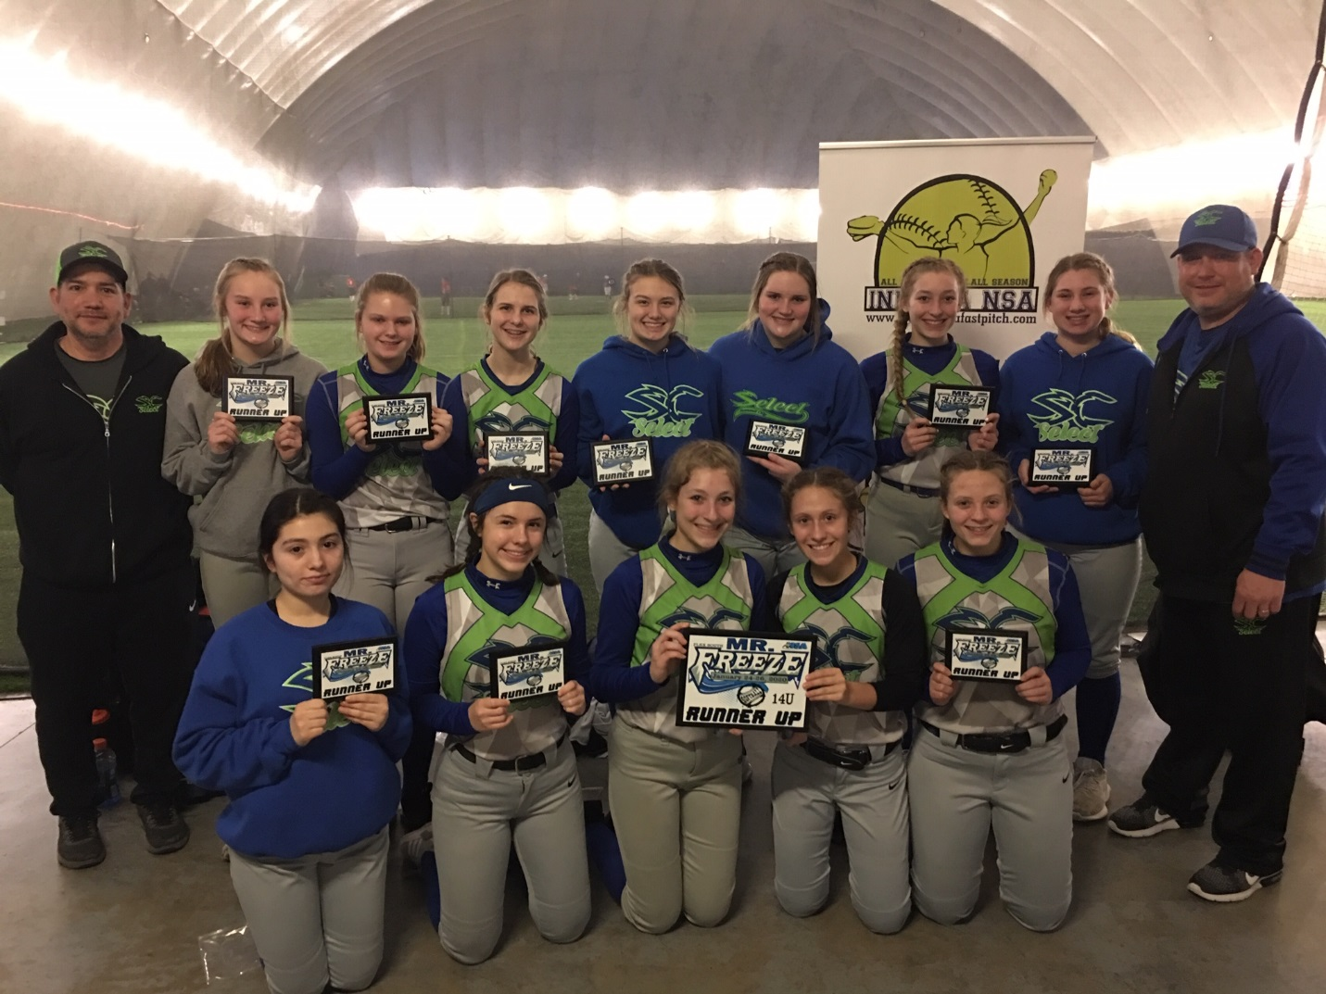
14u Runner Up Summit City Select

