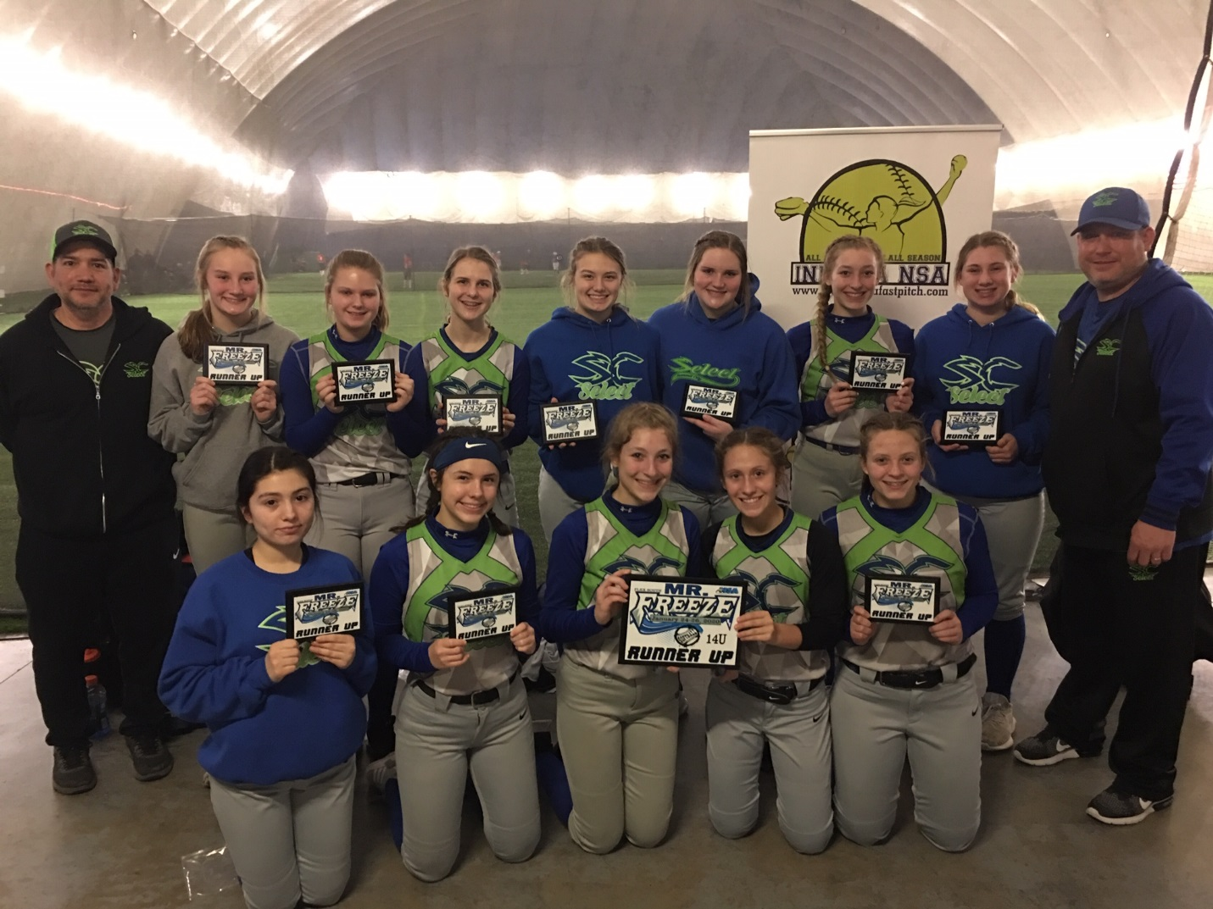

**14u Runner Up Summit City Select**