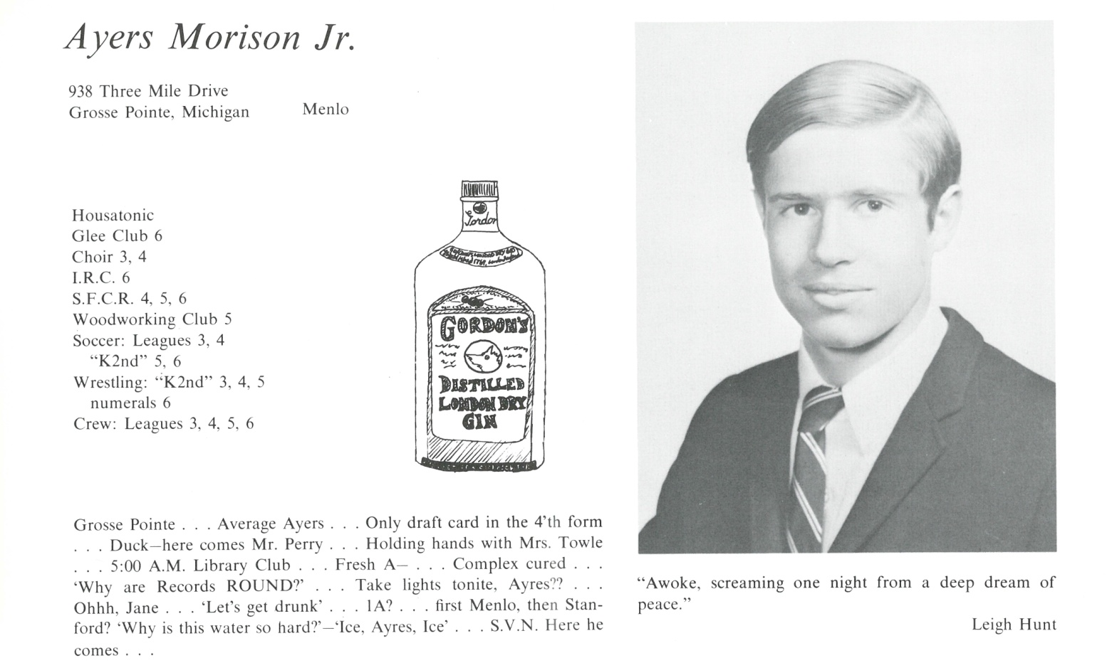

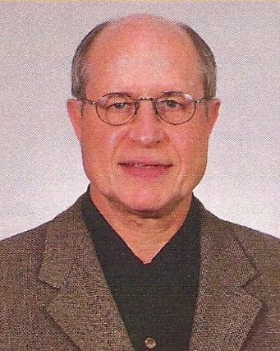Ayers Morison, Jr.

After graduation, the summer of ’67 was a tumultuous, rude awakening given the on-going rioting in Detroit, working the night shift at Uniroyal making tires, and a month traveling around Europe before heading off to college in California.

- ‘67-’71, spent the next 4 years in and out of 3 different colleges/universities, on and off motor bikes, finally graduating from UC Berkeley in ’71 with a BFA, Architecture major. Being there during “the revolution” was a coming of age education in and of itself!

- ‘71-’74, lived in Charlottesville for graduate school at the University of Virginia, M Architecture & Urban Design, lost all my hair there, worked the summer of ’74 for an architect in Philadelphia before heading back to Michigan.

* ’74-’80, worked for architecture firms in Michigan and met my wife in 1980. We had gone to 2 universities at the same time, only to meet on an elevator in downtown Detroit.
* ’80-’82, we lived together and married in ’82. No children/lots of goddaughters (full disclosure: previously married from ’71-’77, too young!)
* ’82-‘12, lived and practiced in the Detroit area.
* ’10-’12, Susan and I helped my sister, Clare (Kent, ’64) battle ovarian cancer until she died in Dec.’12. An exhausting/sobering experience…
* ’12-’14, practiced less; and, adjunct prof’d a senior architecture studio class (a really rewarding /frustrating experience shifting from practitioner to academician)
* ’12-’15, residential architecture practice while caring for my mother who was full of p… and v…right up until she had a stroke and died in April of ‘15 at 96.
* ’15-present, retired, designing and building an addition to our house (way overdue) and restoring a family sailboat in anticipation of more adventures on the Great Lakes.

After 50 years, it took a surprise visit from my roommate, Jack Hutchinson, to get me excited about our 50th. We’ve all had our ups and downs since then; but, my Kent experiences really cultivated a passion for trying it all. Or, at least, in the words of Bill Armstrong, “Try not to be a pimple on the ass of progress”.



______________________________________________________________

______________________________________________________________ ______________________________________________________________ ______________________________________________________________ ______________________________________________________________ ______________________________________________________________ ______________________________________________________________ ______________________________________________________________ ______________________________________________________________

Attach Picture in .jpg Format

______________________________________________________________

______________________________________________________________

___________________________________________________________________________________ _________________________________________________________________________________________________________________________________________________________________________________________________________________________________________________________________________________________________________________________________________________________________________________________________________________________________________________________________________________________________________________________________________________________________________________________________________________________________________________________________________________________________________________________________________________________________________________________________________________________________________________________________________________________________________________________________________________________________________________________________________________________________________________________________________________________________________________________________________________________________________________________________________________________________________________________________________________________________________________________________________________________________________________________________________________________________________________________________________________________________________________________________________________________________________________________________________________________________________

___________________________________________________________________________________