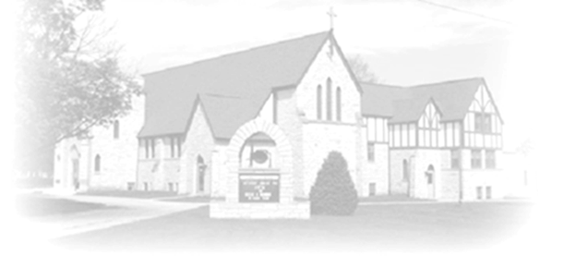
Trumpet Minor
May 24 & 25, 2025

Christ Lutheran Church
ANNOUNCEMENTS
STORY BOOK COURT FULL OF BEANS! : Christ Lutheran Church will be offering a Children’s play directed by Paula Fulton on Saturday July 26th at 7 pm and Sunday, July 27th at 2 pm. Auditions will be open for ages 8 – 14 years old and will be held May 31st from 9 am – 3 pm. Questions: email pkfulton50@gmail.com.

COWORKERS IN THE GOSPEL: Consider being a part of one our leadership teams. As of this month, three teams will be helping connect the council and congregation as we work together to do ministry together. Three teams have formed; Worship Team, Building Team and Education Team. If you are interested in being a part of one of the teams, please see Pr Chrissy or someone on the team.
- Worship team leader is Janet Haas -anyone who is interested in serving in any area of worship, especially baking communion bread, communion set up, serving or clean up.
- The Property team will access, and address issues related to the building. Please see Cory Haas, team leader, if you would like to help with the building.
  - We are also looking for people interested in helping with mowing the lawn come spring.
- The Education Team over sees Confirmation, Sunday School and Vacation Bible School. Vacation Bible School is going to happen June 2-6. from 9-11:30. If you would like to be a part of the education team or help with VBS Campfire Adventure please see Leisa Hubb (team leader).
  - Help us decorate for VBS after worship on June 1st.

4TH OF JULY GRAB N GO MEAL: Need workers for the Grab ‘N Go meal before the fireworks on July 4th to make the sandwiches and fill and serve the bags to people that walk up to the church. The event is 6-8 PM and we plan on making sandwiches and setting up at 4:00 PM. Please contact Cindy Bonnet (815-541-8426). Thank you!
THE COMMUNITY TABLE: The Community Table is an opportunity for outreach to the local community. This is a bi-weekly meal on the first and third Tuesday of the month at 11:30, here at Christ to gather for food, fellowship and fun, if you are interested in volunteering please talk with Janet Haas or Debbie Goebel.

AMAZON WISH LIST: did you know that everyday items used at the church are items you could contribute? Also included is items needed for VBS! Find our list here or on our Facebook page. Thank you! Upcoming Events
- May 24-5:30 pm Worship
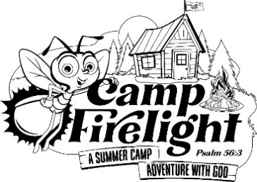
- May 25- 10 am Worship LSSI speaking
- May 28- 9 am Bible Study
- May 27-June 1 Pastor Chrissy is on Vacation
- May 31- 9-3 pm Children’s play auditions
- May 31- 5:30 Worship (no communion)
- June 1- 10 am Worship (no communion)
- June 1- after worship- Decorating for VBS
- June 2-6 Vacation Bible School
- June 3- 11:30 am Community Table
- June 7 – no Saturday Evening worship
- June 8- 10 am VBS Celebration Worship
- June 11- 1 pm - Naomi Circle
- June 12- 9 am Rebecca Circle
- June 14- 11-2 WELCA Brat Stand
- June 14-15 Synod Assembly

