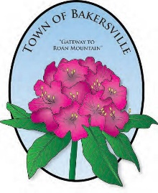
2021 CALENDAR OF EVENTS

NORTH CAROLINA RHODODENDRON FESTIVAL
JUNE 18-19

FOURTH OF JULY FIREWORKS
JULY 2

NORTH CAROLINA MOUNTAINEER FESTIVAL
SEPTEMBER 18

APPLE BUTTER FESTIVAL
OCTOBER 9

CHRISTMAS TREE LIGHTING
NOVEMBER 27

CHRISTMAS PARADE
DECEMBER 4

