RSAI Legislative Update
May 4, 2018
These updates and Capitol Video Recap are posted on the RSAI web page http://www.rsaia.org/legislative.html.

Several actions signal the end to the 2018 session, including appearance of the Standings Appropriations bill in both chambers. The Education Appropriations bill, SF 2415, is approved by the Senate. SAVE extension and Operational Sharing Extension HF 633 are still on the Senate Debate Calendar, while HF 2406 adding Social Worker positions to operational sharing was referred back to the appropriations committee with an estimated $2 million impact. Initial action on the tax proposal in the Senate is expected this weekend. See the April 20 report for suggested advocacy actions on RSAI priorities that are still relevant. Let us know if you need assistance with your advocacy work. Thanks for all you do to advocate for Iowa’s children. margaret@iowaschoolfinance.com

Tax Cuts
The Senate is planning on debating HF 2489 with a significant amendment likely this Saturday. RSAI is registered opposed to the bill. In summary terms, the amendment is expected to include:
- coupling with various federal tax provisions in 2018 and 2019,
- cuts to Iowa individual income tax rates in TY 2019,
- sales tax modernization provisions effective January 1, 2019,
- multiple changes to income tax credits.
- change to the corporation income tax that would become effective in TY 2021, and
- assuming revenue targets are met, additional reform to the individual income tax that would become effective in TY 2023.
A letter by the Department of Management policy staff to the Legislative Services Agency provided 49 pages of analysis, but of primary importance is the fiscal impact to the state, included in Table 21. Please note – the total general fund change in net receipts annual impact is determined by subtracting the prior year, for example, FY 2020 impact of $261.7 million minus the FY 2019 impact of $100.2 million, means that the loss to the state’s general fund revenue in FY 2020 will be $161.7 million compared to the prior year. Those claiming that this is a billion tax cut must be considering several years of cumulative impact to get to that number.
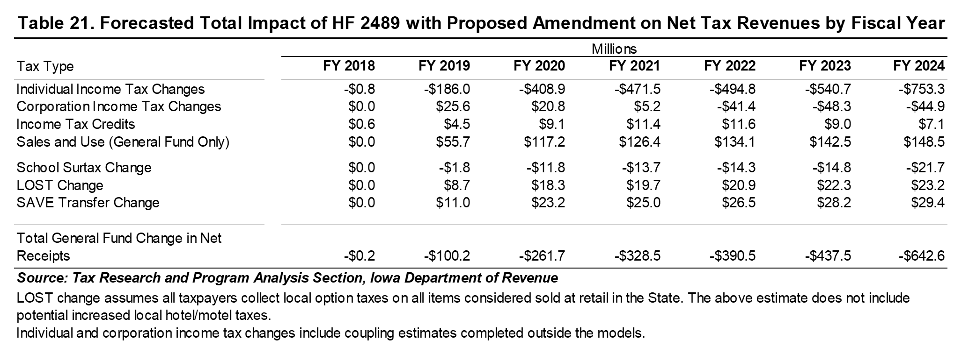

Appropriations
Budget bills were approved in appropriations committees this week, and the House engaged in floor debate. The Health and Human Services Appropriations bill, which, next to Education, is the second largest expenditure of state government, was introduced this week in Senate Appropriations Committee. The following table includes spending bills that typically are approved before adjourning.
Budget Area | Bill # | Initial Chamber Action | Second Chamber | Status | Done
Education | SF 2415  HF 2496 | Passed in Senate 5.2 | On House Calendar
Standings | HSB 690  SSB 3221 | H Approps Committee  S Approps Committee
Admin & Regulation | SF 2416 | Passed in Senate 5.2 | Amended & passed 5.2 | Back to Senate
Agriculture & DNR | HF 2491 | Amended and passed by House 4.25 | Passed senate 5.1 | To Gov.
Economic Develop | HF 2493 | Amended and passed by House 4.25 | Amended & passed 5.1 | Back to House
Health and Human Services | SSB 3222 | In Senate Committee 5.2
Judicial Branch | HF 2495 | Amended and passed House 4.30 | Passed Senate 5.1 | To Gov.
Justice Systems | HF 2492 | Amended and passed House 4.30 | Amended & passed 5.2 | Back to House
RIIF Infrastructure Fund | SF 2414 | Passed in Senate 4.26. | House 5.2 | To Gov.
Transportation/Capitals | HF 2494 | Amended and passed by House 4.25 | Amended & passed 5.1 | Back to House

SF 2415 Education Appropriations: the bill was amended and approved by the Senate and is over in the House. The Notes on Bills and Amendments NOBA provides details of all of the appropriations of the bill. RSAI is registered undecided. The following appropriations to the DE and statutory language are of particular interest to schools:

- A new appropriation of $2.7 million to be distributed to school districts for the statewide student assessment. This is lower than the Governor’s recommendation, which was based on the RFP award to the American Institutes of Research, AIR. House File 2235 required the DE to adopt administrative rules setting the statewide assessment for students as the assessment created by the Iowa Testing Program and administered by the Iowa Testing Program's designee.
- A new appropriation of $250,000 for the creation of a statewide clearinghouse regarding work-based learning.
- A new appropriation of $600,000 for a Summer Joint Enrollment Program to allow high school students to enroll in community college classes during the summer months under an agreement between the school district and the community college.
- A new appropriation of $500,000 for the Computer Science Professional Development Incentive Fund. SF 274 Computer Science Act created this program last year. The funds will be used for professional development and compensation for teachers seeking a new computer science endorsement. Senate File 274 was approved by the General Assembly on April 18, 2017, and signed by the Governor on April 28, 2017.
- An increase of $1.0 million for Jobs for America’s Graduates, iJAG, and language allowing JAG to work with middle school students in addition to high school students.
- An increase of $1.9 million for an Early Warning System. The bill requires the DE to provide reading assessments for PK-6 to detect students not proficient in reading. Local school districts use universal screening and progress monitoring assessments, and store student performance data on a statewide database. Currently, the DE provides the assessments at no cost to schools. This language allows the DE to charge school districts for the cost of the assessment, which school districts may pay out of Early Intervention funds or other funds.
- Continues the $7.8 million appropriation for the Successful Progression for Early Readers.
- An increase of $345,000 compared to estimated net FY 2018 to support the Reading Research Center's programming, which is disseminated to school districts.
- An increase of $2.0 million for Community Colleges
- An appropriation of $5.0 million to the UNI for the Science, Technology, Engineering, and Mathematics (STEM) Collaborative Initiative. This is the current level of funding and FTE positions compared to estimated net FY 2018.
- An increase of $54,000 to Early Childhood Iowa which restores them to the FY 2018 level.
- An increase of $50,000 to the Student Achievement Teacher Quality Program (for Career Development/Evaluator Training and Teacher development academies)
- Delays the $10 million allocation of SATQ funds to implement High Needs Schools Grants until FY 2020.
- Modifies provisions enacted under Division VII of Senate File 475 (FY 2018 Education Omnibus Act), allowing the personal finance literacy credit required for graduation to count as a half unit of social studies or other combination of coursework otherwise required in Iowa Code 256.11. The financial literacy mandate is effective July 1, 2019.
- Modifies provisions regarding online education enacted under Senate File 475 (FY 2018 Education Omnibus Act). Specifies that the online course subject to the offer and teach waiver must be developed either by the school district or accredited nonpublic school staff or through a private provider that meets the standards of the Iowa Online Learning Initiative.
- Specifies that teacher shortage loan forgiveness program will not accept new applicants for FY 2019 but may continue serving eligible previous recipients.

HSB 690 Standing Appropriations: this bill sets the state match for the instructional support program at zero (which has been done annually since the great recession eliminated the funding in FY 2011), continues the $15 million cut to the AEAs which has also been done for many consecutive years, and conforms PPEL statute to new law which requires lease-purchase agreements that exceed the bid thresholds go through a competitive bid process (HF 2253 signed by the Governor states that local governments must go through competitive bid process for lease purchase, so this applies the language specifically to PPEL Chapter 298). RSAI is registered as undecided.
SF 2311 Utility Regulation: this bill strikes requirements for municipal utilities for filing energy efficiency plans and results. Does not require municipal utilities to have a preference for renewables in energy efficiency plans. Requires approval from the IUB for automatic rate adjustments or new charges and approval for the filed rate schedule before raising rates to recover energy and transmission costs. Allows consumer opt-outs from the energy efficiency program. Allows utilities to request an energy efficiency modification plan. Requires utilities to file a five-year energy efficiency/demand response plan. Includes provisions on making recovery for energy efficiency reasonably comparable for customers. Includes exemptions from plans for utilities meeting certain criteria. Caps energy efficiency spending (1.5% for gas and 2%). Requires the IUB to approve rate-regulated utilities refund schedules due to federal tax cuts. Makes changes related to IUB determinations of actual costs and revenues and that those determinations are reasonably consistent with the rates that are approved. Makes changes to timelines for review/approval of various rates and requests. RSAI is opposed to the bill as the investments of energy efficiency including rebates have helped school districts to implement energy efficiency programs and save scarce general fund dollars. The bill was approved in the House 52:42, and in the Senate 28:20. It is awaiting the Governor’s signature.

RSAI Contacts
RSAI Professional Advocate, margaret@iowaschoolfinance.com 515.201.3755
Robert Olson, Chair, Clarion-Goldfield/Dows, Superintendent, robert.olson@rsaia.org ,
Paul Croghan, East Mills and Essex Superintendent, pcroghan@emschools.org ,
Lee Ann Grimley, Springville, Board President, leeann.grimley@rsaia.org ,
Dennis McClain, Clay Central-Everly, Superintendent, dmcclain@claycentraleverly.org
Laurie Noll, Fairfield, Superintendent, laurie.noll@fairfieldsfuture.org
Dan Smith, Harmony, Board President, dan.smith@rsaia.org
Duane Willhite, Superintendent, North Fayette Valley, dwillhite@nfv.k12.ia.us

