Mars UP Church
Come Holy Spirit, Come
Before the Service – Speak to God!
During the Service – Let God speak to you!
After the Service – Speak to each other!

(*Please stand, if able)
Welcome and Mars Messages

Prelude

Apostles’ Creed
I believe in God the Father Almighty, Maker of heaven and earth; and in Jesus Christ His only Son our Lord; who was conceived by the Holy Ghost, born of the Virgin Mary, suffered under Pontius Pilate, was crucified, dead and buried; He descended into hell; the third day He rose again from the dead; He ascended into heaven, and sitteth on the right hand of God the Father Almighty; from thence He shall come to judge the quick and the dead. I believe in the Holy Ghost, the holy catholic church; the communion of saints; the forgiveness of sins; the resurrection of the body; and the life everlasting. Amen.

Gloria Patri
Glory be to the Father, and to the Son, and to the Holy Ghost. As it was in the beginning, is now and ever shall be,
world without end.
Amen. Amen.

The
Lord’s Prayer

Our Father,
who art in heaven,

hallowed be Thy
name,

Thy kingdom come,
Thy will be done,
on earth
as it is in heaven.

Give us this day
our daily bread;

and forgive us
our debts,
as we forgive
our debtors;

and lead us not
into temptation,
but deliver us
from evil.

For Thine
is the kingdom,
and the power,
and the glory,
forever. Amen.

The Doxology

Praise God
from whom
all blessings flow;
praise Him
all creatures
here below;
praise Him above,
ye heavenly host;
praise Father, Son,
and Holy Ghost.
Amen.

The Call to Worship
Leader: May God be gracious to us and bless us and make
his face to shine upon us.

People: Let the peoples praise you, O God; let all the
peoples praise you.

Leader: Let the nations be glad and sing for joy, for you
judge the peoples with equity and guide the
nations upon earth.

People: Let the peoples praise you, O God; let all the
peoples praise you.

Leader: The earth has yielded its increase; God, our God,
has blessed us.

People: May God continue to bless us; let all the ends of
the earth revere him.

All: Let us Worship God!

Pastoral Invocation

*Hymn 182
“For the Beauty of the Earth”

Passing of the Peace

Leader: May the peace of Jesus Christ, the love of God, & the fellowship of the Holy Spirit be with you all.
People: and also with you

MSPS Minute Heidi Beahm
Jill Cesare

Children’s Chat

*Hymn 692
“God Will Take Care of You”

Scripture John 5:1-9

Morning Message Rev. Brian Hauser
“Do You Want To Be Made Well?

Prayers of the People and Lord’s Prayer

Offering
*Doxology

*Offering Prayer

*Hymn 139
“Great Is Thy Faithfulness”

*Benediction

*Congregational Response (Everyone sings)
Blest be the tie that binds
Our hearts in Christian love
The fellowship of kindred minds
Is like that to that above.

Church Staff
Rev. Brian Hauser
Pastor
pastor@mars-up.org
724-689-3412

Ms. Jamie Daugherty
Choir Director & Organist
JamieD0714@gmail.com

Mrs. Shelly Bocheff
Administrative Assistant
marsup@mars-up.org

AV TEAM
Alma Staskiewicz, Lisa Barbour, Marie Matthews, Bill Guesman, John Ivory, Keith Nichols, Mike Bocheff, Herb Wellman

Mars United Presbyterian Church

232 Crowe Ave
PO Box 805
Mars, Pennsylvania 16046
724-625-1365
www.mars-up.org
marsup@mars-up.org

Church Office Hours:
Mon -Thurs from 9 a.m. -2:30 p.m.
Morning Worship:
10:00 am

6th Sunday of Easter

Prayer of Preparation
Lord, we come to you today with so many things on our hearts.

You call us to be in relationship of trust and love with you and you offer healing to us for those portions of our lives that are broken and injured.

Help us to be open to your mercy and healing love. For we ask this in Jesus’ Name.
AMEN.

*Postlude

WELCOME BACK KATHY! Please stop and say hello to Kathy Kelso, our organist today. Kathy is pinch-hitting while Jamie plays for Sam Govan's wedding in Somerset this weekend.

Karen Purvis would like to thank everyone for the numerous cards, well wishes and prayers during her recent illness.

MUP Session

Class of 2024 Class of 2023 Class of 2022
Alma Staskiewicz Lisa Barbour Mike Bocheff
Louise Fox Mary Ann Croop Sally Olsen
Marie Matthews Don Lewis Susan Cox
Herb Wellman Linda Lees

Clerk of Session: Herb Wellman

MUP Deacons

Class of 2024 Class of 2023 Class of 2022
Steve Martin Sharon Gibbs Jay Wilson Nancy
Marge Nicklas Carol Kopar Jenny Ivory
Pat Auld Alice Leonberg Pat Jackson

Moderator: Steve Martin

Mars United Presbyterian Church
Welcome!

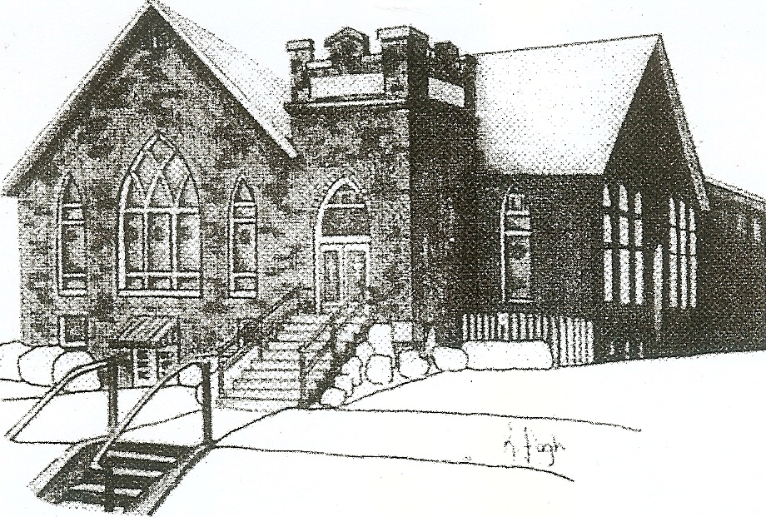
We are your hometown church: Faithful to Tradition, Loving in Fellowship, & Reaching for Tomorrow!

May 22, 2022

We welcome you and we are glad you’ve chosen to Worship with us today!

CALENDAR: May 22, 2022 – May 29, 2022

Church Office Hours: Monday -Thursday from 9 a.m. – 2:30 p.m.

Today, May 22, 2022
VOLUNTEERS☺

LAST SUNDAY’S In-House ATTENDANCE: 54

LAST SUNDAY’S OFFERING:
Operating Funds: $4295.00
Kindness Offering: $30.00
Total: $4325.00

Tarry N Talk Hosts
Stewardship Committee
9:00 a.m. Sunday School Hour
10:00 a.m. THE MORNING WORSHIP SERVICE
Monday, May 23, 2022
7.00 pm Boy Scouts
Tuesday, May 24, 2022
9:00 am A team
7:00 pm AA
Wednesday, May 25, 2022
9:00 am Material Girls
6.00 pm Girl Scouts
Thursday, May 26, 2022
Friday, May 27, 2022
Saturday, May 28, 2022
Sunday, May 29, 2022
10:00 am THE MORNING WORSHIP SERVICE

Welcome to all who are Worshiping with us today!
Guests
We sincerely hope our service is a blessing to you. We ask that our guests please take a few minutes to complete one of the Connect Cards found in the pew holder.

Should you have questions regarding any aspect of our church, including membership, please contact Pastor Brian or the church office during the week at 724-625-1365. Thank you for being with us today.

PRAYER – JOYS & CONCERNS
Lou Beckwith Kennedy (Great Granddaughter of Marlene Edwards
Nancy Govan Paige Barbour (daughter of Andrew and Steph Barbour
Reid Christopher Hall (June Stirling’s nephew) Maria Elizabeth McKaveney (June Stirling’s niece)
Lindy McCartney (Lisa Barbour’s Sister) Chuck Kennedy
Patty Jackson Isabel Boynton

ANNOUNCEMENTS
Bulletins are printed Thursday mornings; let us know if you have an announcement…

GRADUATION SUNDAY Sunday, June 12th is the day chosen to honor the Graduates from High school and College. If you know of anyone who will be graduating this year, please contact the office.

VACATION BIBLE SCHOOL “MONUMENTAL” Registration for VBS is available now online at www.mars-up.org. June 26th thru June 30th 6:00 to 8:30 pm. SPECIAL OPENING SUNDAY AFTERNOON- Families join us for a HOT DOG BEAN kickoff at 5:00 pm in MUP Fellowship Hall

SAVE THE DATE Mars UP church annual picnic will be held Sunday, September 11th at Adams Township Park. More Details to Follow

GRIEFSHARE SUMMER MEETINGS Griefshare will continue to hold one monthly meeting during the summer. Meetings will be held on June 13th, July 11th, and August 8th. The fall session will resume on September 12th at 6:30 For more information, please contact Denise @ ddemarco5@yahoo.com

COMING THIS FALL Mothers of Preschoolers (MOP) group starting at Mars UP Church. To register or questions contact church office or Ashley Hauser at 814-270-9101. More details to follow!!

