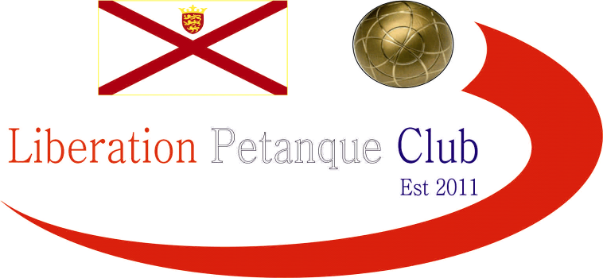

SUMMER 2024 SEASON
WEEK 11 – 12th June 2024
CLUB DOUBLES CUP

The annual Doubles Cup this year had just 11 entries taking part.

Last years winners Keith & Mo played the team they knocked out in the Quarter Finals last year Geoffroy & Matt and almost beat them again just losing 8-7. Last years runners up though did win as Gary & Wendy beat Graeme & Keith 11 – 8.

Big wins for 2022 champions Laurent & Toby over Brian & Lorna 12 – 4 and two 13 – 4 wins for Andrew & Callum over John & Nick and Neil & Ross over Alan & Joey.

Two big matches in round 2 saw Geoffroy & Matt just beat Laurent & Toby 10 – 9 and Andrew & Callum beat Neil & Ross 12 – 5.

No other matches were close though as Gary & Wendy won 13 – 3 over Daniel & James. John & Nick beat Premier League team Graeme & Keith 12 – 3 and Keith & Mo lost heavily to Brian & Lorna 13 – 2.

In Round 3 Geoffroy & Matt handed out a certificate 13 – 0 to Andrew & Callum! Gary & Wendy also made it three wins in a row 13 – 2 over Brian & Lorna.

An amazing shot by Laurent to hit a very hard boule taking the jack out for four points to beat John & Nick 11 – 9 and looked odds on to win. Ala & Joey got their first official win over Daniel & James after a bye in Round 2.

In the final Round 2 wins were needed to get through to the quarter finals. Keith & Mo missed out on the knockout stages with only 1 win (a bye). Geoffroy & Matt finished top of the rankings two years in a row with a 5 – 2!!! Win over Gary & Wendy.

Laurent & Toby win over Neil & Ross put them in second place and Andrew & Callum took third place with a win over Alan & Joey whilst Brian & Lorna 13 – 1 win over Graeme & Keith put them though. John & Nick also went through beating Daniel & James.

FINAL SWISS RANKINGS

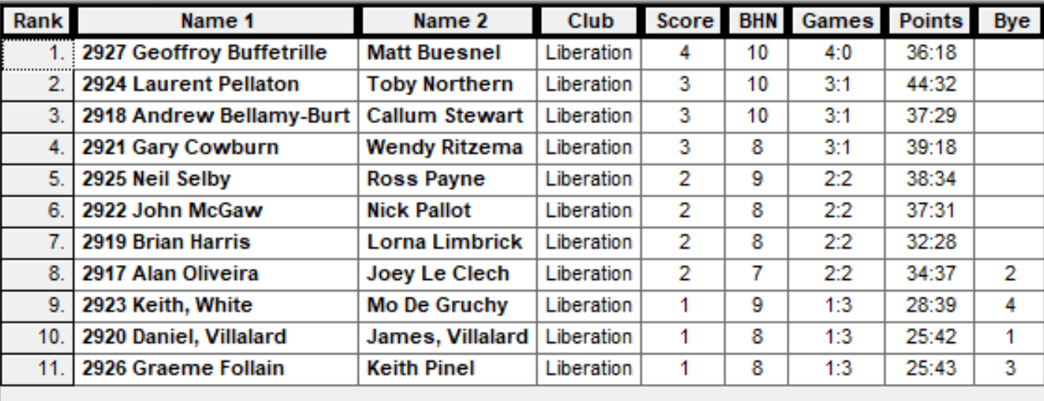

Quarter-Finals

Ranked 1st Geoffroy & Matt v Alan & Joey Ranked 8th

Ranked 2nd Laurent & Toby v Brian & Lorna Ranked 7th

Ranked 3rd Andrew & Callum v John & Nick Ranked 6th

Ranked 4th Gary & Wendy v Neil & Ross Ranked 5th

Well two shocks this year as John & Nick were leading 9 – 0 before a fight back by Andrew & Callum but just too little to late with John & Nick making the semi-finals 11 – 9. Brian & Lorna were losing 8 – 3 with two ends to play but pick up a four and then a two to snatch victory from Laurent & Toby.

Geoffroy & Matt did make it though but very close as Alan & Joey pushed them all the way to 12 – 10. In the final quarter final s Neil & Ross ran out comfortable winners 13 – 3 over Gary & Wendy.

Semi-Finals

Ranked 1st Geoffroy & Matt v Neil & Ross Ranked 5th

Ranked 6th John & Nick v Brian & Lorna Ranked 7th

Well great placing by Neil on the very last end with the jack very close to the string, keeping his boules in with little room took the match 9 – 8 for Neil & Ross over Geoffroy & Matt.

Brian & Lorna hit top form as they both were unplayable to run out 9 – 1 winners over John & Nick.

John & Nick though did take first place with a 13 – 6 win over Geoffroy & Matt for a great tournament.

In the final Brian & Lorna continued their great form to gain a big lead over Neil & Ross and looked odds on to win but a combination of a change in tactic with Brian deciding not to shoot on a few occasions and Neil placing proving hard to beat saw Neil & Ross play well together in the second half of the match to win a great final 13 – 11. This made of for finishing third in the last two seasons.

Winners

2024 – Ross Payne & Neil Selby

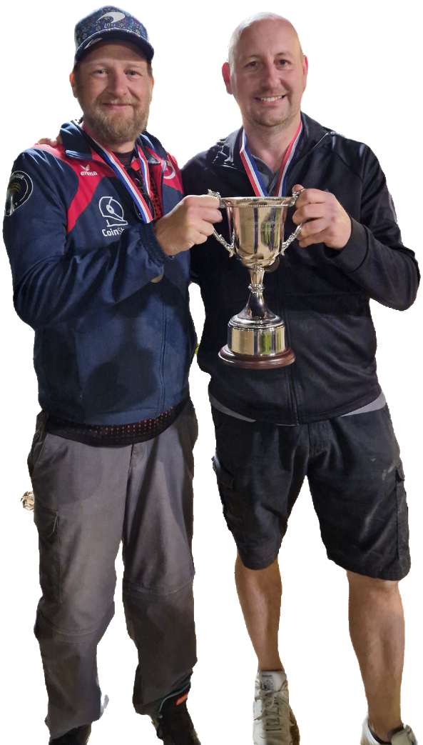

Thank you to all those who helped on the evening and played to make it another successful competition.

NEXT WEEK - SINGLES LEAGUE

Club email address - liberationpc@gmail.com

Club Website - www.liberationpetanque.co.uk

Kind Regards

Toby Northern

Chairman

Liberation Petanque Club

