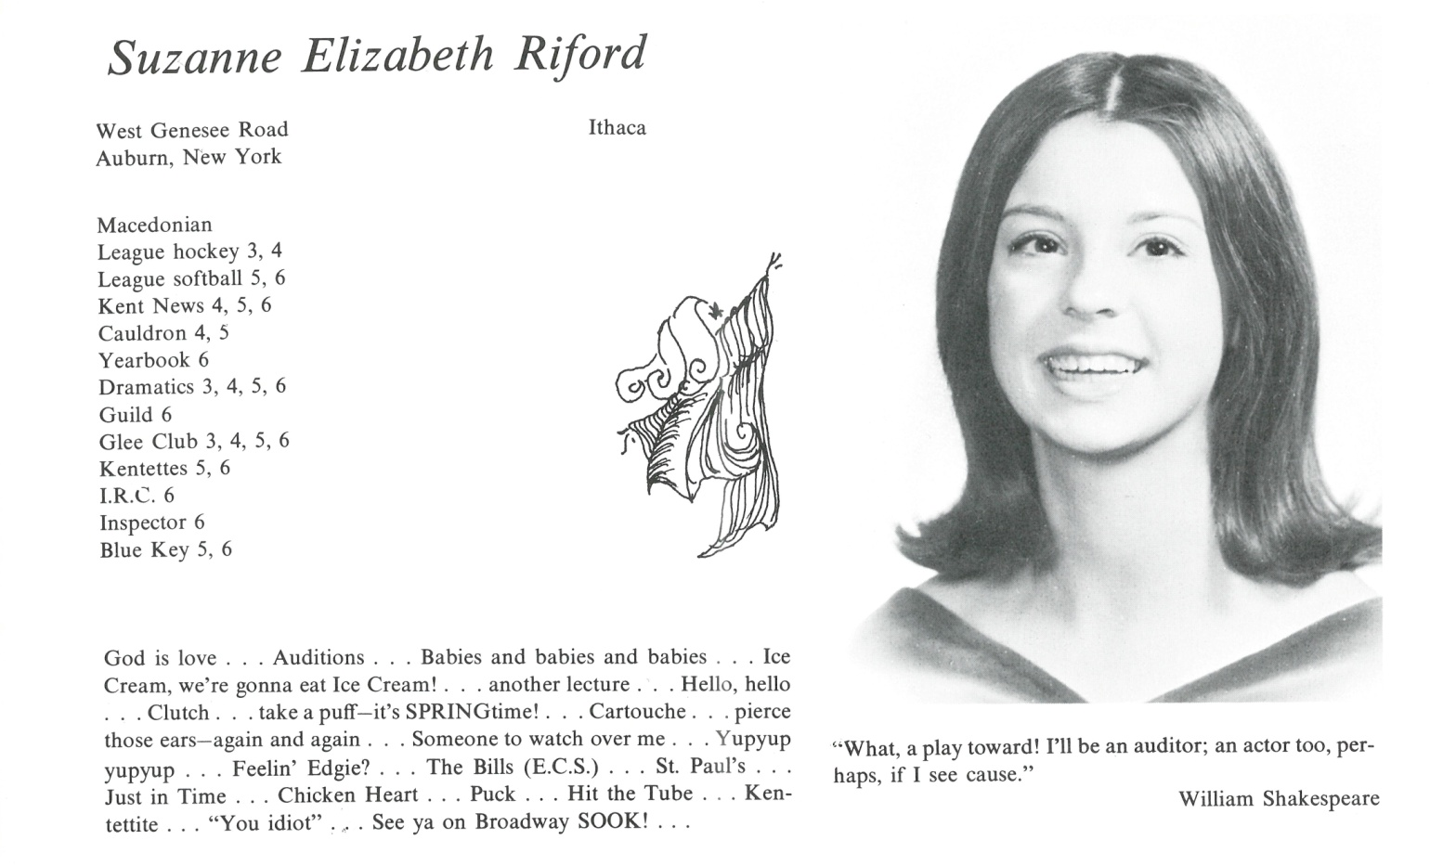

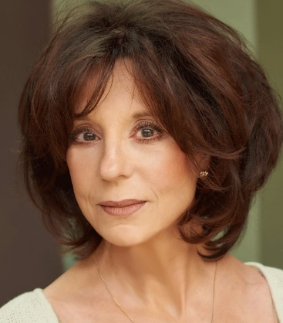Suzanne E. Riford Toman

Sooki (AKA Mrs. Alan Toman, AKA Suzanne Ford) is still acting, having been very active in theatre in New York for twenty years after Kent and college, and then having moved to Los Angeles in 1990, where she (finally) broke into film and television. Here’s a current show biz bio:

Suzanne Ford, seen in "Grace and Frankie" (Netflix) as Mary, and in the indie hit from the Duplass brothers "Manson Family Vacation" (Netflix) as Janice, also appeared in this season of "It's Always Sunny in Philadelphia" as a vulgar New Jersey cougar. She is currently shooting the first episode of a recurring guest star role on the breakout comedy series “Swedish Dicks.” (It’s not porn; it’s about two Swedish detectives in Los Angeles. Really.)

She trained in New York with Stella Adler and William Esper, and has appeared in over 100 stage productions there, on tour and in regional theatres around the country. In Hollywood she has guest starred on shows including "Girlfriends' Guide to Divorce," "Criminal Minds," "Anger Management," "The Middle," "Monk," "Bones," "How I Met Your Mother," "House," "That 70s Show," "Las Vegas," "Friends" and many others. Film work includes festival award-winning "You and Me," "MoniKa," "God's Country," "Darkening Sky" with Rider Strong, "Uncross the Stars" with Barbara Hershey and Ron Perlman, and "Of Silence" with writer/director/star Jeremiah Sayys. She played supporting roles in Joel Silver's thriller, "The Apparition," with Ashley Greene and Tom Felton, "The Informers," with Kim Basinger, Mickey Roarke, Brad Renfroe and Billy Bob Thornton, and "You, Me & Dupree," with Matt Dillon, Owen Wilson and Michael Douglas. She appears regularly in theatre productions on the west coast, recently at Pacific Resident Theatre in the world premiere of Kenneth Jones's "Two Henrys," and at International City Theatre starring as Polly Wyeth in "Other Desert Cities."

[More info at **suzanneford.com**, Twitter: **@suzford**, Instagram: **ford_suzanne**]

Sooki appears regularly as a narrator for the planetarium shows at the Griffith Observatory, which is nearby in the Hollywood Hills neighborhood where she and her husband Alan, a financial adviser with Lincoln Securities, have lived since 1997. Their amazing daughter, Caroline, is a Kent 1987 alumna, who with her husband, Dr. Hugh Snyder, has given them two adorable grandchildren, and, on top of that, is Chair of the English Department at Montclair Kimberly Academy in Montclair, New Jersey.



______________________________________________________________

______________________________________________________________ ______________________________________________________________ ______________________________________________________________ ______________________________________________________________ ______________________________________________________________ ______________________________________________________________ ______________________________________________________________ ______________________________________________________________

Attach Picture in .jpg Format

______________________________________________________________

______________________________________________________________

___________________________________________________________________________________ _________________________________________________________________________________________________________________________________________________________________________________________________________________________________________________________________________________________________________________________________________________________________________________________________________________________________________________________________________________________________________________________________________________________________________________________________________________________________________________________________________________________________________________________________________________________________________________________________________________________________________________________________________________________________________________________________________________________________________________________________________________________________________________________________________________________________________________________________________________________________________________________________________________________________________________________________________________________________________________________________________________________________________________________________________________________________________________________________________________________________________________________________________________________________________________________________________________________________________

___________________________________________________________________________________