**CATTLE FOR SALE**

**ALL CATTLE CAN BE**

**PREVIEWED ON SALE DAY**

|  |  |  |
| --- | --- | --- |
|  | 300 – 2 YEAR OLD BRED HEIFERS & PAIRS | CAZA RANCHES  ARTESIA, NM |
|  |  |  |
|  |  |  |

**300 – 2 YEAR OLD BRED HEIFERS**

**AND PAIRS –**

**Excellent quality black, bwf, Angus & English xb heifers with approximately 100 – 150 calves @ side out of Angus & Angus plus bulls. Remainder to be preg checked and should be in 2nd & 3rd trimester. Super nice set of heifers – off cake & grass – Medium condition.**

**CHAROLAIS BULLS**

**SALE ORDER WILL BE AVAILABLE ON SALE DAY**

**FRONT END, LONG YEARLING CHAROLAIS BULLS**

|  |  |  |
| --- | --- | --- |
| LOT 1 - 25 | 20 CHAROLAIS BULLS | BILL KING RANCH |
|  |  | **MORIARTY, NM** |
|  |  |  |



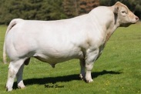

|  |  |  |
| --- | --- | --- |
| LOT 26 - 35 | 6 CHAROLAIS BULLS | GRAU RANCH |
|  |  | **GRADY, NM** |
|  |  |  |

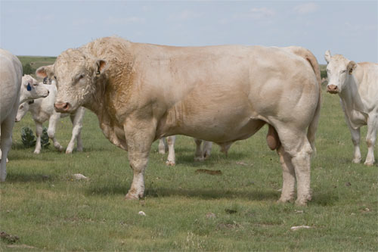

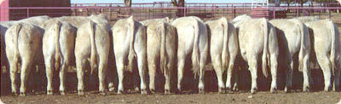

|  |  |  |
| --- | --- | --- |
| LOT 36 - 45 | 6 CHAROLAIS BULLS | BILL SIMS |
|  |  | **EUNICE, NM** |
|  |  |  |

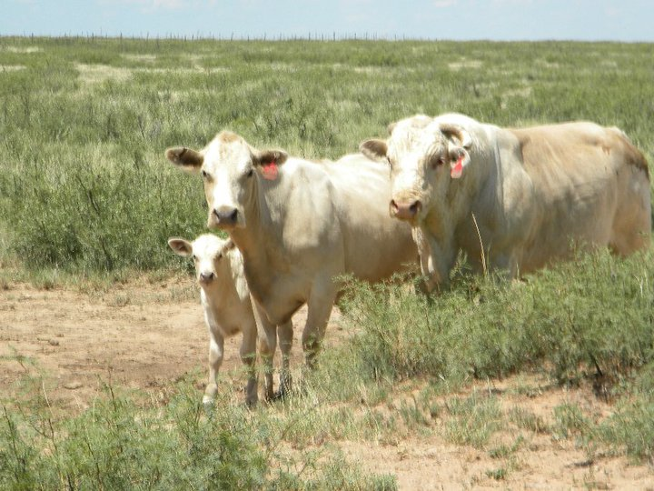

**CORRIENTE ROPING CATTLE**

|  |  |  |
| --- | --- | --- |
|  |  |  |
|  |  |  |
|  |  |  |

**30 – Fresh Native Corriente**

**roping cattle.**

**_________________________**

**ROPING CALVES**

|  |  |  |
| --- | --- | --- |
|  | 70 FRESH ROPING CALVES | DK BOYD RANCHES  ROSWELL,NM  & KERMIT, TX |
|  |  |  |
|  |  |  |

**70 – Fresh roping calves –**

**out of Angus / Charolais heifers and black Corriente bulls**