Vertical press Testers
Brief History:
Dunn’s Valve Testers Inc have been manufacturing Valve Testers since 1978. We were the first to introduce valve testers and set the standard for all valve testing. We strive to maintain that level of Durability Value and Technology well into the future.
Our Valve Testers provide a method of accurately and speedily testing valves at a relatively low cost per unit and designed with the test operator in mind.

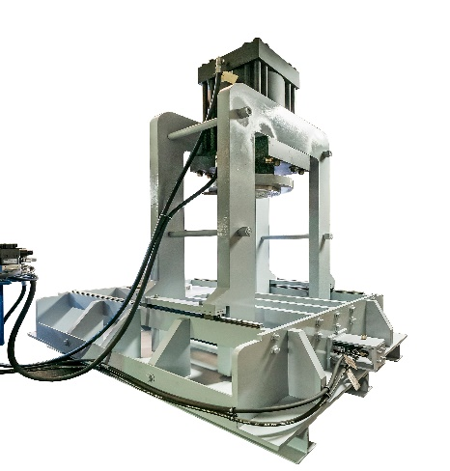
MODEL – Key Features
- All operate with a dual hydraulic system.
- Built to last and withstand the high torque and pressures verifying valve integrity with each valve test time after time.
build Specifications
Our Vertical Press machines come in varies sizes depending on the size of the valves and pressures to be applied.
- Valve Types – Gates ; Globes ; Plug ; Ball ; Butterfly ;
- End Connections – Flange ; Butt Weld ; RTJ ; RF ; S/E ; S/W ; WAFER
Standards - All Dunn’s Valve Testers built to test valves in accordance with USA and International Standards – API 526 ; ANSI/API RP 576 ; API 520 & 527 ; API 6D
Data Acquisition Module – will provide a report certificate that will be compliant with ISO 9000
Delivery – Approx. 10 to 14 work weeks
Start Time - based on payment terms being agreed and complete technical specifications.
Guarantee – All parts, machined parts for 12 months
DVT Range of Testers – Relief Valve; Control Valve; Vertical and Horizontal Press; Frame; Portable Testers
NOTE: Each unit is adapted and built to specific client requirements from these base models
Optional Extras Available – Data Acquisition System, Rapid Recycle System, Safety Shield, Hydro Static system, Regulated Air and Hydraulic System for filling, draining, venting or testing on one or both sides of the valve, up to 30,000 PSI test pressure can be added, Air Test, Auxiliary Port

Vertical types | Valve range | Test system (PSI) | Ton clamping
VP009 | 2” to 12” | 3,000 and up | 100
vp010 | 2” to 16” | 3,000 and up | 200
vp020 | 8” to 36” | 3,000 and up | 300

