
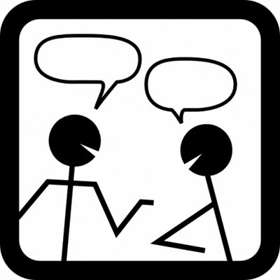
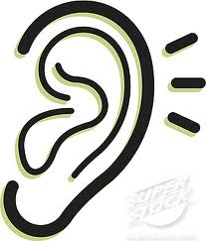
Collaborative Conversation Starter Cards for TRUE DISCUSSION

SPEAKER
LISTENER
©www.kbumreading.com
©www.kbumreading.com

*I’m wondering…?

*What I’m thinking is…

*My opinion is ___ because…

*This is confusing to me because…

*I figured out…I noticed…

*Based on the text I think that…..

*I was also wondering…?

*I think I hear you saying…

*I agree…(OR) I disagree..?

*I understand your confusion because….

*Can you tell me that again in a different way to help me understand?

*Can you show me text evidence that supports___?

SPEAKING
LISTENING
www.kbumreading.com
www.kbumreading.com

