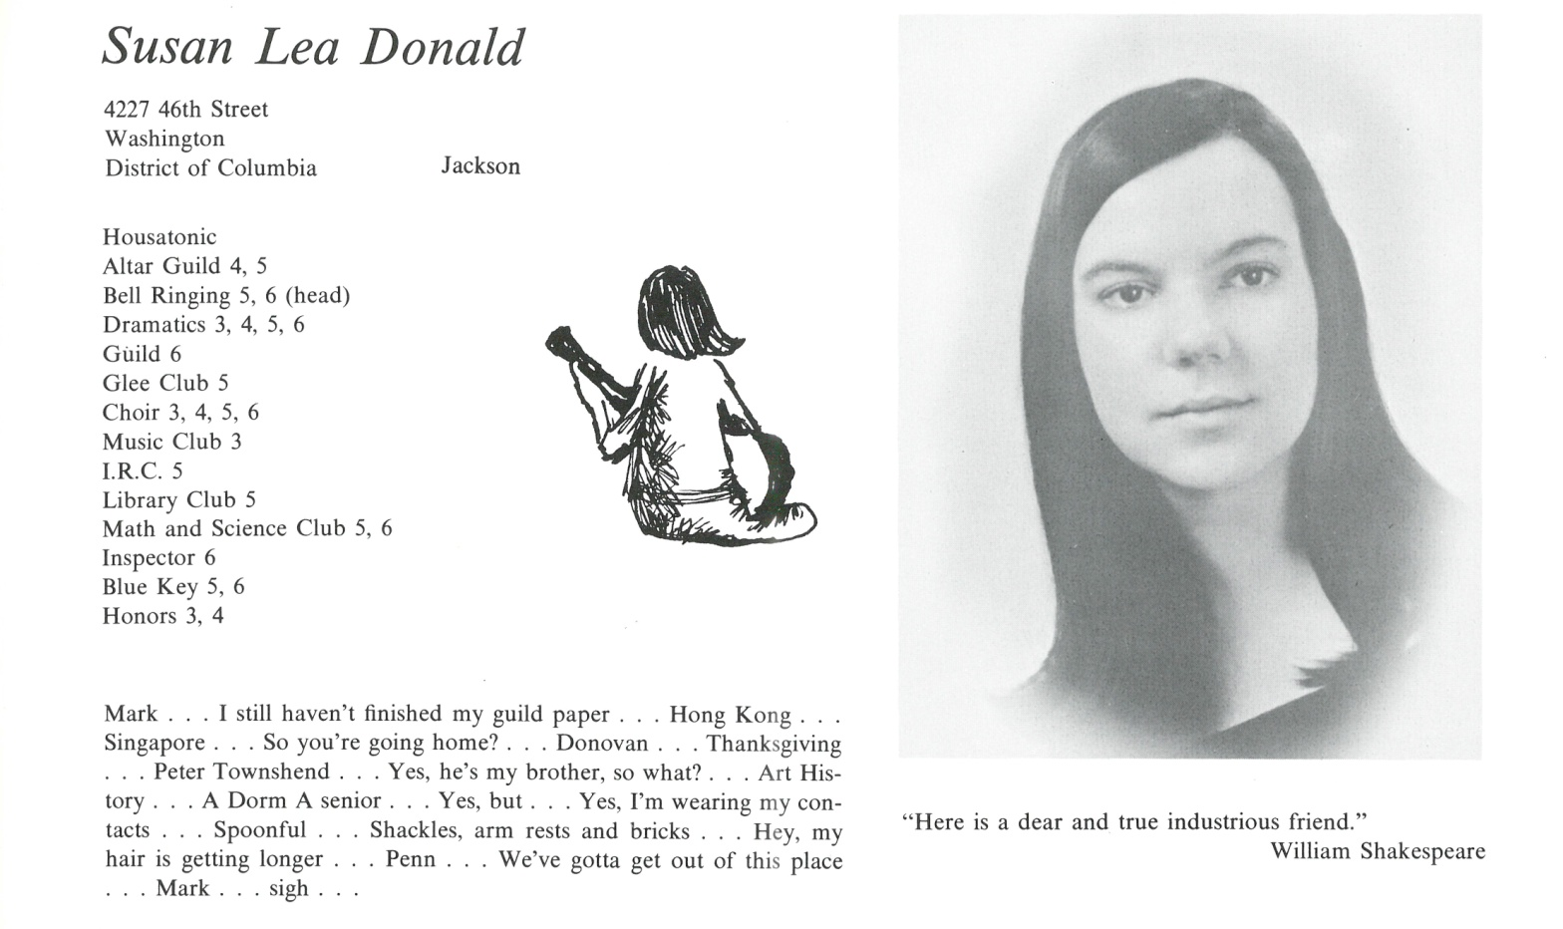

Dr. Susan L. Donald

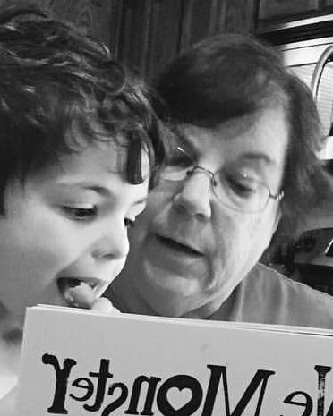I have just retired after many years working as a Speech Language Pathologist in schools in the Tampa Bay area. And, after 28 years of life in Florida, I’m planning to move to Kansas City to make it easier to spoil my two grandsons. That’s what retirement is for, isn’t it?

This seems an appropriate time to look back on the trajectory of my life. After Kent, I spent 5 years getting my B.A. at Tufts, taking off one year to join my family in Indonesia. My gap year! After getting a Ph.D. in Linguistics, focusing on experimental phonetics, I went to Iran to work at a university, and left 3 days after the Shah. Not yet having learned my lesson about jaunts abroad, I took a Fulbright Fellowship and spent 2 years in Somalia. Having been assured that Francophone West Africa was not the same as Mogadishu, I spent 3 years in Niger, where I ran an English Language program for the American Cultural Center. Having had my fill of Africa, I spent 4 years in Strasbourg, France teaching at a university.

Once I returned to the States, I floundered a while, and put together all the disparate aspects of my professional life into Communication Disorders, and became a Speech Language Pathologist. After 20 or so years working in inner city schools brings me up to date.

Whew! No wonder I’m tired. No, re-tired!



______________________________________________________________

______________________________________________________________ ______________________________________________________________ ______________________________________________________________ ______________________________________________________________ ______________________________________________________________ ______________________________________________________________ ______________________________________________________________ ______________________________________________________________

Attach Picture in .jpg Format

______________________________________________________________

______________________________________________________________

___________________________________________________________________________________ _________________________________________________________________________________________________________________________________________________________________________________________________________________________________________________________________________________________________________________________________________________________________________________________________________________________________________________________________________________________________________________________________________________________________________________________________________________________________________________________________________________________________________________________________________________________________________________________________________________________________________________________________________________________________________________________________________________________________________________________________________________________________________________________________________________________________________________________________________________________________________________________________________________________________________________________________________________________________________________________________________________________________________________________________________________________________________________________________________________________________________________________________________________________________________________________________________________________________________

___________________________________________________________________________________