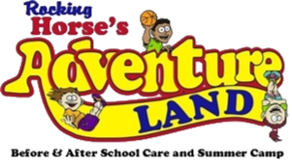

Our Apologies
Our Summer Camp Program
Is Currently Full

Please call (225) 749-6177 For
Further Options

