
RICK A SHACKET
DO, MD(H)

Main Office:

Scottsdale Vein & Proctology Center
8752 E Via De Commercio #2
Scottsdale, Arizona 85258
Office: (602) 492-9919 | Mobile: (602) 920-1023

Name: _______________________________________ DOB: ___________ Date: ___________

PRESCRIPTION

Rx: Orabase® Paste
Sig: Apply thin film to effected area as directed for canker sores.
Dispense: Paste Only. DO NOT SUBSTITUTE solution or gel for the PASTE!

___________________________________
Rick A. Shacket, DO, MD (H), BS9262611
Diplomate American Osteopathic Board of Family Physicians

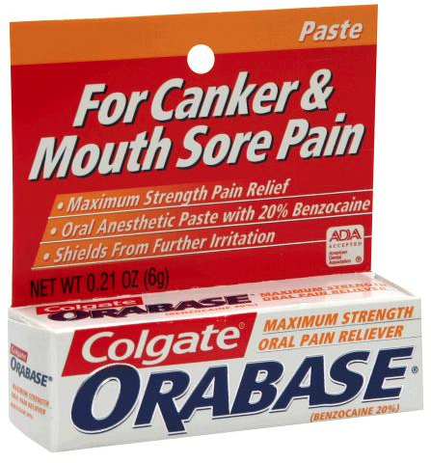

LOCATIONS
Scottsdale Vein & Proctology Center 8752 E Via De Commercio, Suite 2, Scottsdale, Arizona 85258
Dr. Rick Shacket PLLC 3543 N. 7th Street, Phoenix, Arizona 85014
Rick Shacket, DO, MD(H) 81 W. Guadalupe Road, Suite 111, Gilbert, Arizona 85233

