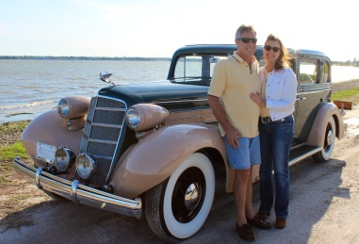
Real Restorations
By Pistorius Collectible Autos

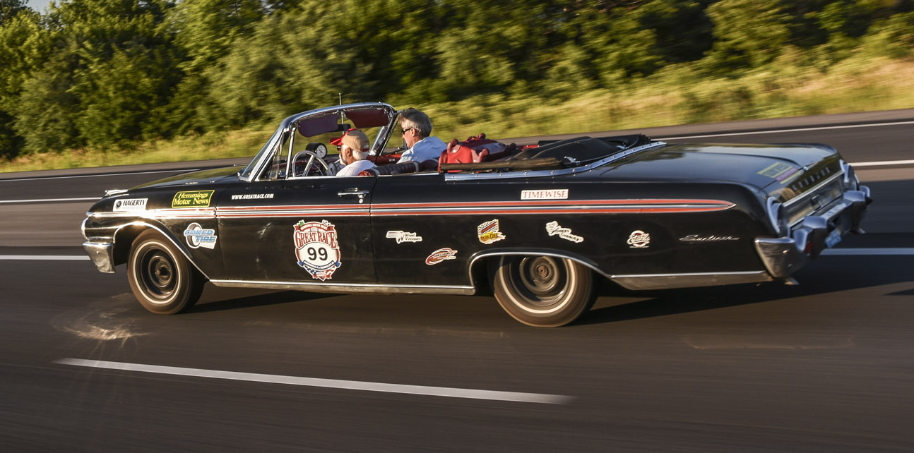
We ended last promising to talk more about matching your expectations to the different types of paints, and the best choice for your car.
We need to switch gears for one issue…. As our master restorations expert (Brando) is off on a 2,000 mile race that has been crisscrossing North America for over 34 years. The Great Race is an annual event where approximately 200 vintage cars rally from a different starting point every year, then follow strict route guidelines that are based on accuracy, not speed. Hidden checkpoints are set up to note the time the car passes, and being too early is just as costly as being too late.
Entrants are from all over the world. We met 7 teams from Japan at the starting line banquet. Ordinary car guys are treated as celebrities, signing autographs and answering countless questions from people who admire their efforts in this race. Thousands of people meet and greet them as they progress along the route, with breaks for lunch and dinner planned by the Great Race organizers and local car clubs in every town they stop. It is a journey to remember and should be listed on every car enthusiasts bucket list.
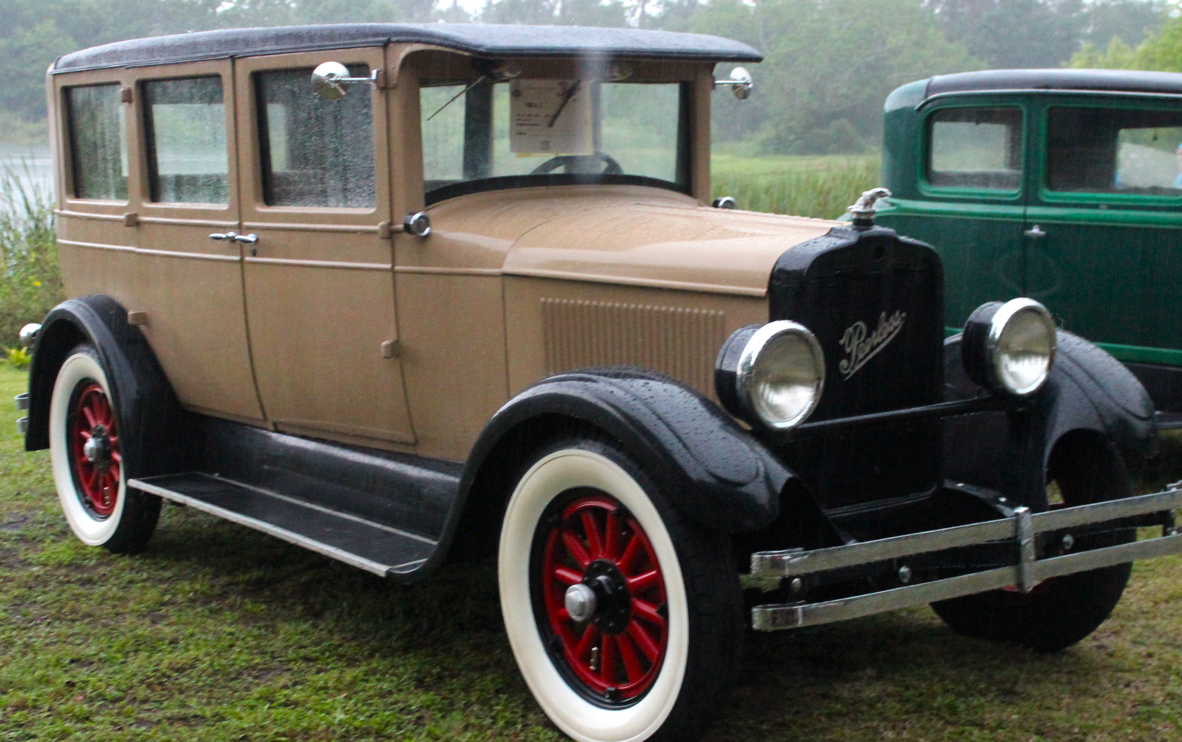
Brando is the Navigator with Ron Martin, the Driver and owner of the 1962 Ford Galaxie Sunliner that they are racing in. Ron and Brando worked on restoring Ron’s 1927 Peerless for 2 years for entry into this competition. But as Rookies, their assigned Mentor strongly recommended they reconsider using a car with wooden wheels, as the grueling route would certainly break down the wooden spokes,

as it has done so many times in the past. Ron flew to Canada, bought the Sunliner, and then test drove it more than 1,300 miles home to Tampa. After substantial engine and transmission work, they set off for Jacksonville to start their Great Race journey.
At the writing of this article they are on Stage 4 and running right in the middle of the pack and 6th for the Rookies. By the time you will be reading this, it will be over and another great adventure will be listed in the memories of Brando and Ron, and all of us blessed to participate in this fantastic experience. Brando and Ron have enjoyed many rewarding experiences individually (Brando having travelled hundreds of thousands of miles across America in the vintage car hobby and Ron having flown across the world as a professional balloonist). They have already described this Great Race experience as one of the highlights of their lives. And as Brando often says “Let’s drive those old cars!”

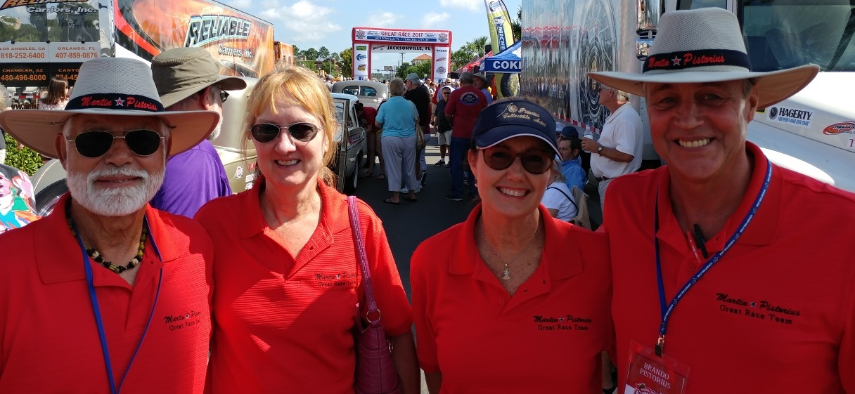

Cheers!
Brando & Joanne Pistorius

