## St. Luke’s Episcopal Church

**Palm/Passion Saturday & Sunday**

**Blessing of the Palms & Holy Eucharist**

The Reverend Michael L. Delk, *Celebrant*

The Reverend Allison Caudill, *Preacher*

**THE WORD OF GOD**

**Organ Voluntary “All glory, laud, and honor” J. S. Bach**

**The Opening Acclamation Page 270**

***Celebrant*** Blessed is the King who comes in the name of the Lord.

***People* Peace in heaven and glory in the highest.**

***Celebrant*** Let us pray.

Assist us mercifully with your help, O Lord God of our salvation, that we may enter with joy upon the contemplation of those mighty acts, whereby you have given us life and immortality; through Jesus Christ our Lord. ***Amen.***

**A Reading from the Gospel of Matthew 21:1-11**

When they had come near Jerusalem and had reached Bethphage, at the Mount of Olives, Jesus sent two disciples, saying to them, "Go into the village ahead of you, and immediately you will find a donkey tied, and a colt with her; untie them and bring them to me. If anyone says anything to you, just say this, 'The Lord needs them.' And he will send them immediately." This took place to fulfill what had been spoken through the prophet, saying, "Tell the daughter of Zion, Look, your king is coming to you, humble, and mounted on a donkey, and on a colt, the foal of a donkey." The disciples went and did as Jesus had directed them; they brought the donkey and the colt, and put their cloaks on them, and he sat on them. A very large crowd spread their cloaks on the road, and others cut branches from the trees and spread them on the road. The crowds that went ahead of him and that followed were shouting, "Hosanna to the Son of David! Blessed is the one who comes in the name of the Lord! Hosanna in the highest heaven!" When he entered Jerusalem, the whole city was in turmoil, asking, "Who is this?" The crowds were saying, "This is the prophet Jesus from Nazareth in Galilee.”

**The Blessing of the Palms Page 271**

***Celebrant*** The Lord be with you.

***People* And also with you.**

***Celebrant*** Let us give thanks to the Lord our God.

***People* It is right to give him thanks and praise.**

It is right to praise you, Almighty God, for the acts of love by which you have redeemed us through your Son Jesus Christ our Lord. On this day he entered the holy city of Jerusalem in triumph, and was proclaimed as King of kings by those who spread their garments and branches of palm along his way. Let these branches be for us signs of the victory, and grant that we who bear them in his name may ever hail him as our King, and follow him in the way that leads to eternal life; who lives and reigns in glory with you and the Holy Spirit, now and for ever. ***Amen.***

***Celebrant*** Blessed is he who comes in the name of the Lord.

***People* Hosanna in the highest.**

***Celebrant*** Let us go forth in the name of Christ.

***People* In the name of Christ. Amen.**

Almighty God, whose most dear Son went not up to joy but first he suffered pain, and entered not into glory before he was crucified: Mercifully grant that we, walking in the way of the cross, may find it none other than the way of life and peace; through Jesus Christ our Lord. ***Amen.***

**The Processional “All glory, laud, and honor” Hymnal, 154**

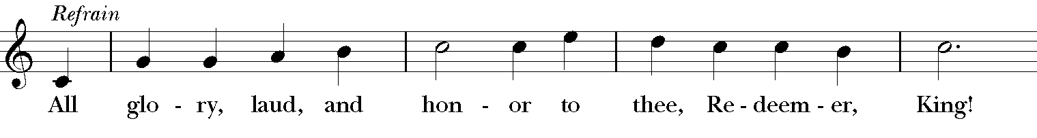

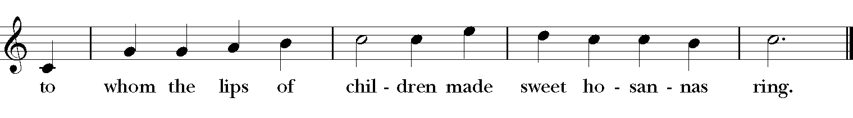

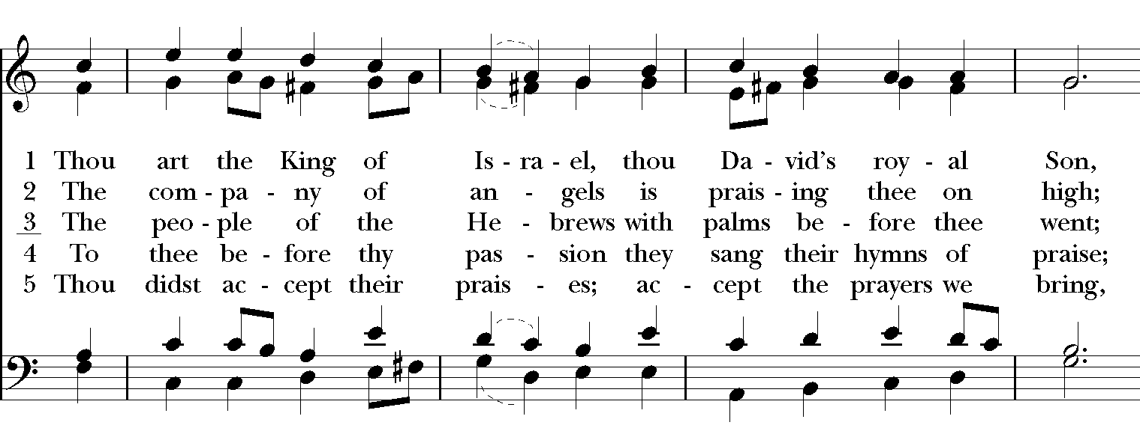

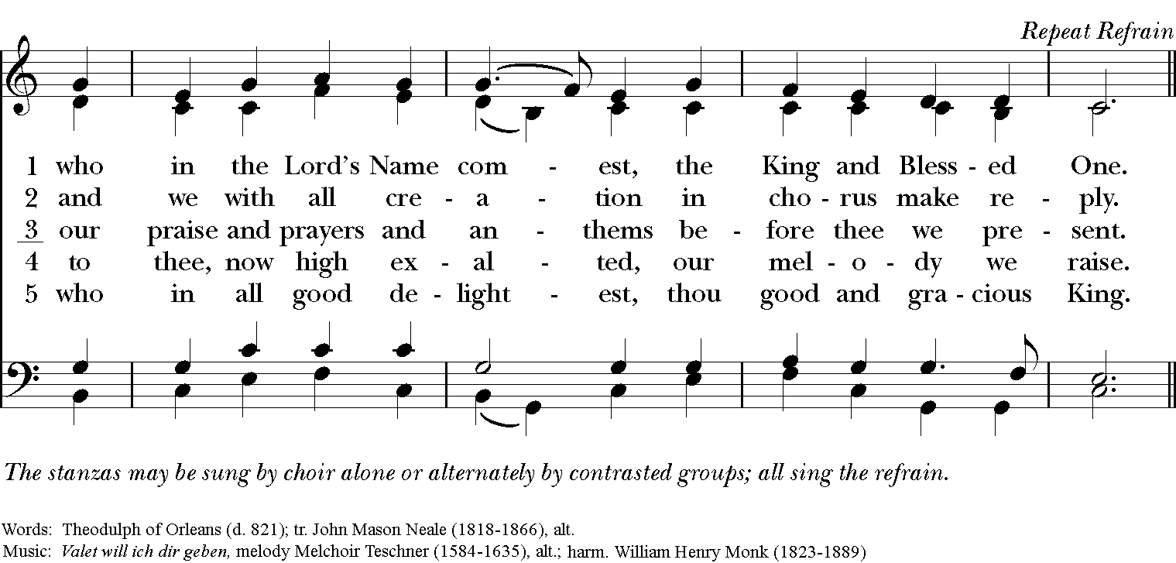

**The Salutation & Collect of the Day Page 357**

***Celebrant*** The Lord be with you.

***People* And also with you.**

***Celebrant*** Let us pray.

Almighty and everliving God, in your tender love for the human race you sent your Son our Savior Jesus Christ to take upon him our nature, and to suffer death upon the cross, giving us the example of his great humility: Mercifully grant that we may walk in the way of his suffering, and also share in his resurrection; through Jesus Christ our Lord, who lives and reigns with you and the Holy Spirit, one God, for ever and ever.  ***Ame*n.**

**The First Lesson Isaiah 50:4-9a**

The Lord God has given me the tongue of a teacher, that I may know how to sustain the weary with a word. Morning by morning he wakens – wakens my ear to listen as those who are taught. The Lord God has opened my ear, and I was not rebellious, I did not turn backward. I gave my back to those who struck me, and my cheeks to those who pulled out the beard; I did not hide my face from insult and spitting. The Lord God helps me; therefore I have not been disgraced; there I have set my face like flint, and I know that I shall not be put to shame; he who vindicates me is near. Who will contend with me? Let us stand up together. Who are my adversaries? Let them confront me. It is the Lord God who helps me; who will declare me guilty?

The Word of the Lord.

***People* Thanks be to God.**

**Psalm 31:9-16 Page 623**

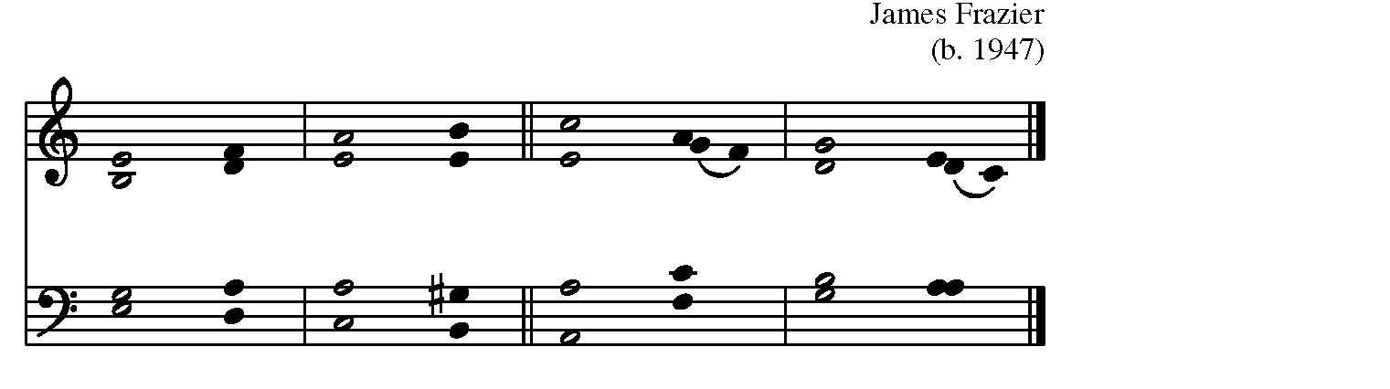

  
9 Have mercy on me, O Lord, for I am in **trouble**;*

my eye is consumed with sorrow, and also my throat and my **belly**.

10 For my life is wasted with grief, and my years with **sighing**;*

my strength fails me because of affliction,

and my bones are con-**sumed.**

11 I have become a reproach to all my enemies and even to my neighbors,

a dismay to those of my ac-**quaintance**;*

when they see me in the street they a-**void me.**

12 I am forgotten like a dead man, out of **mind**;*

I am as useless as a broken **pot**.

13 For I have heard the whispering of the crowd; fear is all a-**round**;*

they put their heads together against me; they plot to take my **life**.

14 But as for me, I have trusted in you, O **Lord**.*

I have said, “You are my **God**.”

15 My times are in your **hand**;*

rescue me from the hand of my enemies,

and from those who **persecute me**.

16 Make your face to shine upon your **servant**,*

and in your loving-kindness **save me.”**

**The Second Lesson Philippians 2:5-11**

Let the same mind be in you that was in Christ Jesus, who, though he was in the form of God, did not regard equality with God as something to be exploited, but emptied himself, taking the form of a slave, being born in human likeness. And being found in human form, he humbled himself and became obedient to the point of death—even death on a cross. Therefore God also highly exalted him and gave him the name that is above every name, so that at the name of Jesus every knee should bend, in heaven and on earth and under the earth, and every tongue should confess that Jesus Christ is Lord, to the glory of God the Father.

The Word of the Lord.

***People* Thanks be to God.**

**Sequence Hymn “Go to dark Gethsemane” Hymn 171**

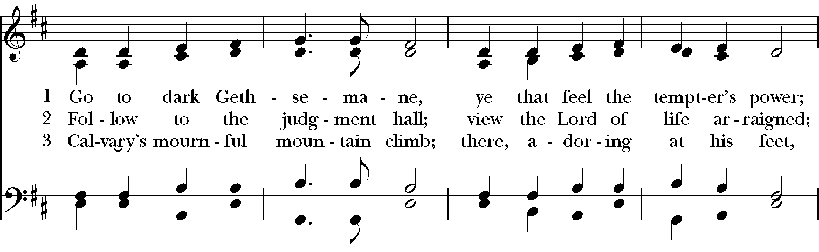

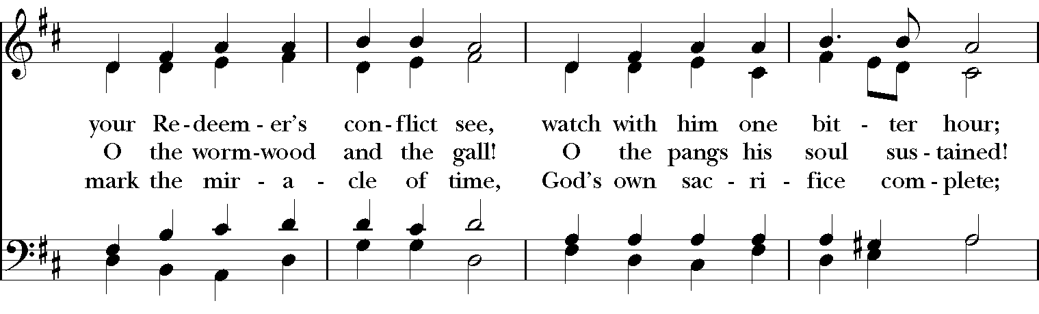

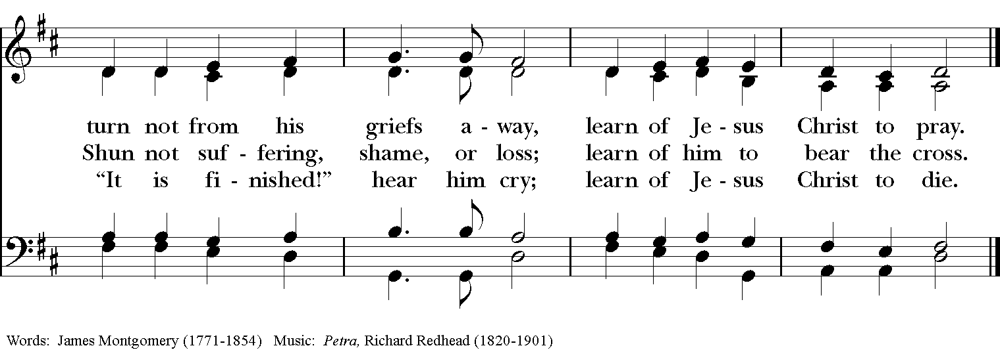

**The Holy Gospel Matthew 26:14 – 27:66**

*The Gospel will begin with a brief introduction and no congregational response.*

*The congregation remains seated, then stands at the mention of Golgotha.*

Then one of the twelve, who was called Judas Iscariot, went to the chief priests and said, "What will you give me if I betray him to you?" They paid him thirty pieces of silver. And from that moment he began to look for an opportunity to betray him. On the first day of Unleavened Bread the disciples came to Jesus, saying, "Where do you want us to make the preparations for you to eat the Passover?" He said, "Go into the city to a certain man, and say to him, 'The Teacher says, My time is near; I will keep the Passover at your house with my disciples.'" So the disciples did as Jesus had directed them, and they prepared the Passover meal. When it was evening, he took his place with the twelve; and while they were eating, he said, "Truly I tell you, one of you will betray me." And they became greatly distressed and began to say to him one after another, "Surely not I, Lord?" He answered, "The one who has dipped his hand into the bowl with me will betray me. The Son of Man goes as it is written of him, but woe to that one by whom the Son of Man is betrayed! It would have been better for that one not to have been born." Judas, who betrayed him, said, "Surely not I, Rabbi?" He replied, "You have said so."

While they were eating, Jesus took a loaf of bread, and after blessing it he broke it, gave it to the disciples, and said, "Take, eat; this is my body." Then he took a cup, and after giving thanks he gave it to them, saying, "Drink from it, all of you; for this is my blood of the covenant, which is poured out for many for the forgiveness of sins. I tell you, I will never again drink of this fruit of the vine until that day when I drink it new with you in my Father's kingdom." When they had sung the hymn, they went out to the Mount of Olives. Then Jesus said to them, "You will all become deserters because of me this night; for it is written, 'I will strike the shepherd, and the sheep of the flock will be scattered.' But after I am raised up, I will go ahead of you to Galilee." Peter said to him, "Though all become deserters because of you, I will never desert you." Jesus said to him, "Truly I tell you, this very night, before the cock crows, you will deny me three times." Peter said to him, "Even though I must die with you, I will not deny you." And so said all the disciples.

Then Jesus went with them to a place called Gethsemane; and he said to his disciples, "Sit here while I go over there and pray." He took with him Peter and the two sons of Zebedee, and began to be grieved and agitated. Then he said to them, "I am deeply grieved, even to death; remain here, and stay awake with me." And going a little farther, he threw himself on the ground and prayed, "My Father, if it is possible, let this cup pass from me; yet not what I want but what you want." Then he came to the disciples and found them sleeping; and he said to Peter, "So, could you not stay awake with me one hour? Stay awake and pray that you may not come into the time of trial; the spirit indeed is willing, but the flesh is weak." Again he went away for the second time and prayed, "My Father, if this cannot pass unless I drink it, your will be done." Again he came and found them sleeping, for their eyes were heavy. So leaving them again, he went away and prayed for the third time, saying the same words. Then he came to the disciples and said to them, "Are you still sleeping and taking your rest? See, the hour is at hand, and the Son of Man is betrayed into the hands of sinners. Get up, let us be going. See, my betrayer is at hand." While he was still speaking, Judas, one of the twelve, arrived; with him was a large crowd with swords and clubs, from the chief priests and the elders of the people. Now the betrayer had given them a sign, saying, "The one I will kiss is the man; arrest him." At once he came up to Jesus and said, "Greetings, Rabbi!" and kissed him. Jesus said to him, "Friend, do what you are here to do."

Then they came and laid hands on Jesus and arrested him. Suddenly, one of those with Jesus put his hand on his sword, drew it, and struck the slave of the high priest, cutting off his ear. Then Jesus said to him, "Put your sword back into its place; for all who take the sword will perish by the sword. Do you think that I cannot appeal to my Father, and he will at once send me more than twelve legions of angels? But how then would the scriptures be fulfilled, which say it must happen in this way?" At that hour Jesus said to the crowds, "Have you come out with swords and clubs to arrest me as though I were a bandit? Day after day I sat in the temple teaching, and you did not arrest me. But all this has taken place, so that the scriptures of the prophets may be fulfilled." Then all the disciples deserted him and fled. Those who had arrested Jesus took him to Caiaphas the high priest, in whose house the scribes and the elders had gathered. But Peter was following him at a distance, as far as the courtyard of the high priest; and going inside, he sat with the guards in order to see how this would end. Now the chief priests and the whole council were looking for false testimony against Jesus so that they might put him to death, but they found none, though many false witnesses came forward. At last two came forward and said, "This fellow said, 'I am able to destroy the temple of God and to build it in three days.'" The high priest stood up and said, "Have you no answer? What is it that they testify against you?" But Jesus was silent. Then the high priest said to him, "I put you under oath before the living God, tell us if you are the Messiah, the Son of God." Jesus said to him, "You have said so. But I tell you, From now on you will see the Son of Man seated at the right hand of Power and coming on the clouds of heaven." Then the high priest tore his clothes and said, "He has blasphemed! Why do we still need witnesses? You have now heard his blasphemy. What is your verdict?" They answered, "He deserves death." Then they spat in his face and struck him; and some slapped him, saying, "Prophesy to us, you Messiah! Who is it that struck you?"

Now Peter was sitting outside in the courtyard. A servant-girl came to him and said, "You also were with Jesus the Galilean." But he denied it before all of them, saying, "I do not know what you are talking about." When he went out to the porch, another servant-girl saw him, and she said to the bystanders, "This man was with Jesus of Nazareth." Again he denied it with an oath, "I do not know the man." After a little while the bystanders came up and said to Peter, "Certainly you are also one of them, for your accent betrays you." Then he began to curse, and he swore an oath, "I do not know the man!" At that moment the cock crowed. Then Peter remembered what Jesus had said: "Before the cock crows, you will deny me three times." And he went out and wept bitterly.

When morning came, all the chief priests and the elders of the people conferred together against Jesus in order to bring about his death. They bound him, led him away, and handed him over to Pilate the governor. When Judas, his betrayer, saw that Jesus was condemned, he repented and brought back the thirty pieces of silver to the chief priests and the elders. He said, "I have sinned by betraying innocent blood." But they said, "What is that to us? See to it yourself." Throwing down the pieces of silver in the temple, he departed; and he went and hanged himself. But the chief priests, taking the pieces of silver, said, "It is not lawful to put them into the treasury, since they are blood money." After conferring together, they used them to buy the potter's field as a place to bury foreigners. For this reason that field has been called the Field of Blood to this day. Then was fulfilled what had been spoken through the prophet Jeremiah, "And they took the thirty pieces of silver, the price of the one on whom a price had been set, on whom some of the people of Israel had set a price, and they gave them for the potter's field, as the Lord commanded me."

Now Jesus stood before the governor; and the governor asked him, "Are you the King of the Jews?" Jesus said, "You say so." But when he was accused by the chief priests and elders, he did not answer. Then Pilate said to him, "Do you not hear how many accusations they make against you?" But he gave him no answer, not even to a single charge, so that the governor was greatly amazed. Now at the festival the governor was accustomed to release a prisoner for the crowd, anyone whom they wanted. At that time they had a notorious prisoner, called Jesus Barabbas. So after they had gathered, Pilate said to them, "Whom do you want me to release for you, Jesus Barabbas or Jesus who is called the Messiah?" For he realized that it was out of jealousy that they had handed him over. While he was sitting on the judgment seat, his wife sent word to him, "Have nothing to do with that innocent man, for today I have suffered a great deal because of a dream about him." Now the chief priests and the elders persuaded the crowds to ask for Barabbas and to have Jesus killed. The governor again said to them, "Which of the two do you want me to release for you?" And they said, "Barabbas." Pilate said to them, "Then what should I do with Jesus who is called the Messiah?" All of them said, "Let him be crucified!" Then he asked, "Why, what evil has he done?" But they shouted all the more, "Let him be crucified!" So when Pilate saw that he could do nothing, but rather that a riot was beginning, he took some water and washed his hands before the crowd, saying, "I am innocent of this man's blood; see to it yourselves." Then the people as a whole answered, "His blood be on us and on our children!"

So he released Barabbas for them; and after flogging Jesus, he handed him over to be crucified. Then the soldiers of the governor took Jesus into the governor's headquarters, and they gathered the whole cohort around him. They stripped him and put a scarlet robe on him, and after twisting some thorns into a crown, they put it on his head. They put a reed in his right hand and knelt before him and mocked him, saying, "Hail, King of the Jews!" They spat on him, and took the reed and struck him on the head. After mocking him, they stripped him of the robe and put his own clothes on him. Then they led him away to crucify him.

As they went out, they came upon a man from Cyrene named Simon; they compelled this man to carry his cross. And when they came to a place called Golgotha (which means Place of a Skull), they offered him wine to drink, mixed with gall; but when he tasted it, he would not drink it. And when they had crucified him, they divided his clothes among themselves by casting lots; then they sat down there and kept watch over him. Over his head they put the charge against him, which read, "This is Jesus, the King of the Jews." Then two bandits were crucified with him, one on his right and one on his left. Those who passed by derided him, shaking their heads and saying, "You who would destroy the temple and build it in three days, save yourself! If you are the Son of God, come down from the cross." In the same way the chief priests also, along with the scribes and elders, were mocking him, saying, "He saved others; he cannot save himself. He is the King of Israel; let him come down from the cross now, and we will believe in him. He trusts in God; let God deliver him now, if he wants to; for he said, 'I am God's Son.'" The bandits who were crucified with him also taunted him in the same way.

From noon on, darkness came over the whole land until three in the afternoon. And about three o'clock Jesus cried with a loud voice, "Eli, Eli, lema sabachthani?" that is, "My God, my God, why have you forsaken me?" When some of the bystanders heard it, they said, "This man is calling for Elijah." At once one of them ran and got a sponge, filled it with sour wine, put it on a stick, and gave it to him to drink. But the others said, "Wait, let us see whether Elijah will come to save him." Then Jesus cried again with a loud voice and breathed his last. At that moment the curtain of the temple was torn in two, from top to bottom. The earth shook, and the rocks were split. The tombs also were opened, and many bodies of the saints who had fallen asleep were raised. After his resurrection they came out of the tombs and entered the holy city and appeared to many.

Now when the centurion and those with him, who were keeping watch over Jesus, saw the earthquake and what took place, they were terrified and said, "Truly this man was God's Son!" Many women were also there, looking on from a distance; they had followed Jesus from Galilee and had provided for him. Among them were Mary Magdalene, and Mary the mother of James and Joseph, and the mother of the sons of Zebedee. When it was evening, there came a rich man from Arimathea, named Joseph, who was also a disciple of Jesus. He went to Pilate and asked for the body of Jesus; then Pilate ordered it to be given to him. So Joseph took the body and wrapped it in a clean linen cloth and laid it in his own new tomb, which he had hewn in the rock. He then rolled a great stone to the door of the tomb and went away.

Mary Magdalene and the other Mary were there, sitting opposite the tomb. The next day, that is, after the day of Preparation, the chief priests and the Pharisees gathered before Pilate and said, "Sir, we remember what that impostor said while he was still alive, 'After three days I will rise again.' Therefore command the tomb to be made secure until the third day; otherwise his disciples may go and steal him away, and tell the people, 'He has been raised from the dead,' and the last deception would be worse than the first." Pilate said to them, "You have a guard of soldiers; go, make it as secure as you can." So they went with the guard and made the tomb secure by sealing the stone.

**Sermon**

**The Prayers of the People, Form VI Page 392**

*The Leader and People pray responsively*

In peace, we pray to you, Lord God.

*Silence*

For all people in their daily life and work;

***For our families, friends, and neighbors, and for those who are alone*.**

For Donald our President, Andy our Governor, and Thomas our Mayor, and for this community, the nation, and the world;

***For all who work for justice, freedom, and peace.***

For the just and proper use of your creation;

***For the victims of hunger, fear, injustice, and oppression*.**

For all who are in danger, sorrow, or any kind of trouble;

***For those who minister to the sick, the friendless, and the needy*.**

For the peace and unity of the Church of God;

***For all who proclaim the Gospel, and all who seek the Truth.***

For Justin, the Archbishop of Canterbury, Michael, our Presiding Bishop, Terry, our Bishop, for Michael, Allison, Anne, Art, and Jim, our clergy and all bishops and other ministers;

***For all who serve God in his Church*.**

For the special needs and concerns of this congregation, especially for . . .

*Silence*

*The People may add their own petitions*

Hear us, Lord;

***For your mercy is great*.**

We thank you, Lord, for all the blessings of this life.

*Silence*

*The People may add their own thanksgivings*

We will exalt you, O God our King;

***And praise your Name for ever and ever*.**

We pray for all who have died, that they may have a place in your eternal kingdom.

*Silence*

*The People may add their own petitions*

Lord, let your loving‑kindness be upon them;

***Who put their trust in you*.**

We pray to you also for the forgiveness of our sins.

*Silence may be kept*.

*Leader and People*

**Have mercy upon us, most merciful Father; in your compassion forgive us our sins,**

**known and unknown, things done and left undone; and so uphold us by your Spirit**

**that we may live and serve you in newness of life, to the honor and glory of your Name; through Jesus Christ our Lord. Amen.**

**The Absolution**

**The Peace**

***All stand. The celebrant says to the people***

The peace of the Lord be always with you.

***People* And also with you.**

**THE HOLY COMMUNION**

**Offertory Anthem “O sacred head, sore wounded” David Hurd**

Doug Murray, *bass*

**The Great Thanksgiving: Eucharistic Prayer A**

**Page 361**

*S120a*

*Celebrant* It is right and a good and joyful thing, always and everywhere to give thanks to you, Father Almighty, Creator of heaven and earth.

*Here the Celebrant adds a Proper Preface*

Therefore we praise you, joining our voices with Angels and Archangels and with all the company of heaven, who for ever sing this hymn to proclaim the glory of your Name.

*Celebrant and people*

**Sanctus: S-124 “Holy, holy, holy Lord”**

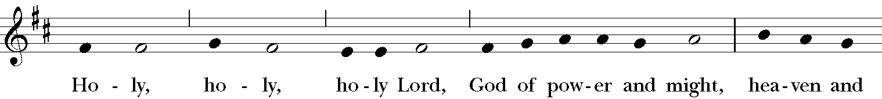

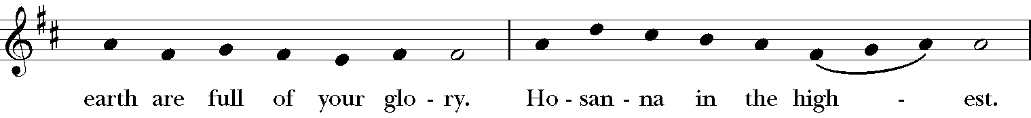

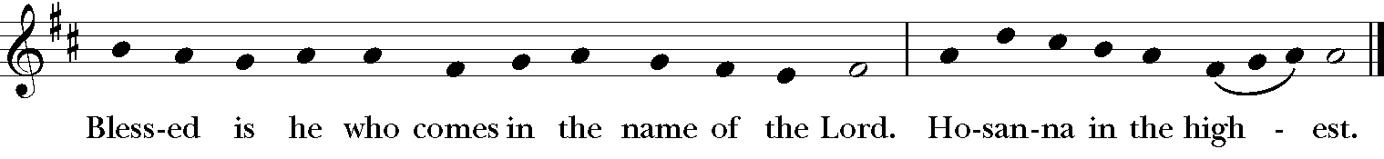

*The Celebrant continues*

Holy and gracious Father: In your infinite love you made us for yourself; and, when we had fallen into sin and become subject to evil and death, you, in your mercy, sent Jesus Christ, your only and eternal Son, to share our human nature, to live and die as one of us, to reconcile us to you, the God and Father of all. He stretched out his arms upon the cross, and offered himself, in obedience to your will, a perfect sacrifice for the whole world.

On the night he was handed over to suffering and death, our Lord Jesus Christ took bread; and when he had given thanks to you, he broke it, and gave it to his disciples, and said, “Take, eat: This is my Body, which is given for you. Do this for the remembrance of me.”

After supper he took the cup of wine; and when he had given thanks, he gave it to them, and said, “Drink this, all of you: This is my Blood of the new Covenant, which is shed for you and for many for the forgiveness of sins. Whenever you drink it, do this for the remembrance of me.”

Therefore we proclaim the mystery of faith:

**People Christ has died.**

**Christ is risen.**

**Christ will come again.**

*The Celebrant continues*

We celebrate the memorial of our redemption, O Father, in this sacrifice of praise and thanksgiving. Recalling his death, resurrection, and ascension, we offer you these gifts.

Sanctify them by your Holy Spirit to be for your people the Body and Blood of your Son, the holy food and drink of new and unending life in him. Sanctify us also that we may faithfully receive this holy Sacrament, and serve you in unity, constancy, and peace; and at the last day, bring us with all your saints into the joy of your eternal kingdom.

All this we ask through your Son Jesus Christ. By him, and with him, and in him, in the unity of the Holy Spirit all honor and glory is yours, Almighty Father, now and for ever. **AMEN**.

**The Lord’s Prayer**

**Our Father, who art in heaven, hallowed be Thy Name. Thy kingdom come, Thy will be done, on Earth as it is in heaven. Give us this day our daily bread, and forgive us our trespasses, as we forgive those who trespass against us, and lead us not into temptation, but deliver us from evil, for thine is the kingdom and the power and the glory, for ever and ever. Amen.**

**Agnus Dei: S-161**

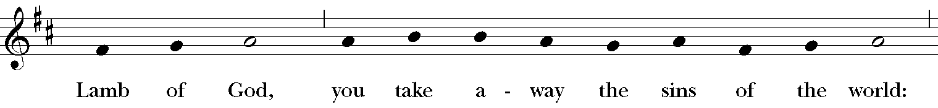

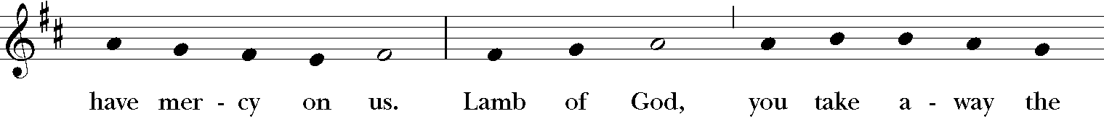

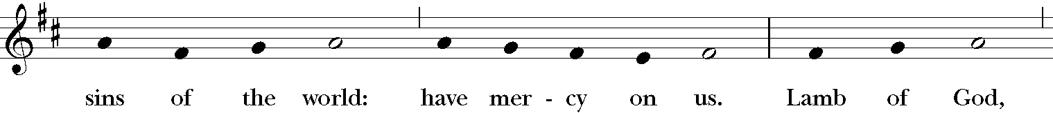

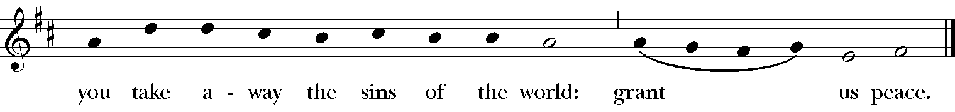

**A Prayer from the St. Augustine Prayer Book**

*As the clergy receive the elements of Communion, the congregation says aloud this prayer*

***All* Jesus, my Savior, I ask you to come into my heart and fill me with your love. Although I cannot physically join with others to celebrate the Eucharist today, I desire to offer my thanksgivings and prayers in union with all who worship you, wherever they may be. And although I cannot receive you now sacramentally in the bread and wine of Holy Communion, still I desire to receive your body and blood spiritually and feed on your love, that I may be united with you and with all your people in one communion and fellowship, your mystical body the church, now and ever more. Amen.**

**Communion Hymn “Were you there?” Hymnal, 172**

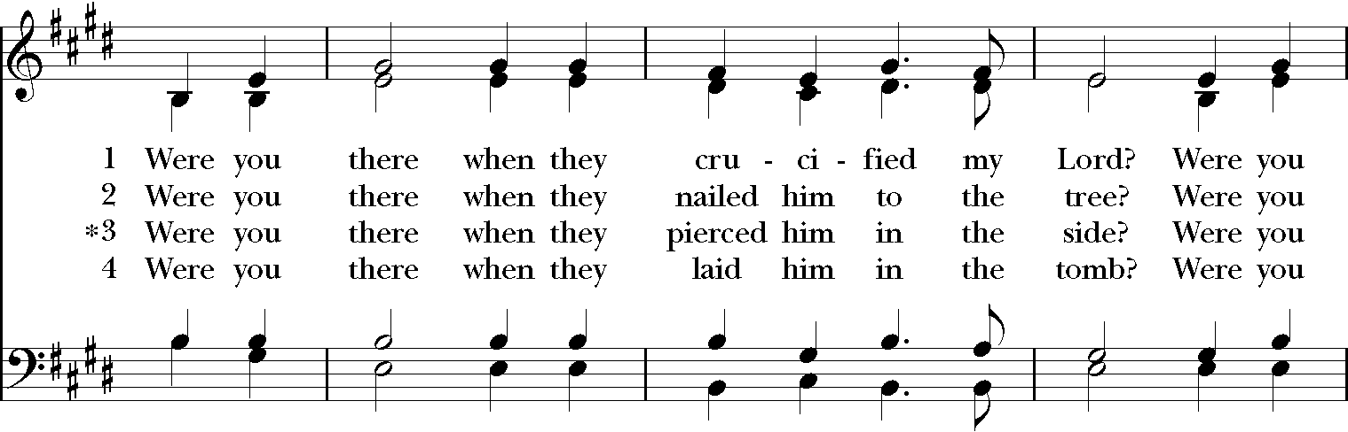

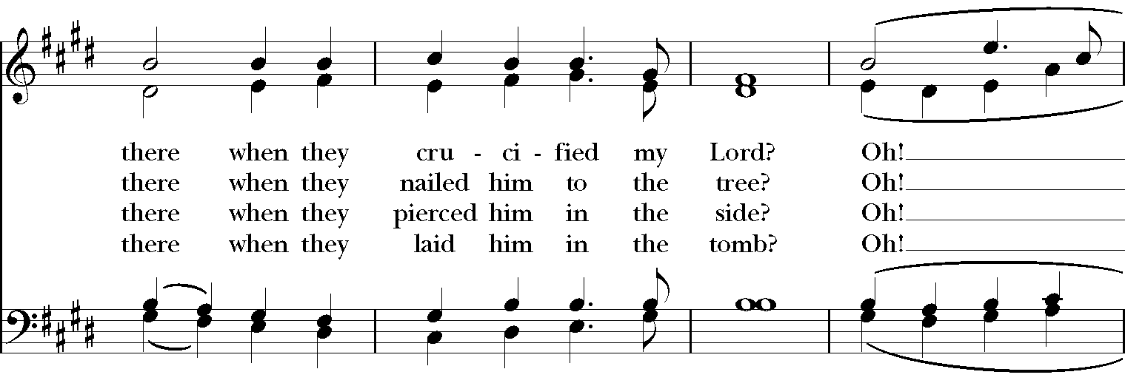

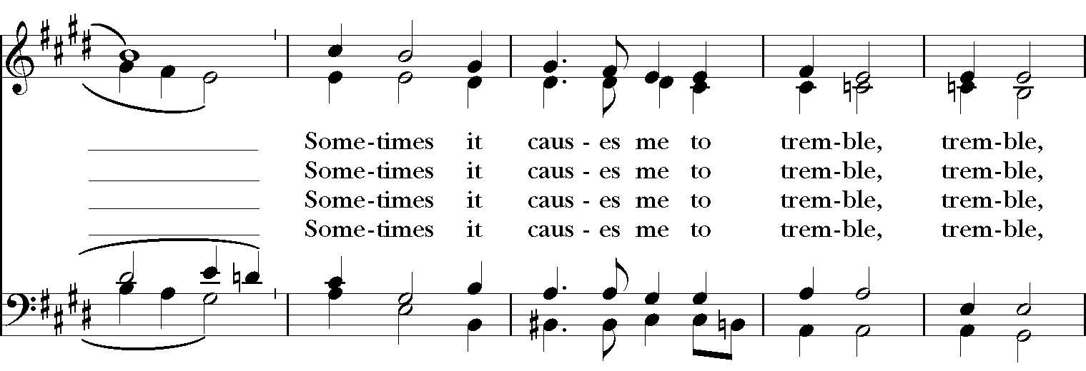

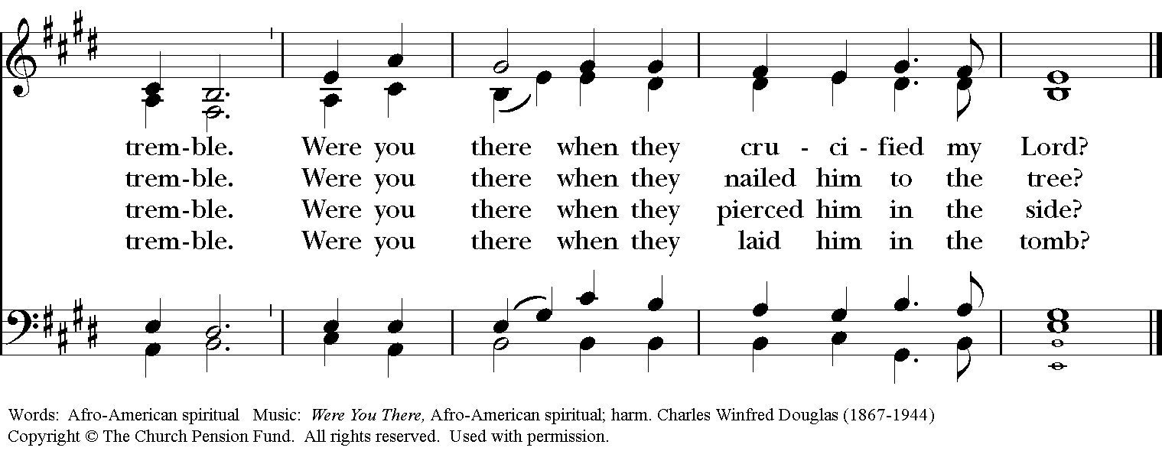

**The Post-Communion Prayer Page 366**

***All* Almighty and everliving God, we thank you for feeding us with the spiritual food of the most precious Body and Blood of your Son our Savior Jesus Christ; and for assuring us in these holy mysteries that we are living members of the Body of your Son, and heirs of your eternal kingdom. And now, Father, send us out to do the work you have given us to do, to love and serve you as faithful witnesses of Christ our Lord. To him, to you, and to the Holy Spirit, be honor and glory, now and for ever. Amen.**

**Solemn Prayer Over the People**

**The Processional “O sacred head, sore wounded” Hymnal, 168**

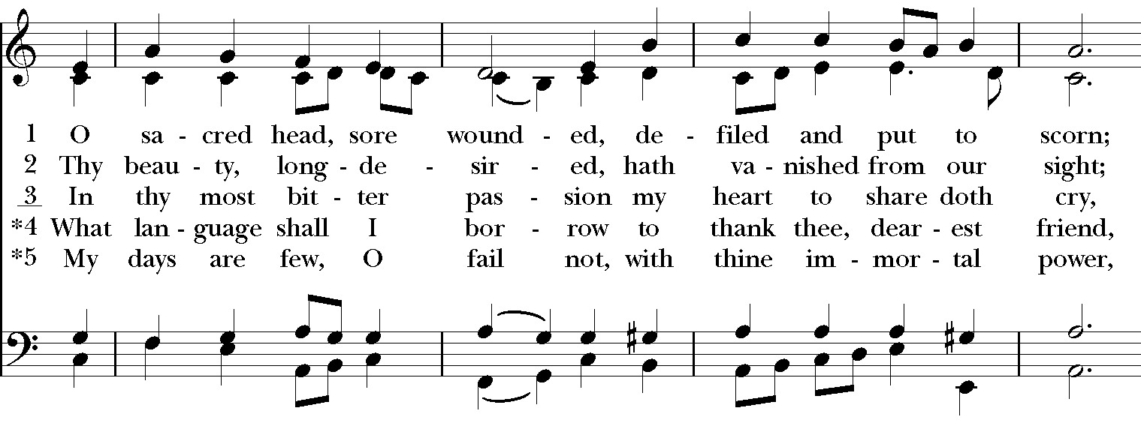

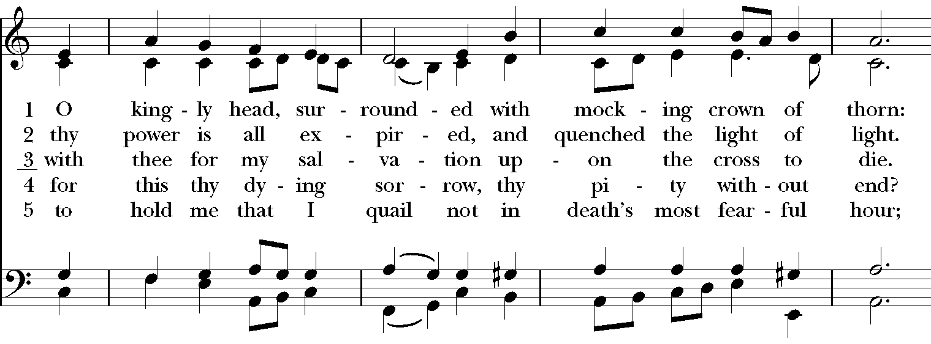

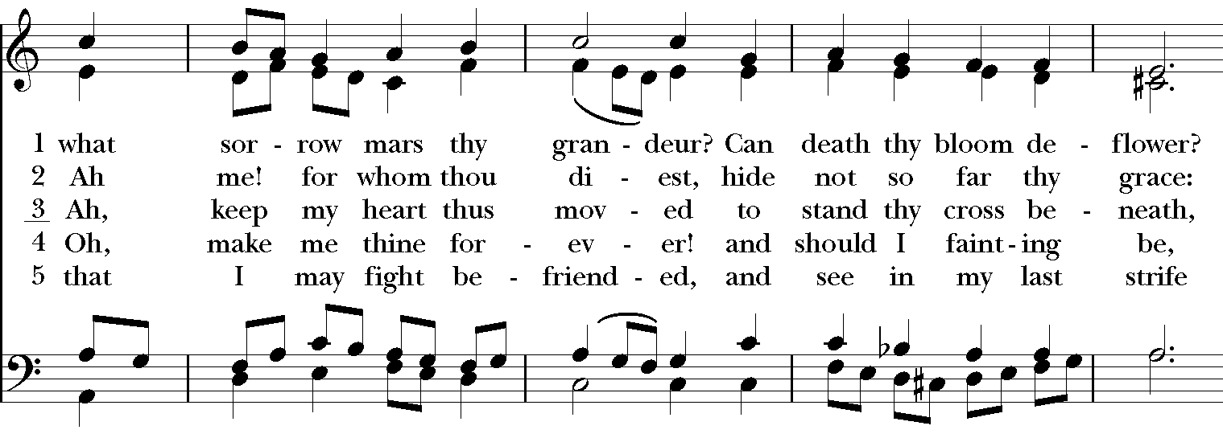

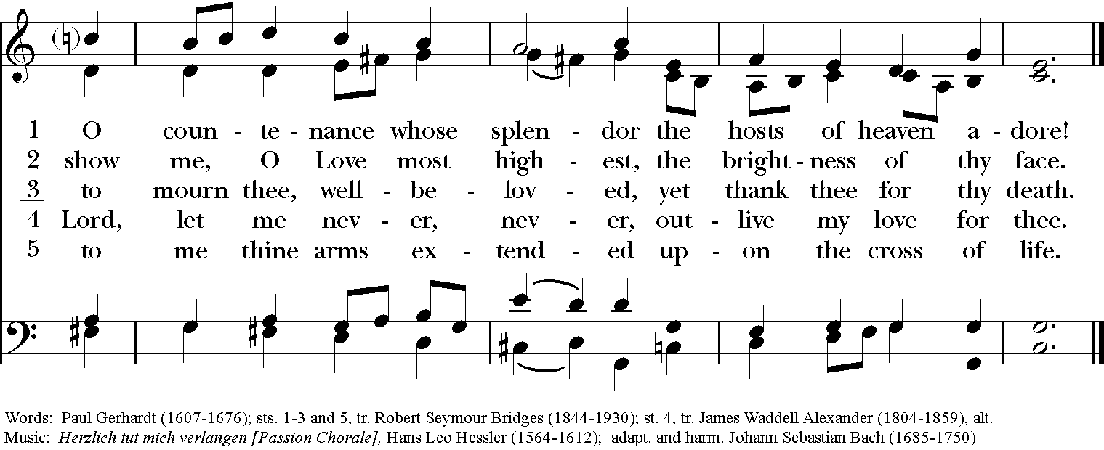

**The Dismissal**

***People* Thanks be to God.**

**Organ Voluntary “O sacred head, sore wounded” J. S. Bach**