[lab name]

Trends and Control Charting Policy and Procedures

[#]

In Compliance with V1

VERSION #1.0 Effective date: January 1, 2024

APPROVED BY

Signature
[name] Technical Manager

Signature
[name] Quality Manager

New SOP

Revision History

Version number and effective date | Revisions made
V 1.0 January 1, 2024 | Conforms to TNI 2016 standards.

Table of Contents
1 Table of Contents 3
1.1 Figures 4
1.2 Equations 4
2 Trend Analyses 5
2.1 Trend definition 5
3 Control Charts 5
3.1 Control Chart General Procedures 6
3.2 Warning on Computation of Mean and Standard Deviation 7
3.3 Computation of Mean and Standard Deviation 7
3.4 Requirements for Data Collection 8
3.5 Data Collection 9
4 Establishing Control and Warning Limits 9
4.1 Static or prescribed limits 9
4.2 Statistically established limits 10
5 Procedures for when a Trend is Detected 10
6 Effectiveness of Actions Taken 10
7 References 10
8 Definitions and Acronyms 11
8.1 Definitions 11
8.2 Acronyms 11
9 Appendices 12

Figures
Figure 1 Positive Control chart 5
Figure 2 Relative Percent Difference for Duplicate Analyses 6
Figure 3 Example of Normally Distributed Data 7

Equations
Equation 1 Mean (average) 9
Equation 2 Standard Deviation of sample 9

Trend Analyses

The TNI Standard in V1M2 5.9.1 requires that all quality control data be organized so that trends in the data may be observed. Trends are representative of systematic errors, such as bias, as opposed to random errors. Trends are generally defined as any non-random outcome that shows a pattern or maintains a direction. However, the details of what this means is not captured in the Standard or is generally defined in reference methods or texts.

Trend definition

Trends in statistical analyses will be based on observation of the following.

- Movement in an upwards or downwards direction defined as 5 out of 7 recent values.
- More than 5 consecutive values above or below the average
- Other non-random patterns, such as all values are the same.
- If warning limits are established, then more than 3 out of 5 analyses between the Warning and Criterion limit.

In addition to monitoring Method Performance Component values, the laboratory will record trends in support equipment.

- Frequent adjustment in one direction.
- Adjusting oven, furnace, or incubator temperatures 5 out of 10 readings.

Control Charts

Control charts will be used to help visualize data and trends. The following are examples.

Figure 1 Positive Control chart

Figure 2 Relative Percent Difference for Duplicate Analyses

Control Chart General Procedures

Control charts will be used to visualize trends in the results generated by the analysis of Positive Controls, Precision, and Recovery. Negative Controls will be charted where they are used to monitor contamination. Warning Limits will be created when appropriate. Control Limits will be set based on the following.

- Regulatory requirements.
- Method requirements.
- Statistical analysis of relevant data.

Generation of statistical data-based Limits will be the average plus/minus 2 standard deviations for Warning Limits and the average plus/minus 3 standard deviations for Control Limits. The analysis will cover at least a minimum of 20 to 32 relevant results. Limits will be recomputed only if the following occurs.

- The base technology is changes, such as ICP to IPCMS.
- A different method is used.
- The values were generated by a single individual and that individual is either permanently replaced or other analysts can conduct the analysis.

Charts will be kept for at least 100 analyses. If they are regenerated, the Average, Warning and Control values will remain the same. Any trends that may have begun will be continued by the inclusion of 10 data points.

Warning on Computation of Mean and Standard Deviation

Note that the values for the Mean and Standard Deviation are dependent on the data provided for computation. Be sure to adhere to the requirements for censoring data and be aware that altering the pool of data used to compute the Mean and Standard Deviation will alter the values.

Computation of Mean and Standard Deviation

Data must be known to be randomly generated and it is normally distributed. Normal distributions are known to have a bell-shaped curve. Normally distributed data has a maximum number of data points at or near the mean and the distribution of data around the mean can be described by the value of the standard deviation. The percentage of values generated by an analysis will fall within a given number of standard deviations. We would expect the following.

- 68.2% of the data will be within 1 standard deviation of the mean.
- 95.4% of the data will be within 2 standard deviations of the mean.
- 99.6% of the data will be within 3 standard deviations of the mean.
- 99.8% of the data will be within 4 standard deviations of the mean.

Figure 3 Example of Normally Distributed Data
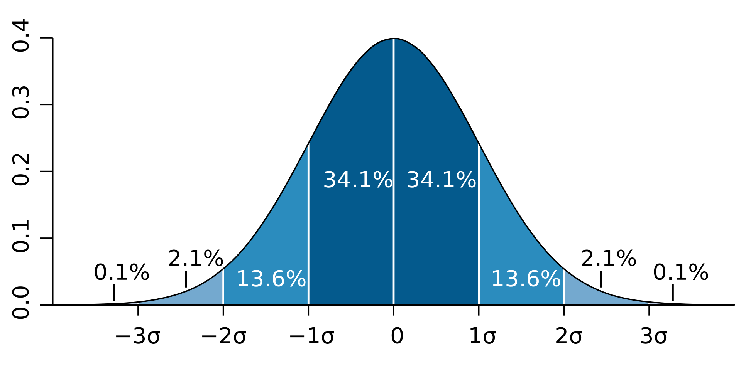

Although we can go to more numbers of standard deviations, the amount of data encompassed by the boundaries will never equal 100% of the data.

It is assumed that all chemical analysis quality control data is normally distributed. Microbiological data is known to have a different distribution unless the data is converted to its log base 10 (log₁₀). Since there is no batch QC for microbiology, this process is not further discussed.

Requirements for Data Collection

DO NOT Censure Data

All data is to be used regardless of the outcome of any quality control parameters. No value is to be censured in any fashion unless the following occurs.

- The method was not performed as described in the SOP including missed or added steps to the process.
- The equipment or instrument used is known to be inoperative or not operating as expected.
- There was a failure in the materials provided, including standards that were improperly prepared or stock solutions were degraded or otherwise improper.
- Any reagent or intermediary process failed, such as a block digestor failing to operate.

Report all method blanks as indicated by the instrument or display. DO NOT censor by ascribing a value of ND or <. This may mean the recording of negative values.

Data Collection

Collect at least 32 data values. The more data beyond 32, the more robust the determination of the mean and standard deviation. If the pool of data is very limited, 20 data values may be selected, but the robustness of the computed values is not assured. The data cannot come from a pool where there was censoring of the data by either a less than or greater than indicator; or where values were discarded for reasons other than instrument, calibration, or other failure in the test process. There are procedures for computing means and standard deviations where the data is censored by less than or greater than indicators, but it is beyond the scope of this procedure.

Using standard statistical procedures, compute the mean and standard deviation from the pooled values. Equations are as follows.

Equation 1 Mean (average)

$$mean=\frac{\sum_{1}^{n}{x_{n}}}{n}$$

Equation 2 Standard Deviation of sample

$$Standard deviation=\sqrt{\frac{1}{n-1}}\sum_{1}^{n}{{\left(x_{i}-mean\right)}^{2}}$$

Establishing Control and Warning Limits

When establishing Control and Warning Limits, determine if a preset (static) or statistically derived limit will be used. Switching from Static to Statistically derived limits is permissible and even encouraged, the reverse is not allowed.

Static or prescribed limits

In some cases, quality control limits are set by the reference method or by project or other-directed means. In those cases, the limits are put into place as the control limits. There is usually no directed warning limits.

Statistically established limits

Although not firmly established in reference materials, the norm is to use plus and minus a specific number of standard deviations to establish warning and control limits. The following represents standard convention.

- Drinking water quality control parameters – no warning limits are established, and control limits are set at + 2 standard deviations.
- Wastewater quality control parameters – set warning limits at + 2 standard deviations and control limits at + 3 standard deviations.

In certain cases, the limits are set at +2 and +3 standard deviations. These are where the calculations do not create negative numbers, such as always subtracting smaller values from larger values or using the absolute value from a subtraction.

Procedures for when a Trend is Detected

If a trend is detected (as defined in 2.1 above), the following is to be investigated.

- Censoring of data.
- A change in the procedure.
- Changes in equipment used.,
- Changes in instrument or equipment conditions.
- Issues with standards or reagents.
- Addition of new personnel.
- Altering conditions under which the method operates
- Changes in the source of Positive Control solutions.
- The possibility of contamination.

The investigation is to attempt to determine a Root Cause as this is a systemic error. Any identified corrective actions need to address the Root Cause and come under the provision of the Corrective Action procedures found in the QSM.

Effectiveness of Actions Taken

The efficacy of any action taken will be evidenced by a return to random errors and a lack of a defined trend in data.

References

- Management and Technical Requirements for Laboratories Performing Environmental Analyses, The NELAC Institute (TNI), Rev 2.1, September 1, 2016

Definitions and Acronyms

Words specific to this document or used outside of their dictionary definition are defined here. Acronyms can be defined in the text above on their first appearance.

Definitions

Acronyms

Appendices

