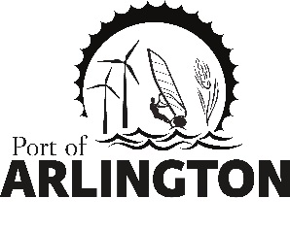

Regular Commission Meeting

THE PORT OF ARLINGTON BOARD MEETING IN CONDON HAS BEEN CANCELLED FOR TUESDAY APRIL 14, 2020

Upcoming Meetings:

Budget Committee Meeting Tuesday May 12, 2020 at 4 pm – The Port will Post Location as Soon as Available
Regular Commission Meeting on Tuesday, May 12, 2020 at 5 pm – The Port will Post Location as Soon as Available

Posted: Tuesday, April 6, 2020: Bank of Eastern Oregon - Condon & Arlington; U.S. Post Office –
Condon & Arlington;
Condon Times-Journal; Arlington City Hall; Port Office and Website.
PO Box 279, Arlington, Oregon 97812

